A 40 yo man presents with a one hour history of palpitations

He has no significant medical history and is on no medications

He is alert with BP 110/65 and chest clear and is fully monitor in the resuscitation bay

This is his ECG

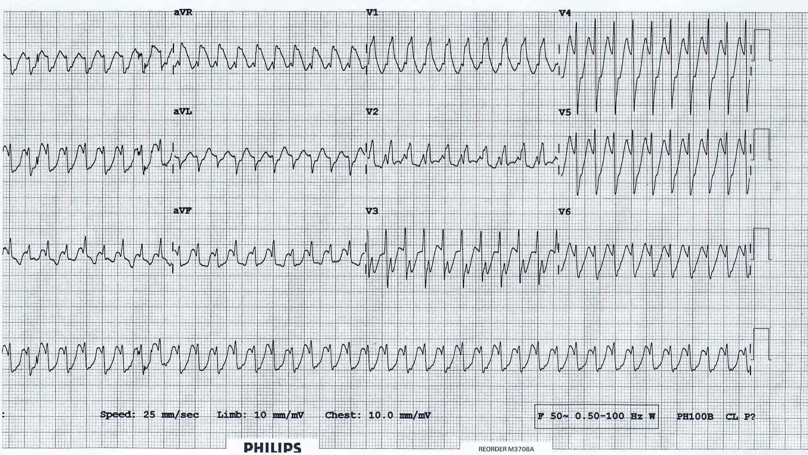

Describe 4 important findings on the ECG:

1. …………………………………………………………………………………………………………………………
2. …………………………………………………………………………………………………………………………..
3. ……………………………………………………………………………………………………………………………
4. …………………………………………………………………………………………………………………………..

What is the most likely underlying rhythm?

……………………………………………………………………………………………………………………………………………………….

Assuming that the patient remains haemodynamically stable, outline 2 medications (including the dose and method of administration) that could be used to manage this patient’s rhythm:

1. ………………………………………………………………………………………………………………………………………
2. ………………………………………………………………………………………………………………………………………

The patient becomes hypotensive (70/50) to commencing any medication, outline 6 steps involved in electrically cardioverting this patient:

1. ………………………………………………………………………………………………………………………………..
2. ………………………………………………………………………………………………………………………………..
3. …………………………………………………………………………………………………………………………………
4. ……………………………………………………………………………………………………………………………………
5. ………………………………………………………………………………………………………………………………….
6. …………………………………………………………………………………………………………………………………….

The patient’s heart rate spontaneously decreases prior to any intervention, this is his new ECG

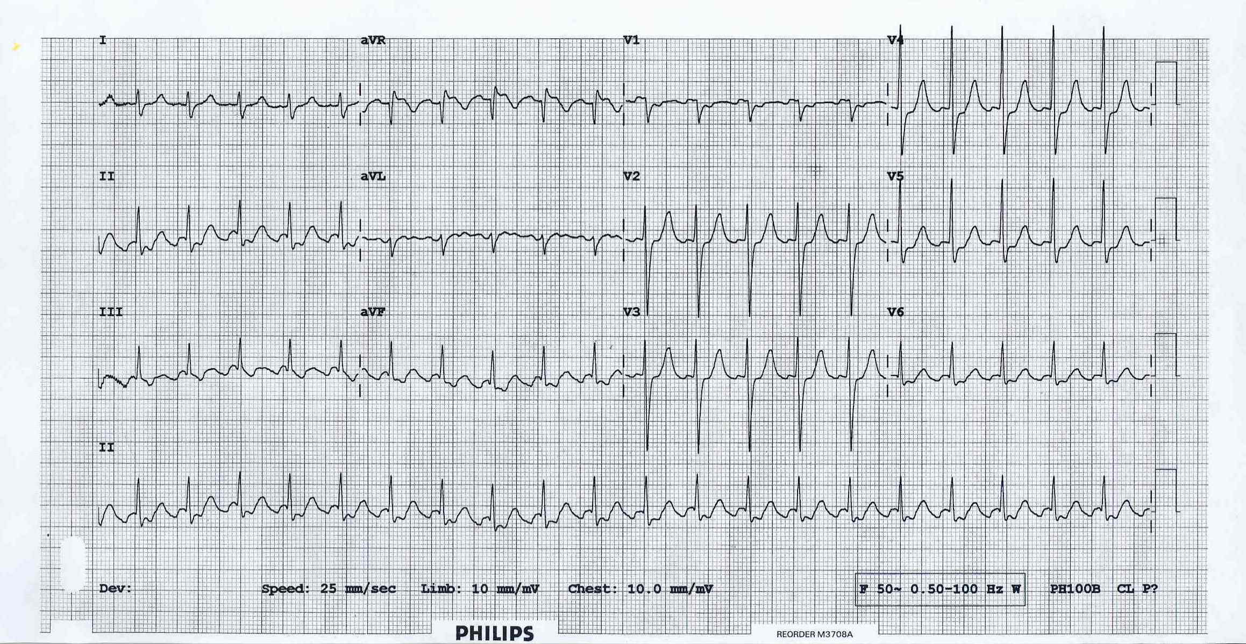

What is the underlying rhythm?

……………………………………………………………………………………………………………………………………………….