Investigation of the Week

ECG: 5/9/17

85M presents with palpitations and mild dyspnoea

Triage: Category 2

ECG performed on arrival

RR 18, SpO2 98% RA, BP 150/90, Temp 36.4, GCS 15

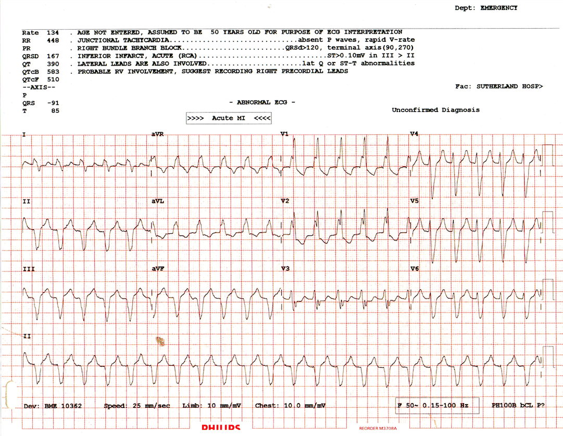

1. Describe the ECG
2. What is your provisional diagnosis?
3. What are your differentials?
4. Discuss you management approach.

(suggested template: Rate/Rhythm/axis/intervals/Pwaves/QRS/Twaves/QT/extras)

BONUS ECG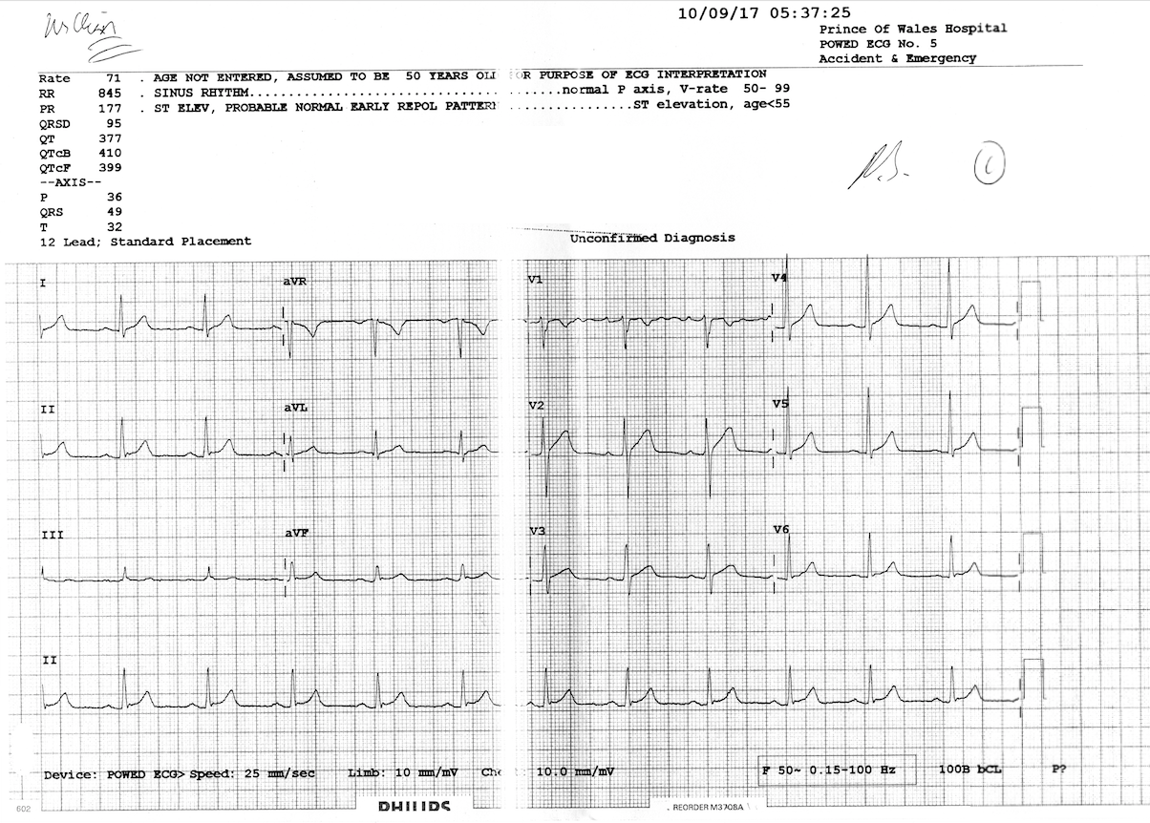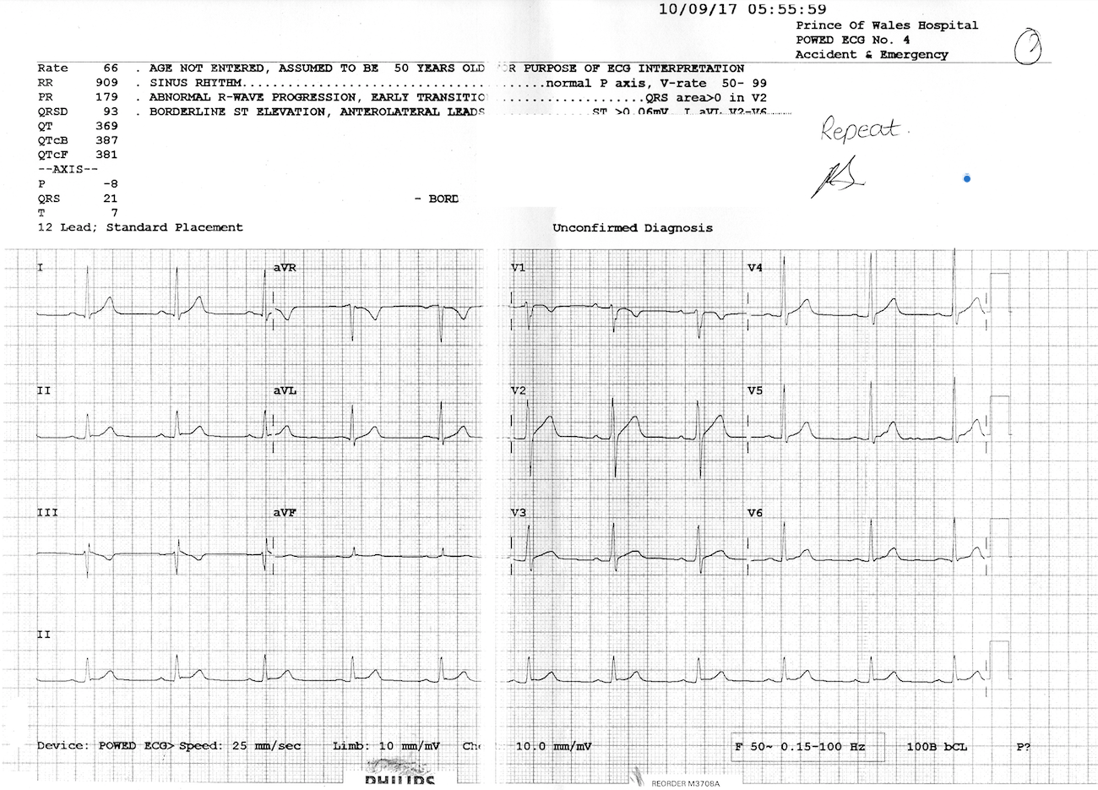

35M retrosternal wakes up at 5am with retrosternal squeezing chest pain for 1 hour. He has no past medical history. Serial troponins are 12 and 11.

1. Describe any significant ECG features.
2. What is the HEART score?
3. What would this patient score?
4. What is your next action based on your risk assessment?
5. Sinus rhythm, HR 134, axis -91 (N to Northwest: ?bizarre), absent P waves (best checked in AVR/V1), QRS 167 (long), QT 9x40= 360ms,

Other features

Right rabbit ear taller than the left

Discordance across the chest leads

Absent capture or fusion beats

Absent brugada’s sign (brugada +ve if the bottom of S is >100ms from the start of the QRS)

ECG features to support VT:

Fusion beats  
capture beats  
Bizarre axis (northwest)  
all negative or positive concordance precordial leads  
V1-V2: left rabbit ear higher in RSR  
very broad complex >160ms  
AV dissociation  
Signs  
Josephson's - notching near nadir of S wave  
Brugada sign: onset of QRS to nadir of S is >100ms

1. Broad complex regular tachycardia – a number of features consistent with VT (QRS >160ms, bizarre axis, age >35y)
2. SVT with aberrancy  
   SVT with pre-excitation/WPW  
   Ventricular tachycardia  
   Paced rhythm  
   Hyperkalaemia  
   Sodium channel blockade
3. Management
   1. Supportive – from the vitals, none required
   2. Specific
      1. To differentiate between SVT and VT if clinically indicated
         1. AV nodal blockade: adenosine, beta blocker
      2. Antiarrhythmics
         1. Amiodarone: 300mg loading, then 450mg/12hrs IV
         2. Lignocaine 1mg/kg IV if ischaemia suspected
         3. Procainamide 10mg/kg IV
      3. DC cardioversion
         1. Primary option if there is loss of output or features of end organ failure (hypotension, confusion, syncope)
   3. Disposition
      1. Cardiac monitoring
      2. Cardiology admission
      3. Since HD stable, for TOE Cardioversion

Discussion:

* Procainamide vs Amiodarone in VT – PROCAMIO Study n=74
  + This study – procainamide was superior to amiodarone
    - Decreased incidence of adverse events 9% vs 41% p = 0.006)
    - Termination of tachycardia Proc 67% vs Amio 38%

BONUS ECG

Non specific T wave changes in Lead III. Note the different QRS morphology.

HEART score is an externally validated risk assessment tool for chest pain in the emergency department population

There are 5 components of the HEART score, each represented by one letter.

|  |  |
| --- | --- |
| H | History - highly suspicious, moderately, slightly (0,1,2) |
| E | ECG - ST T changes, nonspecific TW, normal (0,1,2) |
| A | <45, 45-65, >65 (0,1,2) |
| R | Risk factors: 0, 1-2, 3 or more (0,1,2) |
| T | Normal, 1-3x upper limit of normal, >3x normal (0,1,2) |

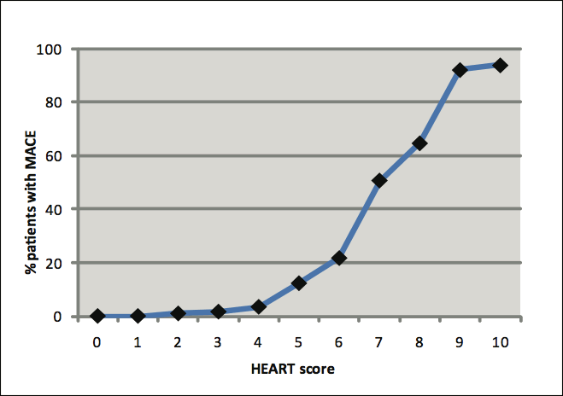

This patient would score one

H: moderate = 1 point

E: non specific TWI = 1 point

Total of 2 points, and low risk ACS and has a 6 week risk of MACE of 1.6%. The suggested disposition plan is for outpatient risk stratification. Eg exercise stress test, CT coronary angiogram, stress echo or a myocardial perfusion scan. In view of practicality, EST is the likely option.

