EMERGENCY MEDICINE Sutherland Hospital
The Weekly Probe
28th June 2016 Volume 13 Issue 20
Leave for “ASET Annie” - Annie from ASET will be on leave from the 29/06/2016-18/07/2016. Throughout this time there will be no ASET nurse coverage in the Emergency Department.
If you have a patient that you would normally refer to ASET, you feel they are safe for discharge and the patient requires a multidisciplinary team assessment or is at risk of representing to the ED, you need to refer the patient to SOS (South care Outreach Service). These patients need to be greater than 70years of age and live in the Sutherland Shire.
This referral is completed on EMR. It is exactly the same way as referring to Community Nurses.
* Go to orders
* Click on Add
* Type in Community
* Click on South care
* Select Team SOS (3rd from the bottom)
* Fill in patient’s information
SOS will follow up patient within 48hrs of the referral where possible.
To ensure the continuation of the ASET service within the ED could you log with the Communications Clerk any patients you would normally discuss or refer to ASET. The Communications Clerk will have a book if you could please give them the addressograph label and they will pop it in the book.

Farewell tonight! – Erin, Ray, Naresh and Erin are moving on so as there a farewell at the Bavarian Beer Café. So get your lederhosen ready for a big night out!
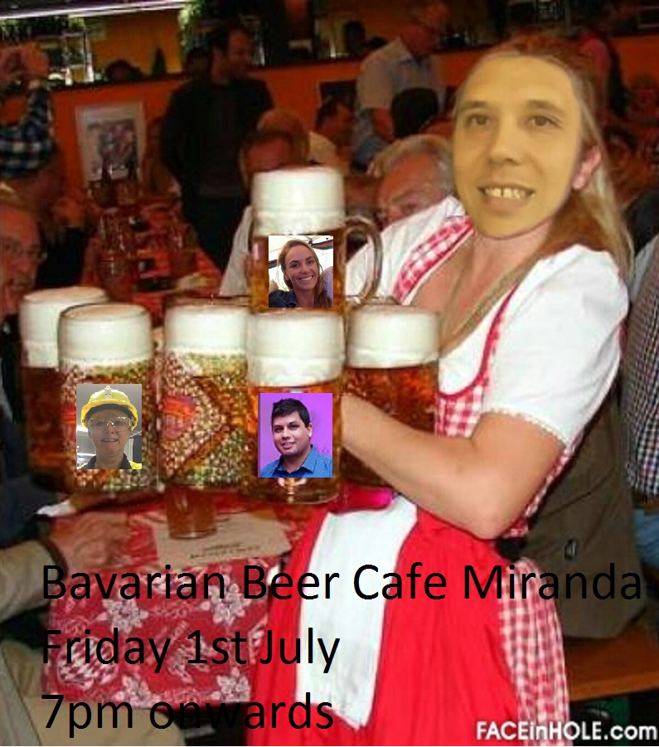

THIS WEEK
Nystagmus and EOM
Joke / Quote of the Week
The Week Ahead

With time you learn that what you have been taught at uni, as a trainee and a SS is not always “correct”. Like technology, the way we approach certain conditions evolve and the challenge is to keep up with these changes. This is particularly relevant for conditions which lead to frequent misadventure and significant consequences, yet you realise that when working in a busy ED there are more red flags to look out for than that seen at a North Korean Socialist Party conference- chest pain, back pain, headache etc etc.

So after a recent case, over the next couple of editions we’ll focus on one area – the Posterior Circulation and the brainstem / cerebellum looking at nystagmus, TIAs, vertigo / dizziness. Best to check this out online as there are lots of links to explain the concepts

NYSTAGMUS and OCULAR MOVEMENT DISORDERS
This initial discussion ties in the other issues mentioned above yet worth looking at to get “the ball rolling”. It started with a good review from a German article (see refs below) with some further info from up-to-date etc etc which go into a lot of detail yet may help you in the assessment of your ? stroke / dizzy patient. However we’ve tried to stop it getting “bigger than Ben Hur” yet the aim is to give you some other aspects to consider!
Part of the neuro exam involves the assessment of the extra-ocular movements looking for nystagmus and diplopia. However is a bit more than “follow my finger and tell me how many fingers you see”. For the eyes to move purposefully there is a complex network of pathways to perform movements including:
- Gaze pursuit – following a moving object
- Saccadic pursuit – jumping from one object to another
- Fixation
- Vergence eye movements- mid brain function
- Vestibulo-ocular reflex (VOR) –eye movement in response to head movement
- Optokinetic movements – combination of both pursuit and saccadic mvts

Examination
- Look for position of head and eyes
  - ? head tilt - may results from 4th nerve lesions or loss of otolithic input to the INC from a central lesion in the medulla, pons, or midbrain (which produces head tilt, skew deviation, and cyclotorsional abnormalities of both eyes)
  - ? Ptosis- if unilateral 3rd nerve (with EOM +/- pupillary changes)
  - Position of eyes when looking straight ahead – look for misalignment- horizontal or vertical
    - When it is deviated laterally = exotropia – inwards= esotropia – upwards= hypertropia – downwards= hypotropia
  - Cover test – test of skew - get the patient to fix on your nose - look for movements of eye (refixation) on moving the cover from one eye to the other. This cover should be VERY BRIEF.
    - This refixation may occur horizontally with a squint. However what we are looking for is VERTICAL refixation.
    - Despite this malalignment, patients may not sense diplopia.
    - This vertical misalignment results from asymmetric disruption of supranuclear input from the otolithic organs (the utricle and saccule of the inner ear contain otoliths which sense linear motion and static tilt of the head and transmit information to the vertically acting ocular motorneurons, as well nuclei within the midbrain) ie it can be peripheral yet central causes of skew deviation are more common – esp basilar artery pathology with lateral medullary or lateral pontine strokes.. An example of this is shown in the Johns YouTube link below in the references (7:30 min into the video).
    - One variant is alternating skew deviation on lateral gaze which may be seen with cerebellar, cervicomedullary junction, or midbrain lesions. This usually manifests as hypertropia of the abducting eye (ie, right hypertropia on right gaze) that switches when gaze is directed to the opposite side (ie, becomes left hypertropia on left gaze).
Examination of oculomotor and vestibular systems
- Move the eyes to the eight final positions (binocular and monocular) – that is, right, left, upwards, downwards, and in the 4 diagonals
- Gaze should be taken to 10°-40° horizontal or 10° to 40° vertical and back to 0°
- However if a normal person beyond this, “end point nystagmus” may result. This end pint nystagmus is only pathological if > 20 seconds duration, is notably asymmetrical or is associated with other oculomotor changes.

- Pareses- Look for pareses in one or both eyes – consider getting the patient to follow a torch and use the reflection relative to the pupil to check parallel eye movements. Ask re diplopia.

  - Gaze palsies- One differentiating factors is that supranuclear problems result in abnormalities to both eyes together and as a result don’t cause diplopia.
    - Horizontal – pontine lesions / frontal – disrupt eye mvt towards side of lesion
    - Vertical – midbrain or posterior commissure (near the midbrain)
    - Internuclear Opthalmoplegia- cant adduct – nystagmus in abducting eye
    - One and a half Syndrome- one eye cannot adduct (1/2) and the other cannot abduct or adduct (1) - nystagmus may be seen in the eye that can abduct- convergence is intact – seen with pontine lesions
    - Bilateral internuclear opthalmoplegia -both eyes diverge and unable to adduct- via MS or brainstem infarct
    - Parinauds –dorsal midbrain- multiple findings vertical gaze disturbance+ convergence/ divergence problems +/- nystagmus, skew deviation , ptosis and pupillary changes

- Nystagmus
  - Nystagmus indicates a problem with the vestibular system. This may be peripheral involving the otoliths and semicircular canal, yet can be caused by ischaemia or other pathology affecting the peripheral vestibular system from the inner ear, the multiple peripheral and central neuro connections and integrators including the brainstem and the cerebellum (for more info on the connections that can be interrupted look at the slideshare link below).

  - The easiest point to remember is that each vestibular apparatus pushes the eyes towards the opposite side. There is normally a balance of the input from the right and left sides- as the left vestibular apparatus pushes the eyes to the right side, this is balanced by input from the right vestibular apparatus and the eyes remain on target.
  - If there are problems with the left side (underactive due to problems with labyrinths or their connections), the right vestibular apparatus predominates and the eyes drift towards the abnormal left side. However as there is a corrective saccade the eyes quickly return to the target (in this case back to the right)– so the FAST PHASE IS AWAY FROM THE ABNORMAL SIDE

  - Look for the direction of the fast phase (horizontal, vertical or rotatory / torsional)
    - Vertical = central
      - Downbeat- esp cerebellar
      - Upbeat- causes include MS, brainstem ischaemia or tumours, Wenicke’s
    - Pure horizontal = suggestive of central aetiology
    - Pure torsional – suggestive of central aetiology
    - Mixed horizontal / torsional= more common with peripheral yet can be central
  - Look at which direction of gaze maximises the nystagmus
    - Unidirectional – regardless of where the patient looks the direction will be the same.
      - Typically the nystagmus is worse looking to the direction of the fast phase.
      - Typical of peripheral lesions yet can be seen with central pathology
    - Gaze evoked ,multidirectional or direction changing nystagmus –as the name suggests the direction changes – look to the left, the fast phase is to the left – look to the right and the fast phase is to the right- indicative of an injury to gaze holding structures in the brainstem and cerebellum
    - There can be other types including pendular (wave like with no fast phase = central), see-saw (one up one down -= central) nystagmus

  - Note that similar to visual fixation suppressing the VOR as discussed later, visual fixation will suppress some types of nystagmus (peripheral). This suppression of nystagmus is suggestive of a peripheral lesion as the central (mainly cerebellar) mechanisms are intact. Conversely, some central types of nystagmus are increased by fixation. To avoid this suppression with possible peripheral nystagmus you can use :
    - A darkened room
    - Pen light cover test
    - Block fixation by placing a blank sheet of paper a few inches in front of the patient and observing for nystagmus from the side
    - Observing the eyes moving through the lids
    - Observing the movement through an ophthalmoscope – note that the fast phase movement of the retina is in the opposite direction to the anterior globe
    - Frenzel glasses (30+ lenses!) 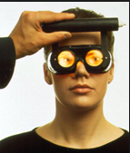

- Pursuit - Look for the smoothness of visual pursuit - smooth or saccadic (jumpy as it “catches up ”reflective of a central disturbance)

- Saccades – rapid horizontal and vertical eye movements – in this context they are voluntary movements in response to visual or auditory prompts. Sit the patient in front or you with instruction to initially look at your nose. Have your hands about 20-30 degrees from the midline and ask them to rapidly look to the hand where you lift the finger. Check horizontal then vertical. YouTube has plenty of demonstrations of this assessment.
  - This function involves the frontal or parietal lobes and with horizontal saccades the pons and vertical saccades the midbrain
  - Attention should be paid to their range, velocity and accuracy (should get to target in 1 or 2 movements) and to whether both eyes move in parallel (may be abN in internuclear ophthalmoplegia). Hypermetric saccades are overshoots & are present in cerebellar impairments, while hypometric saccades (undershoots target) seen mostly in brainstem lesions and neurodegenerative disorders. Here is an example Not an ED issue, but in progressive supranuclear gaze palsy,—the vertical saccades slow down first and later the horizontal saccades also, with bilateral gaze palsy as the ultimate outcome.

- Vergence- Move an object close to the nose- look for vergence of the yes in addition to pupillary reaction. Loss of vergence is indicative of midbrain pathology. Note adduction may still occur with convergence when there is a MLF lesion blocking adduction.

- Vestibulo-ocular reflex (VOR) – this allows the eyes to remain on target when the head is turned.

  - Head movement will make any type of vertigo or nystagmus worse as there is an amplification of the vestibular inputs. However one technique developed in 1988 by Halmaygi at RPAH can assist in our assessment of the dizzy patient.

  - HEAD IMPULSE TEST (HEAD THRUST) - Movement of the head can be used to further assess the vestibular system. As shown in the diagram- when the head is turned to the LEFT the eyes should remain fixed or the target and thus need to move to the RIGHT. This action is achieved by the LEFT vestibular apparatus.

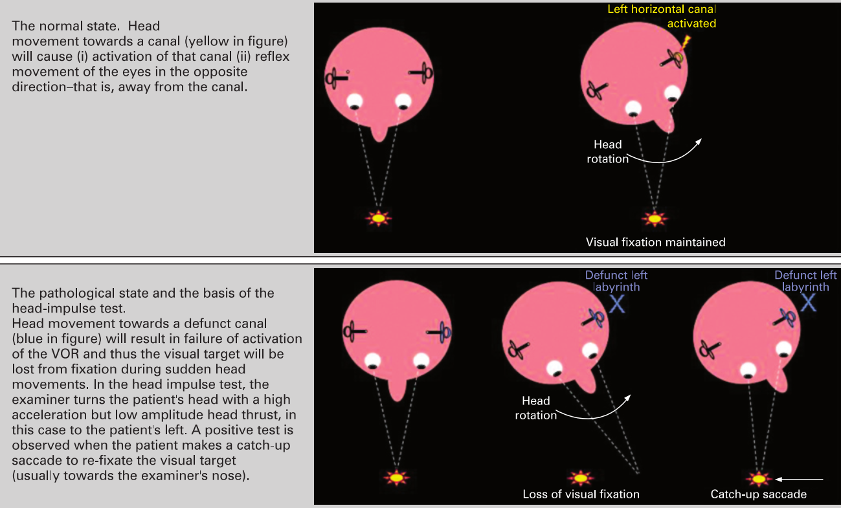
- However when there is a problem with the LEFT side, on rotating towards the abnormal side (ie the left) the eyes are not moved to the right and move with the head. There is then a corrective saccade back to the right – AWAY FROM THE ABNORMAL SIDE ie same direction as FAST PHASE
- Note that the movements do not need to be significant – only 10-20 degrees, yet rapid!

Thus a -ve head impulse test is indicative that the peripheral vestibular system is functioning normally implying that the lesion must be central.

However remember that the peripheral vestibular system may be non-functioning as a result of ischaemia / strokes particularly those lesions involving the anterior inferior cerebellar artery which supplies the lateral pons, inf cerebellum, labyrinth and cochlear. As a result these events may be associated with acute unilateral hearing loss, direction changing nystagmus or skew deviation.

In the Kattah article referenced and accessible below, the HINTS battery of tests which includes looking for a +ve Head Impulse test, negative test of Skew and unidirectional nystagmus was better than a diffusion weighted MRI in ruling out stroke in “acute vestibular syndrome” (100% sensitivity / 96% specificity)
- They looked at 101 patients with ≥1 stroke risk factor who presented with acute vestibular syndrome (rapid onset of vertigo, nausea, vomiting, and unsteady gait +/- nystagmus)- additional patients were also identified by review of stroke admissions for cerebellar infarction- total of 25 peripheral & 76 central – ie different to our ED population
- They excluded patient with recurrent vertigo
- Kattah warns that 1 in 10 strokes will be missed if other subtle extraocular signs are not considered. Therefore the head impulse test cannot be used in isolation.

Who should you use the head impulse test on? Theoretically this is a test of the peripheral vestibular system and thus groups such as Halmaygi use it for testing all causes of peripheral vestibular dysfunction including aminoglycoside toxicity etc.
Have a look their site http://www.headimpulse.com/ and the proprietary equipment they have for documenting this. Part of the subtlety is that we can see “overt” corrective saccades yet they are able to record patents in whom the correction occurs while the head is turning – what they call “covert” saccades which are imperceptible to the naked eye. https://www.youtube.com/watch?v=6JehOm7NEnI (watch from 4 min to 5 min then 9:30 onwards).

Subsequently although not noted in the Kattah HINTS article, one of the authors, David Newman-Toker comments on another article by saying that “ HINTS should only be used in patients AVS (acute vestibular syndrome) with nystagmus” – reading into this, more severe the signs (nystagmus) , the more significant are the results of this test

- VISUAL FIXATION SUPPRESSION OF VOR – however we need to be able to move our eyes in conjunction with the head – imagine watching a tennis match, and despite moving your head to follow the ball, your eyes remained on the net! To avoid this you are able to use this visual fixation to suppress the VOR.
  - To test this have the person fix on their outstretched hand as you rotate them on a swivel chair – their eyes should remain fixed on the finger.
  - If this is abnormal it may be indicative of a central lesion esp cerebellar.

- POSITIONAL (Hallpikes)
  - May be of use in determining if the patient has BPPV- looking at the 3 features + type of nystagmus as described below
  - Not of use if the person already has nystagmus
  - Typically peripheral vertigo + nystagmus induced by a Hallpike’s manoeuver has:
1) Latency ie delay in onset of symptoms when patient is moved
2) Fatigability - symptoms ease with time (seconds to minutes)
3) Adaptability – less symptoms with repeated attempts
  - The most common type of BPPV which involves the posterior semicircular canal, is associated with vertical nystagmus with a torsional / rotatory component towards the downside ear (PS patients with BPPV will often lie on their side and “show you their bad ear” ). This nystagmus is short lived ie ~15-25 sec
  - If the horizontal canals are involved, nystagmus may be triggered when the patient turns to the sides while lying supine- it typically lasts longer than the posterior canal types.
  - Note there is a rare central positioning nystagmus which will produce the same type of nystagmus on moving the head to different positions c/w BPPV which varies with different head positions (different canals stimulated)

- OPTOKINETIC DRUM – not much use in the ED as you need to create a drum or long sheet of paper with vertical lines. The produces an effect seen when you are looking out of a train- your eyes follow or pursue a pole , and then saccade back to look at another pole which is then followed. Apparently it tests the cerebral cortex, in particular the parietal and temporal lobes and if normal implies normal brainstem functioning. It is also touted a way to assess a patient with functional blindness - the patient says they cannot see anything yet nystagmus is induced by moving the drum or sheet in front of the patient’s eyes.

OTHER SYMPTOMS & SIGNS
- Look for other long tract, cranial nerve of cerebellar signs
- Remember to include assessment of truncal ataxia and gait.
- Remember that in ~ 10% of cerebellar infarction they can present with an isolated vertigo (medial branch of PICA)
- Most importantly it is history, examination and investigations.

Links
Links to “guru” David Newman-Toker’s videos

Johns’ video on the dizzy patient assessment - very good summary
For some anatomical info http://www.slideshare.net/laxmieyeinstitute/supranuclear-pathways-and-lesions

Refs: Strupp M et al, Central Oculomotor disturbances and Nystagmus: A window into the Brainstem and the cerebellum Deutches Arzteblatt 2011 Mar; 108(12): 197- 204 http://www.ncbi.nlm.nih.gov/pmc/articles/PMC3077509/
KattahJ et al, HINTS to diagnose stroke in acute vestibular syndrome Stroke 2009; 30: 3504-3510 http://stroke.ahajournals.org/content/40/11/3504.long
Halmagyi GM Diagnosis and management of vertigo Clin Med April 2005;5:159-165
Kerber KA Vertigo and dizziness in the Emergency Department Emerg Med Clin 2009; 39-50
Nelson JA The clinical Differentiation of Cerebellar Infarction from Common vertigo syndromes Western J Emerg Med 2009; 10(4): 273-277
Seemungal BM A practical Approach to acute vertigo Pract neurol 2008:8; 211-221

NEXT WEEK’S CASE
A 65yo man presents with “dizziness”- he denies any vertigo, on a background of alcohol excess and hypertension. What is your approach to his assessment?

JOKE / QUOTE OF THE WEEK
A man with dementia was being assessed with a mini-mental state. He was asked “Spell the word WORLD backwards” to which he said “W-O-R-L-D B-A-C-K-W-A-R-D-S” . He should have got a bonus couple of points for that one!



Please forward any funny and litigious quotes you may hear on the floor (happy to publish names if you want)

THE WEEK AHEAD
Monday 4th July 12:30-13:30 Surgical Meeting – Audit M&M, May June Education Centre, Level 2
Thursday 7th July 12:00-13:30 JMO Education Session – Vascular Surgery, Dr Gai McMullen, Education Centre, Level 2

