EMERGENCY MEDICINE Sutherland Hospital
The Weekly Probe
14th July 2016 Volume 13 Issue 22
Caution when Prescribing –A reminder from Tanya re the significant number of IIMs regarding prescribing errors. If everyone could be more careful with prescriptions/writing med charts, checking that the medications charted are in fact the patients current medications, and avoid prescribing the brand name of drugs ( a couple of cases where patients would have had several doses of the same drug as both the generic and brand names written up separately). If unsure, check with senior staff on.
Chlorprep trial – a reminder on the new skin cleaning device which is being trialled in the department. If you use this please complete the evaluation sheet.

THIS WEEK
Tick removal
Last week’s case – Intramural haematoma
Joke / Quote of the Week
The Week Ahead

TICK REMOVAL
Occasionally with people living close to and going into the “bush”, we get people coming in with ? ticks. Some patients are just unfortunate eg 75yo man from Fairfield last week who has not been near “the bush”. They can be of varying size from a mm to over 3 cm (see below). We’ve talked before about tick borne illnesses (probe 2009 no 12) but how do we remove them? This is from Medscape , (an American site where they worry about a number of infectious conditions such as Lyme, Relapsing fever, Rocky mountain spotted fever etc) and an Australia site called “tick Alert” (http://www.tickalert.org.au/) (by the Tick Alert Group or TAGS) which has all you need to know about ticks in Australia

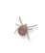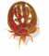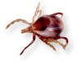

Larvae Nymphs Adults
0.5mm 1.2 X0.8mm up to 3.8X 2.6mm

To remove a tick, use fine-tipped forceps and wear gloves. Grasp the tick as close to the skin surface as possible, including the mouth parts, and pull upward with steady, even traction. Do not twist or jerk the tick because this may cause the mouth parts to break off and remain in the skin; however, note that the mouth parts themselves are not infectious. When removing, wear gloves to avoid possible infection.
TAGS does not currently recommend killing adult ticks before removal by using alcohol, methylated spirits, salt, vegetable oil, nail polish remover or other substances as this might cause the tick to inject more toxins and bacteria.
Whilst some sources claim that applying insecticides such as pyrethrin/pyrethroid repellents such as DEET is safe and effective, TAGS does not currently recommend doing this.
TAGS does, however, suggests the use of sodium bicarbonate (bicarb soda) to help remove infestation by multiple small larval-stage ticks (If many larvae: soak for 30 minutes in a bath with 1 cup of bicarb soda then scrape off - If solitary larvae: fine tweezers, or apply a paste of bicarb soda. Additionally, using lignocaine (subcutaneously or topically) may actually irritate the tick and prompt it to regurgitate its stomach contents.
Finally, do not squeeze, crush, or puncture the body of the tick because its fluids (saliva, hemolymph, gut contents) may contain infectious organisms.

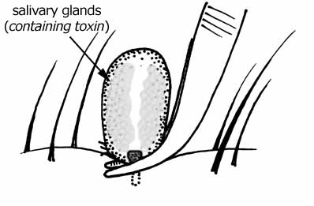

LAST WEEK’S CASE- INTRAMURAL HAEMATOMA
A 66yo lady with a Hx of HT’n and previous type A aortic dissection presents twice in 3 days with left sided posterior chest pain. No BP differences – no regurg – normal exam.

The aortogram (A) is reported as normal and a CTPA is performed (B+C) as PE cannot be ruled out on the first study.
A 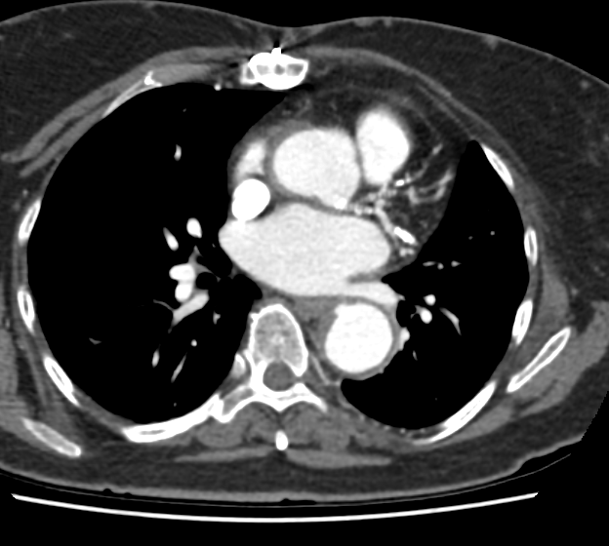 B 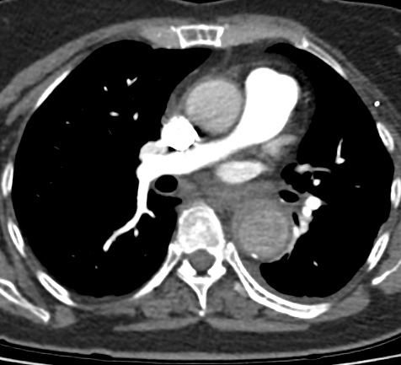
C 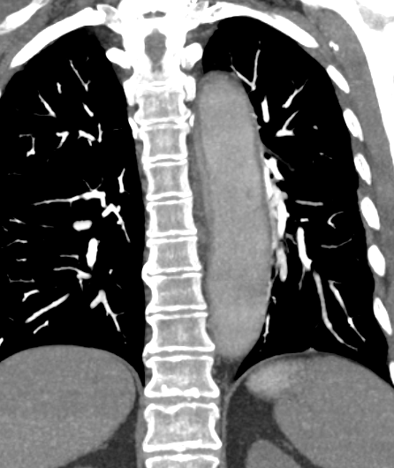
Penetrating ulcer

Cresentic thickening c/w IMH

C

The report of the CTPA showed there was no PEs. However there was cresentic thickening of the descending aorta distal to the left subclavian consistent with a intramural aortic haematoma associated with a penetrating ulcer at the upper edge of the haematoma (just behind the left atrium). 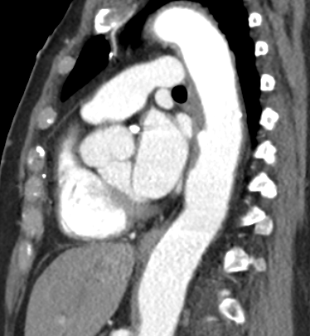
Looking back at the aortogram done 2 days earlier, the changes were there, with the intramural haematoma easier to visualise when the aorta
So what is an intramural haematoma and what do we do about this ?
Most of the information that we have about Intramural Hematoma (IMH) comes from the International Registry of Acute Aortic dissection (IRAD) which is a retrospective registry of dissection cases presenting to 30 centres in 10 countries. Through analysing these cases seen over a 15 year period they try to shed some light on a uncommon variant of this uncommon yet catastrophic disease.

Aortic IMH is considered a precursor of dissection, originating from ruptured vasa vasorum in medial wall layers and resulting in an aortic wall infarct that may provoke a secondary tear, causing a classic aortic dissection.

How often? Of the 2830 dissection variants, 178 were IMHs (ie 6%)
- 42% Type A
- 58% Type B
- (note that when all dissections are considered (mostly “classic”), type A 62% (asc aorta) is more common than type B 38% (desc aorta distal to left subclavian)

The pictures don’t look as bad as “classic” aortic dissection yet there are several facets of the clinical presentation as well as the hospital and 1 year outcomes that do not differ statistically from classic aortic dissections.

Presenting Symptoms / Signs
- In summary, the patients are often older (mean 70 c/w 61yo) but present with nearly indistinguishable clinical, demographic and historical variables and symptoms c/w classical AD. Couple of minor differences:
- Patients with IMH are less likely to develop aortic regurgitation, pulse deficits and coronary involvement (as reflected in ECG changes) (note still seen in 35%, 15% and 53% of IMH pts)
- Patients with IMH are more likely to develop periaortic haematomas., pericardial effusions and are more likely to rupture considering the proximity of the IMH to the adventitia.

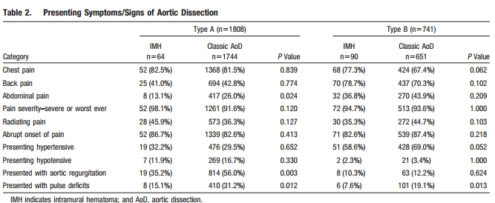

Treatment
- Similar treatment trends are seen with IMH when c/w classic AD - type A more likely to be treated surgically and type B treated medically

Mortality- similar

- In-hospital Type A Type B
IMH 26.6% Classic AD 26.5% IMH 4.4% Classic AD 11.1%

1 year follow-up mortality
IMH 5.3% Classic AD 8.7% IMH 10.3% Classic AD 8.2%
Refs – Harris KM et al, Acute Aortic Intramural Hematoma: An Analysis From the International Registry of Acute Aortic Dissection Circulation 2012; 126: S91-96 http://circ.ahajournals.org/content/126/11_suppl_1/S91.long

JOKE / QUOTE OF THE WEEK
Heard this week “ You have cellulitis – it refers to inflammation of your cells”



Please forward any funny and litigious quotes you may hear on the floor (happy to publish names if you want)

THE WEEK AHEAD
Tuesdays - 0830 – Medical grand Rounds
Wednesday 1300 – Surgical Meeting
Thursday noon – Mgt of Drug Overdoses = Dr Angela Chiew. .

