EMERGENCY MEDICINE Sutherland Hospital
The Weekly Probe
22nd July 2016 Volume 13 Issue 23
Siesta STUDY- A reminder from Gina that we are participating in a multi-centre observational SIESTA study to look at the adverse effects of parenteral sedation for agitation in adults. The study does not change management in any way.
- Inclusion criteria - Adults aged 18 years and over requiring parenteral sedation for acute agitation.
- Consent not required
- The study folder with all the information and study forms is located in the resus room drug cupboard, with an envelope for the completed forms at the back of the folder.
- Place the completed forms in the envelope at the back of the green study folder, and replace the folder in the resus room drug cupboard. The forms will be collected periodically.
- Any queries please speak to Gina

THIS WEEK
Alcohol Withdrawal
Spiked Helmet sign
Next week’s case
Joke / Quote of the Week
The Week Ahead

ALCOHOL WITHDRAWAL
35yo man with a hx of alcohol abuse with consumption of 60-80gm/day of alcohol (admitted to) presented with agitation after stopping drinking 24 hours earlier. He was admitted with alcohol withdrawal, requiring over 300mg diazepam over the following 24 hours for ongoing agitation before being intubated and sent to ICU. What options do we have for such patients and what is the most up to date management ?

Adding onto the info from our last review in 2010 based on the NSW Withdrawal guidelines and a Commonwealth document referenced below, the SSWAHS have produced a new guideline on the Assessment and Management of Alcohol Withdrawal .

As always recommended, if you are not sure then speak to someone if you want management advice- in this case the D&A consultant. However for a summary..

Signs & Symptoms
Onset timing
Usually 6-24 hrs post drink yet in some severely dependent drinkers, withdrawal can occur when the levels decrease even in the context of the patient still being intoxicated ie don’t rely on levels.
Duration- in most patients it is short & inconsequential yet in some it increases in severity through the first 48-72 hrs. Note also that substance abuse, medical and psych conditions can affect the onset, duration and severity of AW.
Most cases are mild and / or do not require medical intervention.

Symptoms and Signs – S+S of alcohol withdrawal are not specific. Consider other substance withdrawal, medical, surgical and psychiatric conditions including:
  - Delirium due to other causes eg sepsis
  - Seizure due to other causes eg head injury, ICH
  - Other cause of tremor eg thyrotoxicosis
  - Substance intoxication eg amphetamines
  - Withdrawal esp benzos
  - Acute psychiatric or other medical states

Severe AW symptoms
Seizures- usually generalised- recurrent in 13-24% of untreated pts
Delirium – AW delirium or delirium tremens or DTs are disturbances of consciousness or changes in cognition or perceptual disturbances with confusion, disorientation, agitation , hyperactivity and tremor. DTs usually commences 2-3 days after ceasing drinking & usually lasts for a further 2-3 days yet it can persist for weeks. Note early studies reported mortality as high as 15% yet with advances this is down to < 1%.
Hallucinations – at any stage of withdrawal- may be visual, tactile or auditory, and may be accompanied by paranoid ideation or delusions & abnormal affect (agitation, dysphoria, anxiety)
AW scores– widely used yet not validated- AWS < 5 = mild , 5-7 mod, 8-14 severe, > 14 “very” severe - - suggested 4 hrly if mild – q2hrly if severe
If AWS > 5 then 2nd hourly AWS- see diazepam regimen below

Note that as other conditions may produce symptoms or signs similar to AW (eg psych , medical (eg sepsis, hepatic encephalopathy), drug withdrawal), the AWS should not be used as a diagnostic tool for other conditions. Also note there is variability with scoring, so review the patient prior to changing management.

Supportive Care
Patient education
Environment – preferably quiet, non-stimulating and non-threatening
Diet/ Rehydration - assess for dehydration- may be dry secondary to sweating, GIT losses or decreased intake

Thiamine- all patients with suspected or confirmed alcohol dependence should receive thiamine prophylaxis for Wernicke’s. The dose, route and duration depend on nutritional status. “eg healthy pts with good intake .

- Patients with risk factors for thiamine deficiency, but low risk of developing Wernicke’s Encephalopathy (WE)
• Chronic alcohol misuse without evidence of malnutrition / Other risk factors for Thiamine deficiency:/ Chronic renal failure / Hyperalimentation, AIDS, drug misuse
- Thiamine 300mg IV, or 200mg IM (not if coagulopathic) then 100mg bd p.o for duration of admission.

- Patients with intermediate risk of developing WE
• Chronic alcohol misuse and evidence of malnutrition / Patients requiring alcohol withdrawal management / Significant protein–calorie malnutrition from malabsorption, or self-imposed inadequate diet / Protracted vomiting e.g., hyperemesis of pregnancy, bulimia nervosa
AND no features listed below
  - Thiamine 300mg IV (over 30 minutes) daily, or 200mg IM daily or twice daily for 3 days - 100mg tds p.o. for duration of admission

- Patients with features of WE or high risk of developing WE
  - Chronic alcohol misuse, AND Acute confusion, decreased conscious level, ataxia, opthalmoplegia / nystagmus, memory disturbance and / or unexplained hypotension or hypothermia
  - Thiamine 300 mg IV (over 30 minutes) tds for at least 3-5 days. If clinically responding, continue for 5 days, or until improvement ceases. -100mg tds p.o.

Other vitamin deficiencies are also common (B, C) + Magnesium - give multivitamin +/- Mg replacement.

Medications
Benzodiazepines- Diazepam is benzo of choice due to its rapid onset and prolonged duration. However in certain circumstances prolonged sedation may be problematic and benzos with shorter duration of effect may be more desirable.
The use of diazepam is contraindicated in the following instances:
• Severe liver impairment (as evidenced by raised bilirubin, low albumin, high INR or clinically jaundice, ankle edema and ascites)
• Respiratory failure: Avoid benzodiazepines unless severe/failure to control e.g. seizures. Seek Respiratory Physician and Addiction Medicine specialist advice re: monitoring, best setting for care.
• Recent head injury/cerebrovascular event / Decreased consciousness
Cautions for the use of Diazepam include:
• Moderate to severe chronic airways diseases
• Severe obesity

For patients where there is a contraindication or caution to Diazepam:
• Oxazepam may be used in modest doses as follows:
• Initial regime: Oxazepam 15-30 mg q 2-4 hourly if AWS > 5, until AWS < 3. Maximum 90-120 mg /24 hours
• Titrate increase in dose cautiously if required

Symptom-Triggered Therapy
Uses AWS to guide treatment eg AWS < 4 = nil / AWS 4-7 = 5-10mg diazepam/ AWS > 7 = 20mg diazepam yet note 1) it should not be used in patients with a history of withdrawal seizures , as these may occur before the onset of withdrawal features 2) should not be used in patients with heavy use of drugs or other significant concomitant medical or psych conditions that may invalidate use of withdrawal scales 3) they require regular patient monitoring and staff trained in the use of scales.

Loading Dose Therapy
Quick administration of high doses of benzos in the early stages of AW especially in those with a history of severe withdrawal complications or in those presenting with severe AW or with complications. One regimen is diazepam 20mg q2hr until 60-80mg given or the patient is sedated. This may be enough to prevent severe AW from occurring; further doses may be required over the next 2-3 days (eg 10mg qid).

Fixed-schedule therapy
Needs regular review re efficacy – reducing doses over 3-6 day period eg if mild withdrawal predicted start at 10mg qid – mod to severe withdrawal predicted start at 20mg qid.

The SWSLHD approach is:

MILD withdrawals or risk of MILD withdrawals:
Less than 6 standard drinks per day; short period of daily drinking; past mild withdrawals only (if any)
AND AWS < 5.
Tx - Thiamine – see above
- If inpatient monitor AWS every 4 hours daily for 48 hours
- No regular regime, unless AWS increases to 5 or more
- Symptomatic care only

MODERATE withdrawals or risk of MODERATE withdrawals:
6 or more standard drinks per day; enduring pattern of drinking
+/- AWS 5 or more at assessment
Tx- Thiamine – see regime above
- Vital signs and AWS every 2 hours
- Diazepam 10mg q 2 hourly p.o. if AWS score is 4-5
- Diazepam 20mg q 2 hourly p.o if AWS > 5 , until AWS < 3, to a maximum of 80mg/24 hours
- Must have medical review at 80mg (severity may be “severe”, or other cause present)
- Once withdrawal controlled, some patients may need no further Diazepam (e.g. AWS 0 -1 and vital signs normal)
- If persistent signs of withdrawal, calculate daily dose needed on day 1; repeat this dose on the following day if persistent signs of withdrawal
- Otherwise, reduce dose by 20% if well-controlled, and taper dose by approximately 20-25% per day on subsequent days

SEVERE withdrawals or risk of SEVERE withdrawals:
15 or more standard drinks per day; enduring pattern of drinking; past severe withdrawals with/without seizures or delirium AND AWS 5 or more at assessment
Tx- - Thiamine – see regime above
- Vital signs and AWS every hour
- Loading dose Diazepam 20mg
- Diazepam 10 – 20mg q 1 – 2 hourly until 80mg reached, or mild
sedation / withdrawal controlled
- Must have medical review at 80mg - other cause present?
- Taper dose by approximately 20 – 25% per day on subsequent days
- Drug Health consultation including medical officer review

Alternative meds – may be considered in alternative settings such as ambulatory withdrawal regimens, or when benzos cause paradoxical reactions (eg violence or agitation) or severe alterations in mental status.
- Anticonvulsants – carbamazepine minimises AW symptoms and prevents withdrawal seizures but does not prevent recurrent withdrawal seizures. No advantage of adding to benzos to prevent seizures. No role of valproate or phenytoin in preventing seizures.
- Anti-psychotics – when used alone may increase seizure risk and do not prevent onset of delirium – thus they should be used in conjunction with benzos when the hallucination or agitation associated with delirium does not respond to adequate doses of benzos. Consider haloperidol 2.5-10mg or olanzepine 5-10mg PO or buccal or resperidone 1-1.5mg PO or IMI bd
- Blood pressure control – benzos first priority – Beta-blockers if persists
- Symptomatic meds – panadol for pain / anti-emetics / loperamide for diarrhoea

AW seizures- remember that heavy alcohol use can also contribute to seizure through other conditions including other metabolic, infectious, traumatic, neoplastic or cerebrovascular conditions / other drugs (esp benzos)- often safest to look for other causes first and “work backwards” with –ve CT, bloods etc. Be suspicious esp if clinical suspicion of signs of these causes, no prior seizures, 2 or more seizures in succession, partial (focal ) seizures, seizures > 48 hrs after last drink , no heavy alcohol use or other features of AW.
- prevention – if no prior Hx and not in severe withdrawal then consider symptom triggered or fixed schedule / if prior Hx or severe then front load
- Tx – benzos
WERNICKE-KORSAKOFF’S SYNDROME

Not a withdrawal complication – can coexist though with alcohol withdrawal, hepatic encephalopathy and other causes of confusion. Initially reversible yet if untreated can laed to korsakoff’s syn with severe STM loss and impaired ability to acquire new info – no Tx for this. For Wernicke’s - ¼ get better , ¼ improve partially, ¼ improve significantly and ¼ need institutional care.
Triad of:
- confusion or mental impairment (80%)
- ataxia (~ 20-25%)
- eye signs such as nystagmus or opthalmoplegia (~ 30%)
yet note only ~10% have all 3 signs thus often undiagnosed.
Prevention – thiamine 300mg /d in healthy pts with good intake – 300mg IMI or IVI if not – thiamine before carbohydrates
Treatment- thiamine 500mg per day (IMI or IVI over 30 min) for 3-5 days then 300mg per day for 1-2 weeks
Refs: www.health.gov.au/internet/main/publishing.nsf/Content/0FD6C7C289CD31C9CA257BF0001F96BD/$File/AustAlctreatguidelines%202009.pdf

SPIKED HELMET SIGN
ECG was taken on a 30yo man who presented 3 weeks post gastric sleeve after experiencing upper abdominal pain followed by presyncopal episode.
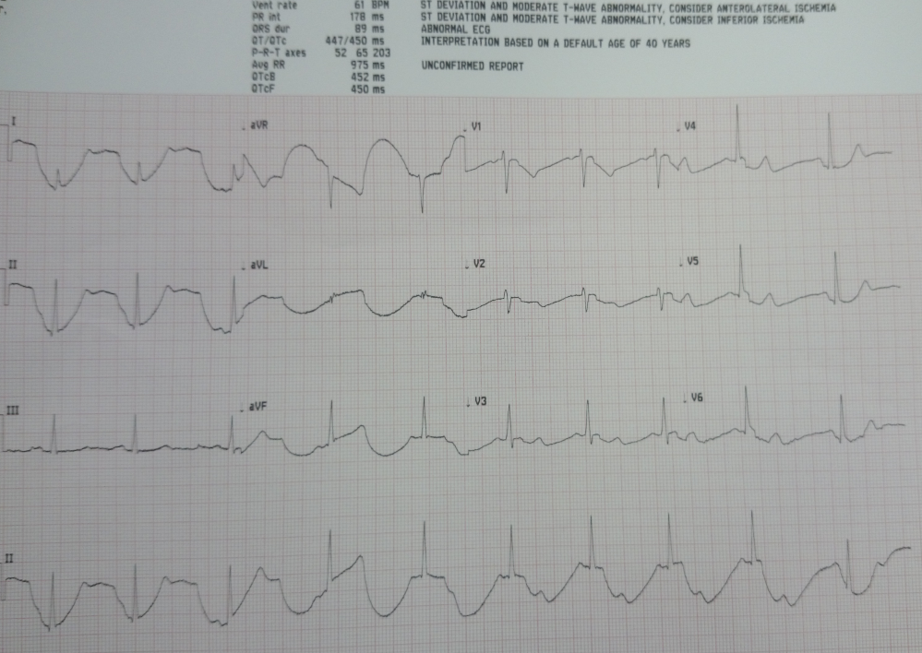
These changes are known as the “spiked helmet sign”, an uncommon ECG finding, the cause of which is unknown.
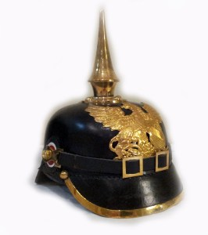
The diaphragm has a central role in the ECG changes Several mechanisms have been proposed including:
- An acute increase in the intra-abdominal or intra-thoracic pressure
- direct stimulation of inferior wall of left ventricle by the diaphragm,
- stimulation of the diaphragm by the left phrenic nerve,
- synchronized contraction of diaphragm along with the cardiac cycle in the setting of alkalosis with latent tetany,
- diaphragmatic breathing that alters ECG patterns
- artefact
As in this case the ECG changes are seen inferiorly (2,3, aVF)
Some studies which report thee changes in the context of a critically ill patient have found it to be a marker of signicant risk of mortality (one study found a mortality of 75% (6/8 pts)
Note that it is a marker of non-cardiac disease- be suspicious of an intraabdominal (or intrathoracic) pathology.
Patient progress: Trops normal – Ct abdo and chest NAD- discharged home well. In this case it was not a potent of disaster!

Refs: - Littmann L The “Spiked Helmet” Sign: A New Electrocardiographic Marker of Critical Illness and High Risk of Death Mayo Clin Proc. 2011 Dec ; 86(12): 1245–1246.

Agarwal A Spiked helmet sign: An under-recognized electrocardiogram finding in critically ill patients Indian J Crit Care Med. 2014 Apr; 18(4): 238–240.

NEXT WEEK’S CASE
70yo lady presents with RUQ pain . Afebrile. Tender RUQ. Bloods then CTs as shown below
What could be going on? Lactate 2.3 bicarb 21 – other bloods normal
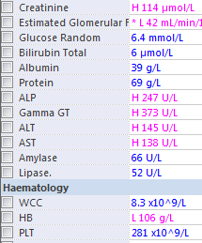
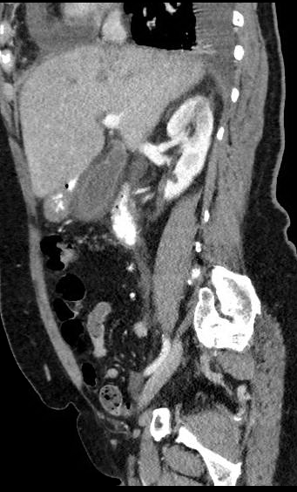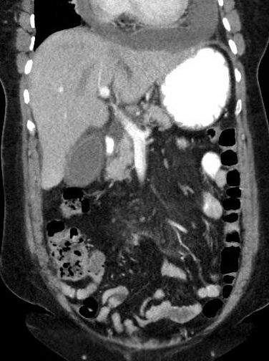

JOKE / QUOTE OF THE WEEK

Please forward any funny and litigious quotes you may hear on the floor (happy to publish names if you want)

THE WEEK AHEAD
Tuesdays - 0830 – Medical Grand Rounds
Wednesday 1300 Surgical Grand Rounds
Thursday 1200 – Cannulation for JMOS
Friday 1300 – Respiratory/Lung Lunch

