EMERGENCY MEDICINE Sutherland Hospital
The Weekly Probe
5th August 2016 Volume 13 Issue 25
Gastro Presentations- there has been an unusually high number of gastro presentations in the last months- viral, salmonella and shigella etc. To identify the source and subsequent attempt to control the spread, the Health Protection NSW strongly encourages the collection of stool samples with a specific request to test for viruses (norovirus, rotavirus and adenovirus) on the laboratory request form in addition to the standard bacterial tests. Shigella should be considered especially in the context of a recent outbreak in gay men presenting with a bacterial gastro syndrome – test and consider treatment with cipro or norfloxacin.

Respiratory Virus testing – a message from micro re respiratory virus testing – Most importantly do a test if it will change the management or disposition – ie not everyone needs it

Virus Panel | When to Order Each Panel  NB: One or More Panels Can be Ordered On Each Specimen
Influenza A/B, RSV | All acute respiratory illnesses where diagnosis will change treatment or infection control decisions (immunocompetent and immunocompromised patients).
Adenovirus, Enterovirus, Parainfluenzae 1-4,  Human Metapneumovirus | Adults: Immunocompromised patients with acute respiratory illness, e.g. Haematology patients, solid organ transplants, Immunology patients  Paediatrics: Immunocompromised patients (as above); suspected enterovirus infections; moderate-severe viral exacerbations of chronic airways disease (e.g. asthma, CF)
Rhinovirus, Coronaviruses, Bocavirus | Adults: Immunocompromised patients with acute respiratory illness, e.g. Haematology patients, solid organ transplants, Immunology patients  Paediatrics: Immunocompromised patients (as above); moderate-severe viral exacerbations of chronic airways disease (e.g. asthma, CF)
Praxbind (idarucizumab). Reminder that the new antidote to dabigatran is now available. Pradaxa / dabigatran is a commonly used oral anticoagulant for patients with thromboemboli or AF. The manufacturer has developed a market for its drug, and like all anticoagulants it causes bleeding which cannot be reversed with vit K, FFP etc. So in consideration of their consumers, they have developed a reversal agent for their drug – Praxbind® (idarucizumab) – ker..ching!!! Couple of pointers:
- It is a specific antibody to dabigatran only- thus it will not reverse the effects of other anticoagulants
- IV administration with short half-life (initial half-life 47 min) – binds to free and bound dabigatran 350 X more avidly than thrombin – renal elimination of idarucizumab-dabigatran complex (apparently renal failure did not impact on reversal effects in trials)
- Well tolerated – no contraindication (just need the indications below)
- It costs $ 3000 per treatment so should only be used in patients treated with dabigatran when rapid reversal of the anticoagulant effects of Pradaxa® (dabigatran) is required ie
- For emergency surgery/urgent procedures; or
- In life threatening or uncontrolled bleeding.
- Send coags and dabigatran level – a normal TT (need to specifically request) excludes dabigatran while a normal APTT does not exclude dabigatran
Remember to use other modalities to control bleeding including:
• Local measures- Mechanical compression +/- surgical intervention or wound packing
• Fluid replacement- Maintain good urine output as dabigatran excreted renally
• Blood product transfusion- - Consider platelets if levels <70-80 X 109 /L or patient on anti-platelet agent
• Administration of anti-fibrinolytic agent - Tranexamic acid
• Oral charcoal – if no C/I and ingested < 2 hrs earlier

Due to the cost, you need to d/w the haematologist on – call for advice before using this drug
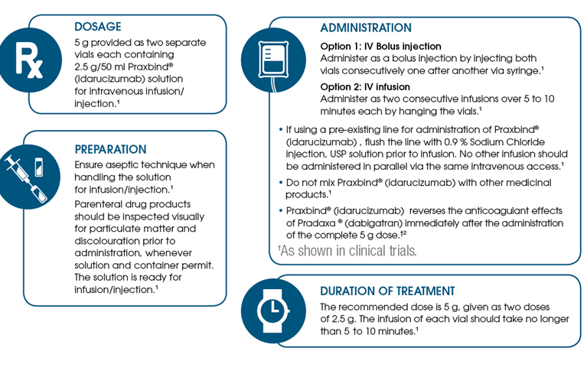THIS WEEK
Last Week’s Case – Meningococcal Disease
Next week’s case
Joke / Quote of the Week
The Week Ahead

LAST WEEK’S CASE – Meningococcal disease:
A 4yo fully vaccinated previously well girl presents with a non-pruritic rash on the legs. She is well looking with a temp of 37.4C –non-blanching petechial rash as shown below- no other signs
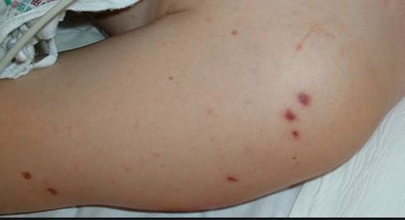
What is going on ? DDs ? Plan?
Despite the well appearance the child had a lactate of 9 which improved with IV fluid boluses. After being given pen and ceftriaxone the child was later transferred to WCH with meningococcal sepsis.

With this recent case and moving into our peak season, it’s worth looking at meningococcal again.

Incidence: ~ 150-200 people in NSW each year, - the peak occurring in winter and spring. Higher rates of infection are seen in young adults and children but infection can occur at any age. About 10% of the population carry it in their nasopharynx.
Subtypes – vaccines- There are at least 13 different subtypes (serogroups). Five of these serogroups, A, B, C, Y, and W, cause almost all invasive disease. The relative importance of these five serogroups depends on geographic location and other factors.
According to the AUSTRALIAN MENINGOCOCCAL SURVEILLANCE PROGRAMME in 2011 when subtypes were identified:
- Serogroup B - 83.6%
- Serogroup C – 4.2%
- Serogroup W135 – 5.2%
- Serogroup Y – 7%

What about the vaccines to protect against this rare yet nasty Dx?
- Meningococcal C conjugate vaccine protects against meningococcal group C disease. It is recommended for all children at the age of 12 months (as part of the free National Immunisation Program with HIB vaccine as Menitorix). It is also suitable for teenagers and adults. Note that there has been a decline in mening C cases over the last 15 years with only 9 cases seen in Australia in 2011!
- Meningococcal B vaccine Bexsero launched in Australia March 2014 - available by private script yet not subsidised by the Government. For infants, the vaccine is given in four doses – at 2, 4, 6 and 12 months of age. For children over 12 months, teenagers and adults, the vaccine is given in two doses ~2 months apart. It is estimated that the vaccine induces protective antibodies against about 75% of mening B strains in Australia
- Meningococcal polysaccharide vaccine is a combination vaccine and protects against groups A, C, Y and W. Recommended for individuals with increased risk of disease due to complement disorders, asplenia and other immunocompromising conditions, or exposure due to occupation (eg micro lab workers) or travel to endemic regions (eg travellers to the Haj in Saudi Arabia). This vaccine is also not subsidised by the Government
- For more info go to the National Centre for Immunisation fact sheet

Presentations
Meningococcus has two significant clinical presentations: septicaemia and meningitis (which may also occur together). The age groups 0-4 and 15-25 have the highest incidence. Overall mortality in Australia in 1999 was 9.1%, but was higher in the C serogroup (yet falling incidence as noted above).

Meningitis is the most common clinical syndrome (80-85% of cases). The diagnosis is relatively straightforward when the patient presents with the typical clinical picture (fever, headache, vomiting and change in conscious state), and treatment is not likely to be delayed. In most cases of meningococcal meningitis (as well as other bacterial meningitis), there is a non specific illness 1-3 days before signs of meningitis appear. Rarely, the clinical picture is dominated by coma, which is both sudden and deep; this syndrome is sometimes referred to as fulminant meningococcal meningoencephalitis. Mortality of patients presenting with meningococcal meningitis is low (1-5%), considerably lower than that of patients with invasive meningococcal disease without meningitis (up to 40%). Furthermore, prognosis of patients with bacterial meningitis (from all causes) was no worse in those whose disease was not recognised for as long as 2-4 days before admission than in those admitted when first seen.
A few patients have less common syndromes, such as pneumonia, septic arthritis and pericarditis. Localising symptoms and signs ensure that diagnosis and treatment are unlikely to be delayed.

Meningococcaemia is another matter: between 15% and 20% of patients present with septicaemia unaccompanied by meningitis or other focal features. Three points to mention- it is rare, it is difficult to pick initially and it progresses rapidly. Trying not to be flippant, it is the “suicide bomber” of the ED world – unsuspected until too late. The illness in patients with pure septicaemia is generally more severe, and has a high case fatality rate. Unfortunately, there is often confusion in the minds of the public, the media and even health professionals between meningitis and meningococcaemia; this may occasionally be a factor in delayed diagnosis.

In most patients, the beginning of meningococcal septicaemia is marked by acute onset of fever, chills and generalised muscle aches or pains in the back or thighs ie a flu like illness. There may be a transient clinical improvement after 4-6 hours; this is often the stage when patients are sent home from EDs. 6-12 hours after onset, a rash typically appears, which may initially resemble a viral rash. The characteristic haemorrhagic rash appears soon after.
How many patients suffer from meningococcal septicaemia without meningitis or a rash in unknown, as the diagnosis may well be missed in these cases, many treated in the community with antibiotics for their “viral illness” or their “no-titis”.

Management on arrival at hospital: All patients who present to ED with features suggestive of meningococcal disease should be assessed urgently. IV penicillin should be given as soon as possible after arrival if not already given (preferably after a blood culture and blood for PCR has been taken).

Triage: The presentation can be more subtle in some, where the patient presents with fever, no evidence of toxicity and other non specific symptoms such as cough, rhinorrhea, vomiting, headache which might resemble an URTI or other viral illness.
About half the patients who die from meningococcal disease do so within the first 24 hours of the first symptoms, thus to significantly reduce the risk of death, we need to suspect the diagnosis in the first 12 hours of the illness.

A petechial rash in association with fever, vomiting and drowsiness is highly suggestive of meningococcal meningitis, but meningococcaemia can present with fewer features, and so any patient with a fever and petechial rash should be evaluated for other signs of shock.

Common signs and symptoms of meningococcal disease:
In children and adults:
- Fever, pallor, rigors and sweats
- Headache, neck stiffness, photophobia, backache or cranial nerve palsy
- Vomiting (34-76%) or nausea, or sometimes diarrhoea
- Lethargy, drowsiness, irritability, confusion, agitation, seizures or altered LOC
- Moaning, unintelligible speech
- Painful or swollen joints, myalgia, difficulty in walking
- While the absence of a rash does not exclude meningococcal disease, any haemorrhagic rash should be particularly noted

In infants & young children the following may also occur:
- Irritability; dislike of being handled
- Unwillingness to interact or make eye contact
- Loss of interest in the surroundings
- Tiredness, floppiness, drowsiness, altered mental state
- Twitching or convulsions
- Grunting or moaning
- Turning from light
- Pallor despite a high temperature
  - Respiratory symptoms are not uncommonly seen with catarrh, cough (27%) and resp distress + otitis

Note in particular:
- Rapid deterioration
- Repeat presentation to GP or ED

Haemorrhagic rash: in Australia, the acutely ill patient with fever and haemorrhagic rash (petechial or coalesce to form purpura) should be assumed to have bacteraemia, and the most common cause is meningococcaemia. Typically, the rash begins within 24 hours of onset of illness – a useful clinical pointer. In the early stages, sparse petechiae can be easily missed unless specifically sought in body folds, groin and axillae, along flexor surfaces, on the ankles, or on the conjunctiva, sclera or oral mucosa. The rash evolves over time, and may become apparent on repeat examination. However note that only 40% of patients with invasive meningococcal disease present with a haemorrhagic rash and this may not appear until 6-12 hours after symptom onset. On the other hand of those presenting with fever and petechiae, one study found 7% to have meningococcal disease.

Blanching macular or maculopapular rash: - In the early stages of meningococcal septicaemia a maculopapular rash can be present. It mimics a non specific viral rash and may disappear completely or dramatically evolve into the typical petechiae. The rash may consist of discrete pink macules or papules that blanch under pressure.

Antibiotic Therapy: The antibiotic of choice in treating all forms of meningococcal disease is benzyl penicillin. If bacterial meningitis is suspected but there are no features of meningococcal disease then empirical treatment should be given in the form of a cephalosporin. Due to penicillin resistance in strep pneumoniae some hospitals advocate further treatment with vancomycin if the clinical examination & investigations are suggestive of pneumococcal meningitis. A history of skin rash following penicillin should not be a contraindication to administration of a cephalosporin. If there is a history of anaphylactic reaction to penicillin the microbiologist on-call should be consulted.

Benzylpenicillin Child 60mg/kg (up to 1.8g) iv 4hrly
Adult 1.8g iv 4hrly
Plus
Cefotaxime Child 50mg/kg (upto 2g) iv 6hrly
Adult 2g iv 6hrly
Or
Ceftriaxone Child 100mg/kg (upto 4g) iv in one or two divided doses
Adult 4g iv daily in one or 2 divided doses

After infection with N. meningitides has been confirmed, monotherapy with benzylpenicillin is suggested and should continue for 5 days after the resolution of the fever. There have been no reports of meningococcus resistant to penicillin or third generation cephalosporins.

Supportive therapy: Intensive care should be consulted early to assist in management. Particular attention should be directed to tissue perfusion and fluid administration, with close monitoring for signs of cerebral oedema and coagulopathy.

Diagnostic studies:

Test | Specimen | Utility
Gram Stain | CSF, skin lesion, joint fluid | Rapidly available
 | Other normally sterile site | Confirms diagnosis if +ve  from sterile site with clinical features
Culture | as for Gram stain plus blood | 24-48hrs  Sensitivity on CSF 95%, Blood 50% (if no prior ABs )
PCR | blood, CSF | Sensitivity CSF 89%  Can determine serotype
Serology | blood | Sensitivity 97%  IgM titre rises in 3-5 days
Antigen test | CSF | Can corroborate diagnosis but unreliable in isolation.

A couple of points:
- NICE does not recommend the use of skin scrapings, skin biopsies, petechial or purpuric lesion aspirates skin scrapings, when investigating for possible meningococcal disease: (obtained with a needle and syringe).
- NO TEST IS PERFECT - negative blood PCR test or cultures for N meningitidis does not rule out meningococcal disease.
- CSF samples can determine meningeal involvement yet remember that meningococcal sepsis can occur without meningitis

What about the WCC or CRP? History, exam, investigations and cautious gestalt – do not get caught up with the “It’s not X because the CRP is only Y”
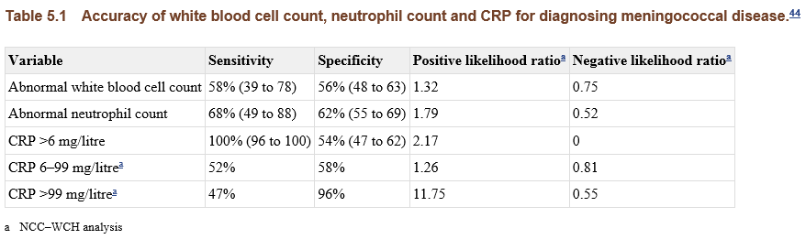
(from Wells article referenced below)

Therapy should not be delayed by diagnostic tests, such as LP or CT. All patients should have a blood culture and throat / nasopharyngeal swabs taken. Further workup should include an VBG, coagulation studies, serology, and blood PCR (purple top).
Meningitis can be associated with raised intracranial pressure. In the presence of a depressed level of consciousness, focal neurological signs or persistent vomiting, an LP should be deferred. Coagulation defects should also be considered. CSF analysis classically shows a high neutrophil count, low glucose and raised protein, microscopy may reveal diplococci. Initial CSF can be normal in around 5% of cases, possibly more after administration of antibiotics. It is also important to remember that meningococcal sepsis can be present without meningitis and therefore a normal CSF will be obtained.

Chemoprophylaxis: The rationale for prophylaxis is to eliminate meningococci from any carrier within the network around the index case. It is not therefore to protect individuals from the index case, but rather from another person in the group who may have been the source. There are no studies proving the efficacy of prophylaxis in preventing further cases. There is evidence from cohort studies showing that carriage rates can be reduced with antibiotics. A two day course of rifampicin (adults 600mg bd, neonates 5mg/kg, > 1 month 10mg/kg) eradicates carriage in 75-95%. It is recommended for those in close contact for the week before, and very close contact since the onset of symptoms. Ciproxin or IMI ceftriaxone are other options (as directed by public health).
Vaccines have limited coverage (see comment above) but takes 10-14 days to become effective and it does not induce long term immunity (~ 3 years of immunity).

Although early recognition and treatment of meningococcal disease decreases complications, neither the history, examination nor blood tests can differentiate those with meningococcus from other viral illnesses.

Staff should report all cases of suspected meningococcal disease by telephoning the public health unit via switch. They will then identify contacts and advise on prophylaxis of “household” or intimate contacts.

LEG PAIN (sea also probe 2005 no 1)
Inkelis et al from UCLA Depts of Pediatrics and Emergency reviewed the frequency of extremity symptoms in the presentation to see if this aided in the diagnosis. The notes of 274 cases of meningococcus in patients < 20 years and found 16% of children with invasive meningococcal disease had extremity symptoms and/ or signs at presentation. The majority of patients c/o either upper & lower extremity pain or just lower extremity pain. The temperature was lower in those with extremity symptoms. NICE reports leg pain in 31-63% of patients (excluding infants) with meningococcal disease.

Localised muscle pain, especially of calf muscles, and joint pains were frequent complaints in a series of 26 World War 2 troops with meningococcus. Case reports also mention severe anterior thigh pain / tenderness.
Of note myalgia is an uncommon symptom in those < 5 years with a viral illness, thus the presence of myalgia in this age group should alert to a specific exclusion of meningococcus.

The cause of the muscle pain is thought to be multifactorial: joint inflammation from bacterial seeding or immune complex deposition; inflammatory mediators causing muscle pain; and thrombosis from DIC causing bony infarcts all may play a role. Arthritis is a well recognised complication of meningococcaemia and occurs in about 5% of patients. The authors conclude that extremity pain and / or a refusal to walk in patients with a febrile illness should raise the possibility of meningococcus. If the patient is in a high risk group (known contact of a case of meningococcus; during outbreaks of meningococcus; presence of petechial rash; students living in college dormitories; adolescents or young adults who frequent bars or nightclubs) and during the history these risk factors should be specifically sought for.

Refs- eTG / NICE clinical guideline Feb 2015 / Inkelis et al. Extremity Pain & refusal to Walk in Children with Invasive Meningococcal Disease , Pediatrics, 2002 Jul; 110(1 Pt 1) / Annual Meningococcal Surveillance report 2011 / Wells LC, Smith JC, Weston VC, et al. The child with a non-blanching rash: How likely is meningococcal disease? Archives of Disease in Childhood. 2001;85(3):218–22

NEXT WEEK’S CASE
A 25yo man is brought in by his mates after being stabbed in the left lateral chest. He is moaning as he is carried in yet then arrests as he “hits the bed”. Someone yells out from the building group on onlookers – “Don’t do CPR” What should we (not) do?
A 58yo man presents with transient bilateral upper limb and lower weakness (more marked in his legs) with no sensory symptoms. Could this be a TIA?

JOKE / QUOTE OF THE WEEK
A man was walking along Cronulla beach and was in deep prayer to the Lord. He said, "Lord, you have promised to give me the desires of my heart. Please give a confirmation that you will grant my wish."
Suddenly the sky darkened and the Lord, in a booming voice said, "I have searched your heart and determined it to be pure. I think that I can trust that you will not disappoint me. Because you have been faithful to me, I will grant you one wish."
The man said, "I've always wanted to go to Fiji, but I'm deathly afraid of flying and I get very sea sick in boats. Could you build a bridge to Fiji, so I can drive there whenever I want?"
The Lord laughed and said, "That's impossible! Think of the logistics! How would the supports ever reach the bottom of the Pacific? Think of the concrete and steel! Your request is very materialistic and disappointing. I could do it but it's hard for me to justify. Take a little more time and make another wish, one you think would honor and glorify Me."
After much thought, the man said, "I've been married four times. My wives always said that I was insensitive to their needs. So I wish that I could understand women. I want to know how they feel and what they're thinking. I want to know why they cry and how to make them truly happy. That's my wish, Lord."
Then, after a few minutes, God said, "You want two lanes or four on that bridge?"

Please forward any funny and litigious quotes you may hear on the floor (happy to publish names if you want)

THE WEEK AHEAD
Monday - 12:30 – 13:30 Surgical Meeting, Auditorium, Level 2
Tuesday – 08:15-09:30 Medical Grand Rounds, Auditorium, Level 2
Thursday – 12:00-13:30 JMO Education, Auditorium, Level 2 – Medico Legal, Dr Joe Lizzio

