EMERGENCY MEDICINE Liverpool Hospital
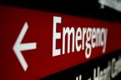The Weekly Probe
9th August 2016 Volume 19 Issue 26
Death documentation - To make it easier, in the 5 bottom slots of the centre column of the pigeon holes in resuscitation area, you will find the following forms
- Coronial check list
- Report of death of a patient to the coroner
- Medical Certificate of cause of death
- Attending Practitioners Cremation Certificate- this should be filled out if the patient is for cremation or if there is a possibility
- A pack put together by Clerical Staff containing all 4 of these forms
Please notify Clerical Staff if any forms are missing, or when you use the last of the packs containing all 4 forms.

THIS WEEK
Last Week’s Case – Traumatic Cardiac Arrest
Next week’s case
Joke / Quote of the Week
The Week Ahead

LAST WEEK’S CASE – Traumatic Cardiac Arrest / ED thoracotomy
A 25yo man is brought in by his mates after being stabbed in the left lateral chest. He is moaning as he is carried in yet then arrests as he “hits the bed”. Someone yells out from the building group of onlookers – “Don’t do CPR” What should we (not) do?
Although this is more of an issue for the trauma centres occasionally we do have patients being brought in by friends / family, so the issues are worth considering.
Looking at algorithm suggested for experienced pre-hospital providers suggested by Sherrin (see refs below) when there is a cardiac arrest in the context of penetrating chest or epigastric trauma, no chest compressions should be provided.
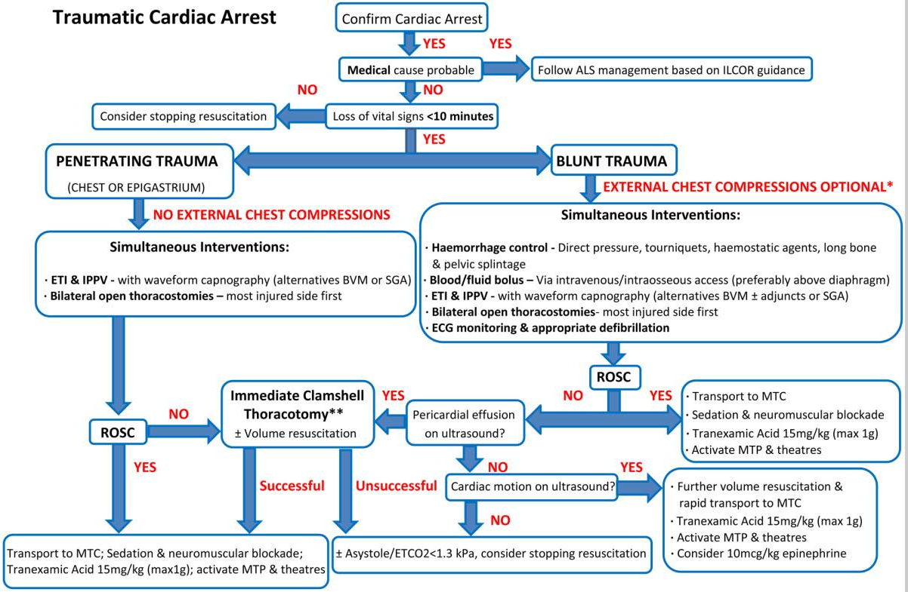
However there are number of issues to be discussed when looking at such approaches
- Survival from out of hospital cardiac arrests (largely cardiogenic aetiology) in Australia is ~ 9%.
- With traumatic cardiac arrest (TCA) the rates of survival are poor with even worse rates of neurologically intact survivors (~ 6%).
- Below is a table from an evidence based review of emergency thoracotomies for trauma looking at the survival rates (see Seamon article referenced/ linked below).
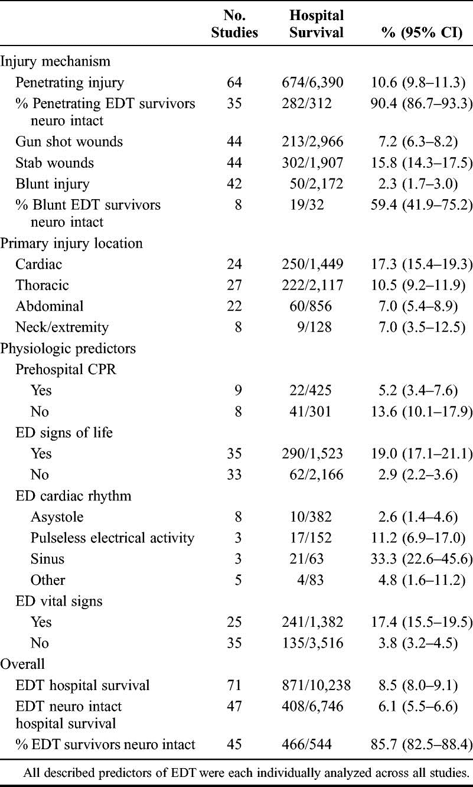

- In Australia we see a predominantly blunt trauma with survival rates- 2.3% (60% of these neurologically intact ie poor).
- For the penetrating trauma, as injuries are more limited to smaller anatomical region, survival is better post arrest when c/w blunt mechanisms- survival post stabbing is better than gunshot.
- Also remember that most studies of EDT are conducted in centres with reasonable patient volumes and subsequent clinical experience, so these number may not be applicable to a Australia ED environment

Treatment
Resuscitation post cardiac arrest is centred on optimising perfusion of cardiac and cerebral tissues whilst simultaneously correcting the precipitating (and complicating) factors such as coronary occlusion or arrhythmias.
Similar to the approach to other cardiac arrests, our approach in TCA is to resuscitate while correcting the main “HOT” factors – Hypovolaemia, Oxygenation and Tamponade / Tension. As the first algorithm suggests this involves haemorrhage control and volume expansion, airway and ventilation Mn, thoracostomies and consideration of thoracotomy particular in the case of penetrating truncal injuries.
While this is occurring there is ongoing ALS / BLS – airway control, optimization of ventilation / oxygenation and potentially chest compressions.
It is frequently quoted that the cardiac output during CPR in euvolaemic subjects is ~ 25-30% of normal values, much of the info based on research involving “minipigs”. In the context of severe hypovolaemia chest compressions are likely to be less effective due to poor cardiac filling and external compressions of an empty heart. Subsequently chest compressions in trauma have less importance yet there is a lack of data to prove definitively of the risks or benefits of chest compressions. Thus depending on the resources available at the time we need to prioritize between correcting the HOT issues and BLS / ALS including CPR. This is particularly relevant in the pre-hospital or single provider environment where it is difficult to perform multiple simultaneous procedural tasks.
However in an in-hospital environment when a team of clinicians is available, there is no impediment to the performance of procedures to simultaneously correct HOT issues and continue BLS / ALS. To quote the European Resuscitation Council guidelines “Chest compressions are still the standard of care in patients with cardiac arrest, irrespective of aetiology”.
The only real exception to this is when there is a need to prioritise the thoracotomy over chest compressions with penetrating truncal trauma, when they impair the ultrasound assessment of cardiac activity and tamponade or when it is time to terminate the resuscitation.
Note that both components need to be considered together, NOT in isolation. To quote Lockey “The patients with the greatest chance of survival are normovolaemic and cardiac compressions may at least be partially effective while reversible pathology is addressed simultaneously. Standard BLS / ALS without urgent attention to reversible pathology is unacceptable and unlikely to result in .. ROSC”
Considering these points, below are 2 algorithms- the first from the European Resuscitation Council (ERC) guidelines , the second from the UK resuscitation council
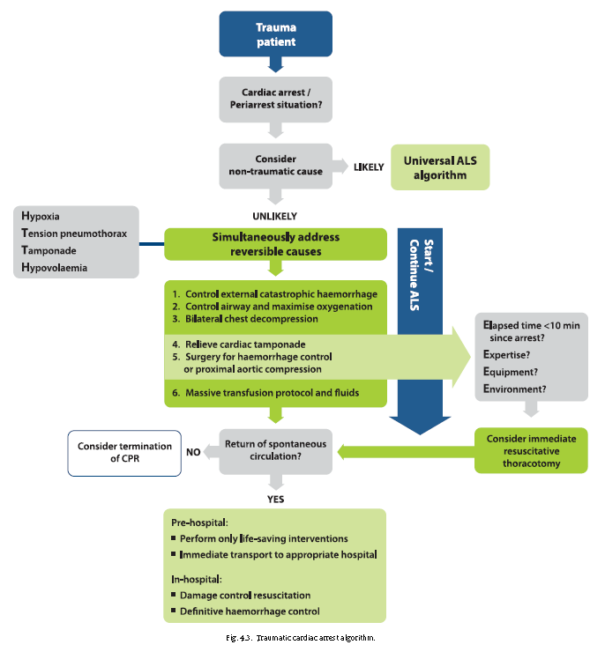
ED thoracotomy - Resuscitative thoracotomy may be indicated in selected patients. Our main aims are to identify and treat cardiac tamponade, close cardiac wounds, perform internal cardiac massage and the cross clamp / compress the descending aorta (+/- hilar twist/ clamping, intercostal vessel pressure). The question is which patients should undergo a resuscitative thoracotomy and when.
In terms of utility / futility a review of the literature from 1966 to 1999, carried out by the American College of Surgeons Committee on Trauma, in those having an emergency thoracotomy they found a survival rate of 7.8% (11.2% for penetrating injuries and 1.6% for blunt lesions) in trauma victims who would otherwise have 100% mortality.
On the other side of the coin there are significant potential risks in terms of needle stick risks and resource issues. So there needs to be a weighing up of the risks vrs benefits. However with the paucity of good quality data, there is no universally accepted criteria.
As shown in the ERC algorithm there are a number of “E” factors which need to be considered:
- Expertise – who is going to do the procedure and what are they going to do? The difficulty is comparing the results (and subsequent recommendations) from a busy unit such as Los Angeles County (see Inaba reference below) where they performed on average 5 per month within the ED (stab wound to “the box” were excluded as they went straight to OT) to Liverpool, a busy Australasian center which performs 2-5 per year.
- Environment / Equipment – ideally in OT – adequate lighting , retractions and ability to deal with injuries encountered
- Elapsed Time – To simplify the indications, there is consensus that thoracotomy should be performed in those with:
  - Penetrating thoracic trauma with less than 15 min of CPR
  - Blunt trauma with signs of life and less than 10 min of prehospital CPR
    - However consider what injuries are likely to be sustained and what the thoracotomy is potentially going to achieve. Subsequently concomitant injuries such as significant head injuries or multiple bleeding points not amenable to cross clamping would be a contraindication to going ahead.
The WEST group for the US (Seamon ref below) looked at the (poor) evidence relating to patient subgroups to develop some consensus based graded recommendations for EDT:
- pulseless but with signs of life after penetrating thoracic injury undergo EDT (strongly recommended)
- pulseless and absent signs of life after penetrating thoracic injury (conditionally recommended)- moderate evidence yet need to consider elapsed time
- pulseless but with signs of life after penetrating extrathoracic injury (conditionally recommended)- depends on injury location (and subsequently what the thoracotomy will achieve ie not head.
- pulseless but with no signs of life after penetrating extrathoracic injury (conditionally recommended)- poor evidence- depends on injury location + severity ie not head + elapsed time
- pulseless with signs of life after blunt injury (conditionally recommended)- moderate evidence – not with significant head injuries
- present pulseless with absent signs of life after blunt injury (conditionally recommend against)
Ultrasound- Ultrasound may help determine the benefits of thoracotomy.
Inaba’s group from LA looked at 187 patients with traumatic cardiac arrest- 51.3% penetrating trauma (as mentioned earlier- better outcomes normally for this mechanism). Of this group 48% lost their vital signs in the field, 23.5% en-route and 28.3% in the ED.
All had a FAST ultrasound for cardiac activity (noted in 29%) and an ED thoracotomy. From this group of 187, they had 6 survivors and 3 organ donors (5 penetrating – 4 blunt). Most importantly, all the survivors / donors had cardiac activity on FAST.
ECG - As an extension of this the ECG may have some prognostic value. One study reported good neurological outcome in 36% of patients presenting post TCA with VF, 7% with PEA and 2.7% with asystole.
So there are number of issues to be considered- the 7 Es - before commencing a thoracotomy - echo (ECG), Elapsed time, Evaluated injuries, Expertise, Equipment and environment
Following down each algorithm there is a limit and termination of resuscitation should be considered when:
- No ROSC after reversible causes have been addressed
- No detectable ultrasonic cardiac activity

Refs-
- Sherren PB et al, Algorithm for the resuscitation of traumatic cardiac arrest patients in a physician-staffed helicopter emergency medical service Critical Care2013 17(Suppl 2):P281-
- European Resuscitation guideline 2015 https://cprguidelines.eu/
- http://blog.ercast.org/no-cpr-trauma-arrest/
- Algorithm for the resuscitation of traumatic cardiac arrest patients in a physician-staffed
- helicopter emergency medical service
- Inaba K et al, FAST ultrasound examination as a predictor of outcomes after resuscitative thoracotomy Annals of Surgery 2015:262(3): 512-518
- Seamon et al, Emergency Department Thoracotomy J Trauma July 2015; 79(1):159-173

JOKE / QUOTE OF THE WEEK
What is wrong with the next picture for the CIAP newsletter which focuses on …orthopaedics?
Is it the intense caring look of the staff member pointing out what battery of test to do in such cases? Is it that the orthopaedic team are looking into new avenues of care or revisiting past personal misadventures ?
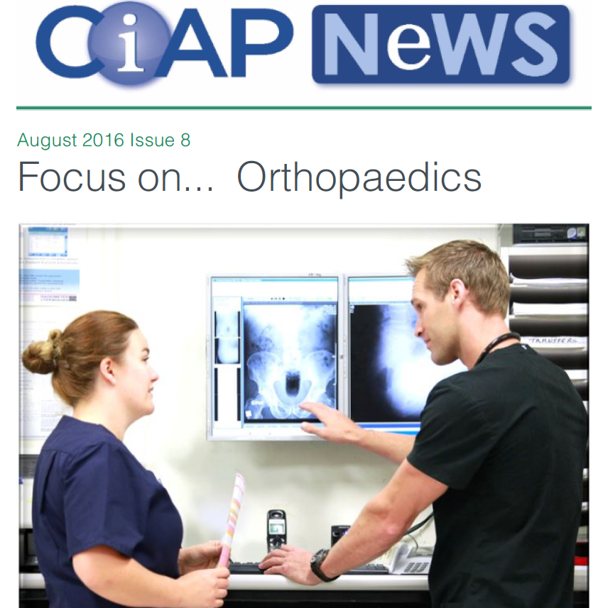

Please forward any funny and litigious quotes you may hear on the floor (happy to publish names if you want)

THE WEEK AHEAD
Monday 12:30-13:30 Surgical Meeting, Education Centre, Level 2
Tuesday 08:15–09:30 Medical Grand Rounds, Education Centre, Level 2
Thursday 12:00-13:30 JMO Education – Oncology for Interns, Dr Julia Chen, Oncology AT Boardroom – Level 4

