EMERGENCY MEDICINE Sutherland Hospital
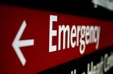The Weekly Probe
19th August 2016 Volume 13 Issue 27
Congrats – congratulations to Andrea who has become a second parent (not a grandmother!) after the arrival of her daughter’s baby girl. Well done Andrea

Private O+G patients – When a patients presenting to the ED with pregnancy related complaints, such as early bleeding in pregnancy, who are current private patients of an O & G Consultant working at TSH, please discuss the case with the Consultant prior to discharge from ED.

Drug name changes – There will be a progressive transition of a number of drug names phased in over the next 4 years. These include indomethacin to indometacin and amoxycillin to amoxicillin for a full list go to www.tga.gov.au/updating-medicine-ingredient-names-list-affected-ingredients

THIS WEEK
Last Week’s Case – Brainstem CVAs and TIAs
Joke / Quote of the Week
The Week Ahead

Last Week’s Case – Brainstem TIAs and CVAs
A 58 yo man presents with transient generalised weakness (bilateral legs > arms) on a background of hypertension. On examination his neuro exam is normal. Could this be a vertobasilar TIA? If so, what do we do next?

Some key points to start:
- About 80% of the brain’s blood supply comes from the carotid, and the remaining 20% from the vertebral.
- Not surprisingly then, posterior circulation strokes make up ~ 15-20% of all ischaemic strokes
- Many TIAs last < 30 min and patient’s symptoms have often resolved by the time of arrival so we are dependent on the history from the patient or relatives.
- Compared with anterior circulation stroke syndromes, posterior circulation ischaemia may have a longer prodrome - with a longer latency between prodromal warning symptoms and stroke onset- so there is an opportunity to intervene.
- Below is a reminder of the blood supply to the brain stem and cerebellum.
  - The 2 vertebrals give off the ant spinal artery and PICAs before uniting to form
  - the basilar artery which gives off pontine branches, labyrinthine arteries, the AICA and superior crb artery, before branching into the two
  - Posterior cerebral arteries which supply the occipital lobes, the inferior temporal lobes, medial parietal lobes and thalamus and upper midbrain.

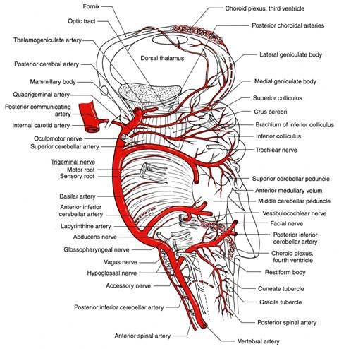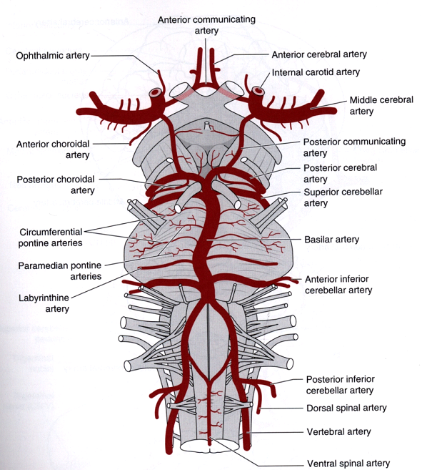

- As this is dense region of neuroanatomical pathways and nuclei, large strokes are clinically obvious with a mix of gross neurological symptoms and signs
- For more info on the anatomy and clinical relevance of these areas look at this video
- However TIAs and stroke may result from occlusion of tiny penetrating vessels with diameters of 0.1-0.4mm. These may produce isolated unusual, unmixed or localised symptoms or signs- brainstem lacunar events
- In these patients in particular, our imaging (including CT and early MRI), screening tests for cerebrovascular disease (eg dopplers) will be negative.
- As a result, this combination of transient, potentially mild or atypical symptoms/ signs with potentially significant consequences if missed, makes brainstem syndromes a diagnostic challenge.

Sources of Ischaemia
- Atherosclerosis – vertebral and basilar arts
- Dissection – vertebral arts
- Embolism from heart, aorta or vertebrals – post cerebral artery
- Arteriolopathy “lipohyalinosis” - disorganization of the vessel wall related to hypertension - small perforating vessels such as those causing pontine lacunae events

Sounds a bit simplistic but the main challenge is looking for a focal neurological deficit explainable to the brainstem. Couple of “take home points”
- There are groups of symptoms / signs which may localize the region involved (and vessel).
- Some of these symptoms / signs may easily get overlooked in the “quick” neuro exam eg pain and temperature
- There are also unusual symptom / signs which may be noted in conjunction with or in isolation when such strokes / TIAs occur.

If you want to localise the lesion LifeintheFastlane discusses one technique, the rule of 4
- There are 4 “Midline” structures beginning with M
- Motor pathways (corticospinal) – contralat weakness
- Medial lemniscus – contralat vibration and prop’n in limbs
- MLF – internuclear opthalmoplegia with inability to adduct ipsilateral eye and nystagmus in contralat eye
- Motor nuclei and nerve – all factors of 12 ( ie CN3,4,6,12) (others are lateral)
- There are 4 “side” structures beginning with S
- Spinocerebellar pathway- ipsilat ataxia of the arm and leg
- Spinothalamic pathway- contralateral change in pain and temperature – esp limbs
- Sensory nucleus of the CNV- ipsilat change in pain and temperature on the face
- Sympathetic pathway- ipsilateral Horner’s
- There are 4 cranial nerves in the medulla (9-12), 4 in the pons (5-8) and 4 above the pons (2 in the midbrain (3 -4))

They suggest that by combining medial or side (lateral) structures involved and the level of the nuclei involved, the site of the lesion can be localized. It is also a prompt to performing a complete neuro exam.
Looking at the effects of a particular vessel being involved in an ischaemic event (moving in a superior direction):

Anterior spinal artery (ant SC and medulla) - aka medial medullary syndrome-
1. Contralateral hemiplegia of the limbs (pyramids /corticospinal) - may also have facial weakness
2. Contralateral loss of position sense, vibratory sense and discriminative touch (medial leminiscus) - there may be parasthesias or less commonly dysaesthesias esp in LL or trunk
3. Ipsilateral deviation and paralysis of the tongue (hypoglossal nucleus or nerve)

Posterior inferior cerebellar artery (or contributing vertebral) - may result in lateral medullary syndrome (Wallenberg’s syndrome) with-
1. A contralateral loss of pain and temperature sense in trunk and limbs (spinothalamic tract)
2. An ipsilateral loss of pain and temperature sense on the face (spinal trigeminal nucleus and tract)
3. Vertigo / dizziness (and all the variants as mentioned below), nausea and vomiting (vestibular nuclei and connections)
4. Horner’s syndrome (hypothalamolspinal tract)
(May also see 1) ocular torsion with head tilt and skew deviation 2) limb ataxia 3) facial pain or dysaesthesias ( nucleus or tracts of CNV) 4) paralysis of palate, pharynx and larynx (with hoarseness and dysphagia) 5) respiratory dysfunction 6) Cardiovascular abnormalities

The size and location of cerebellar ischaemia from a PICA occlusion (or other cerebellar vessels) will also influence the clinical presentations
- Medial vermis – may result in vertigo with nystagmus, similar to a peripheral vestibulopathy. May have truncal lateropulsion
- Lateral cerebellar- “dizziness” (can be vertigo, whirling, being pulled to one side, swaying or rolling), incoordination with drift – may have ataxia with unsteadiness with abnormal alternating movements but can be without vertigo or dysarthria
- Full PICA – headache or high cervical pain – head tilt. Vomiting, gait and truncal ataxia. Cerebellar oedema may later result in pontine compression with gaze palsies esp 6th nerve

Posterior spinal arteries (post SC, spinal trigeminal tract and nucleus, inferior cerebellar peduncle**

Anterior Inferior Cerebellar arteries – may result in combined peripheral and central vestibular damages – be particularly suspicious if this is associated with hearing loss- may also have facial weakness, limb and facial sensory loss, gait ataxia, and cerebellar dysmetria.

Pontine arteries:
Paramedian branches:
1. Hemiplegia of the contralateral arm and leg (corticospinal tracts) + facial weakness
2. Contralateral loss of tactile discrimination, vibratory and position sense (medial leminiscus)
3. Ipsilateral lateral rectus muscle paralysis (abducens nerve or tract) - gaze palsies

Long circumferential branches – (lateral pontine syndrome) with;
1. Ataxia (middle and sup cerebral peduncles)
2. Vertigo, nausea, nystagmus, deafness, tinnitus, vomiting (vestibular and cochlear nuclei and nerves)
3. Ipsilateral pain and temperature deficits from face (spinal trigeminal nucleus and tract)
4. Contralateral loss of pain and temperature sense from the body (spinothalamic)
5. Ipsilateral paralysis of facial muscles and masticatory muscles (facial and trigeminal motor nuclei)

Basilar artery
May result in a combination of the above symptoms or signs. However there are some unusual features.
- Motor – basilar patients with pontine involvement have motor changes which is often lateralised (hemiparetic). Weakness often more severe in the distal limb (hand and foot) c/w proximal. May be stuttering or progressive. However although asymmetrical there is often bilateral changes with slight weakness, ataxia, hyperreflexia, upgoing toe and abnormal spontaneous movements such as shivering, shaking or jerking may be seen on the spared side- this may be so gross to be mistaken as epileptic events . Ataxia may also be seen- this ataxia may be simply clumsiness, awkwardness, slowness of fine manipulation- it may be bilateral or unilateral, and can be accompanied by a sensation of heaviness or weakness.
- Bulbar- Weakness of the face, larynx, pharynx may be seen - may be contralateral to limb weakness but more often the bulbar weakness is bilateral. May be associated with exaggerated facial reflexes with clonic jaw movement or clamping down on the tongue depressor. Palatal myoclonus may be seen resulting in rhythmic involuntary jerking of the soft palate.
The motor and bulbar components may be seen together as a “Clumsy hand-dysarthria” syndrome
- Oculomotor – horizontal gaze palsies, internuclear opthalmoplegia, one and a half syndrome (one eye unable to abd or add + the other unable to adduct) – skew deviation- horizontal nystagmus esp on looking to the side of the paresis – dissociative nystagmus (worse in one eye and not concordant between both eyes) or vertical nystagmus- ocular bobbing. May have small reactive pupils.
- Sensory- not prominent - may have unilateral or bilateral paraesethesias due to medial lemniscus involvement. May have burning facial pain.
- Emotional changes – maybe there are more people out there with pontine infarcts yet another reported symptom is exaggerated crying and laughing spells with hypersensitivity to emotional stimuli

“Top of Basilar” Syndrome- ischaemia of midbrain, thalamus, temporal and occipital lobes
- Oculomotor / pupillary abnormalities – gaze palsies (esp vertical), skew deviation, head tilt, convergence problems, poor pupillary response
- Alertness changes- somnolence- thalamic or midbrain involvement may result in hallucinations (esp visual )- memory defects (anterograde + retrograde)
- Other- movement disorders esp hemiballismus – cerebellar symptoms as described above

Superior Cerebellar artery- rare in isolation (ie often with basilar or vertebral ischaemia) - presents with dysarthria and unsteady gait while vestibular signs such as vertigo are far less frequent.
Headache, nausea-vomiting, gait imbalance, diplopia- other cerebellar signs including dysmetria, dysdiadochokinesia, dysarthria, ataxia.

Post cerebral artery syndrome:
- Visual loss - Homonymous hemianopia or quadrantanopia
- Little or no paralysis
- Prominent sensory loss (thalamic involvement)
- Left PCA: alexia without agraphia (can’t read but can write), aphasias (can’t find words), Gerstmann’s Syn, visual agnosias (unable to process info)
- Right PCA – can’t recognise faces, disorientation to place – visual neglect more common than left PCAs
- Recent memory loss

Imaging the Posterior Circulation Stroke
- CT scan – although sensitive in the detection of intracranial haemorrhage, it is not particularly sensitive for the diagnosis of posterior circulation stroke
  - Look for asymmetry of thalamus, occipital and temporal lobes, cerebellum + asymmetrical hypodensity in the midbrain or pons
  - May see a hyperdense basilar artery (secondary to clot) on a non-contrast study- useful in the correct context
  - CT perfusion studies- increasingly used in an attempt to identify areas of (ir) reversible ischemia — Using an intravenous bolus of CT dye and repeatedly scanning the same portion of the brain parenchyma over the time required for the bolus to pass through the vasculature allows a "perfused blood volume map" to be obtained with estimation of the cerebral blood flow, cerebral blood volume and the mean transit time. More use with larger posterior circulation or ant circulation strokes. This may help define those who are likely to develop larger areas of ischaemia, are more likely to deteriorate, and are more likely to benefit from more aggressive Tx.
- CT angio - need to assess the extracranial (internal carotid and vertebral) and intracranial (internal carotid, vertebral, basilar, and Circle of Willis) large vessels. Note a COW study is inadequate. CT angio +/- doppler (or MRA) should be used unless urgent endovascular therapy is planned. Note that these studies will not identify smaller vessel occlusion as seen with lacunae events
- MRI – more sensitive than CT – most sensitive if diffusion weighted imaging is used yet it is estimated that 6-10% of strokes are DWI negative (thought that there are more false negatives with posterior circulation strokes c/w anterior)

Patient Progress
He was given aspirin - normal CT head
Two days later he represented with left hemiplegia
MRI showed ischaemia medial upper pons
Normal Holter, echo, angio
Improved clinically yet mild intermittent incoordination / ataxia of the left hand

Take home message
“You can never say never” and brainstem ischaemia can result in many different symptoms and signs.
Listen to the history, carefully examine, if in doubt consult, admit and MRI

Refs:
- Demel SL et al Basilar Occlusion Syndromes: An update The Neurohospitalist 2015; 5(3); 142-150
- Kim JS Syndromes of pontine base infarction Stroke 1995; 26: 950-955
- Up to date
- http://ekgmachines.org/article/802979321/central-nervous-system-cns-blood-supply/

JOKE / QUOTE OF THE WEEK

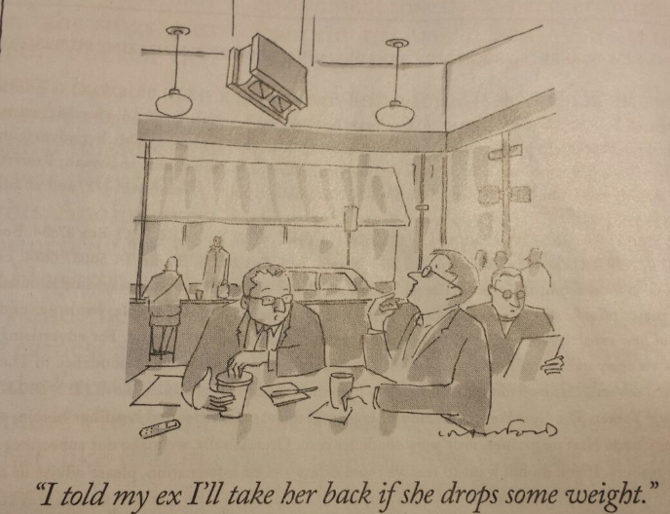

Please forward any funny and litigious quotes you may hear on the floor (happy to publish names if you want)

THE WEEK AHEAD

Monday 1230-1330 Surgical Meeting, Auditorium, Level 2
Tuesday 0815-0930 Medical Grand Rounds, Auditorium, Level 2
Wednesday 0830-0930 JMO Education – Videoconference with SGH, Boardroom, Level 4.
Introduction to Trauma, Trauma Registrar

