EMERGENCY MEDICINE Sutherland Hospital
The Weekly Probe
2nd September 2016 Volume 13 Issue 29
STOP project – the ED has been part of the hospital wide STOP project to reduce the ordering and associated costs of pathology that will not change patient management. Subsequently there has been a 13% reduction in pathology expenditure in the ED over the last 12 months. Well done and keep up the good work. If you have any questions please d/x Katerina
A similar process is being undertaken for radiology. A couple of pointers:
- All CT or US requests require a ED specialist or registrar approval – include the name on the request
- A sonographer should only be called after senior doctor review of the patient- considering the timing of the study in the context of the patient preparation ie make sure they have a full bladder when the sonographer arrives.
- Reports for medical imaging – requests for radiologist reports after hours should not be routinely requested for X-rays and CT brain (unless a report is requested by the ED Specialist or Registrar). These results should be reviewed by an ED Specialist or Registrar.
- If a patient requires medical imaging as an outpatient, there are 2 options:
  - Refer to TSH Medical Imaging Department – need a request in eMR and a patient advice form regarding booking an appointment (forms available on SUTED desktop folder or in Fast Track office). Do not advise the patient to turn up without an appointment.
  - Refer to private outpatient imaging services – forms available in Fast Track office and on intranet (see below). This is preferred if patient is accepting of this option as it reduces work load for a busy hospital medical imaging department.
To find these forms online go to the Intranet – Hospitals – Sutherland then
Then
THIS WEEK
Last week’s case – Portal vein thrombosis and mesenteric Ischaemia
Joke / Quote of the Week
The Week Ahead

LAST WEEK’S CASE – PORTAL VEIN & MESENTERIC THROMBOSIS
70yo diabetic lady presents with 5 days of upper abdominal pain and distension on a background of HT’n, hyperchol and DM
Obs NAD- hydration N
Abdo soft yet tender upper abdo with no peritonism- ECG – sinus – lactate 10.1 – WCC 33
CT abdo-(portovenous phase) below
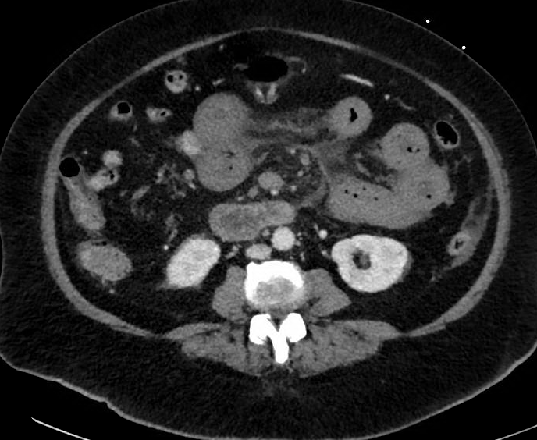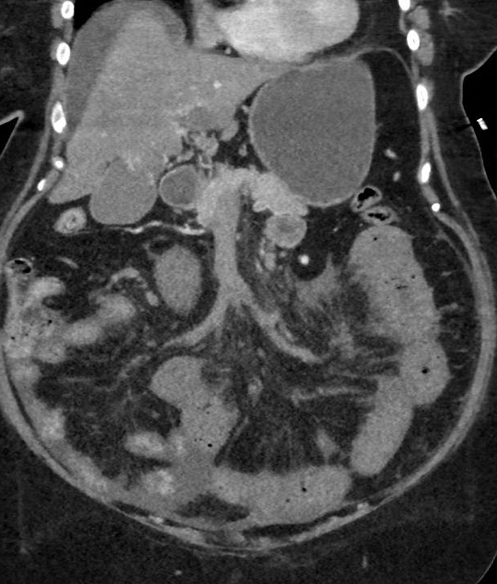

What is going on?

The scan shows oedema of the small bowl (jejunum) with adjacent fluid / stranding. The arterial phase (not shown here) showed normal arterial flow (superior mesenteric artery), yet the portovenous phase showed reduced filling of the superior mesenteric (SMV) and portal veins (compare these pictures with the normal studies shown later). At laparotomy she was found to have thrombosis of her SMV extending into her PV and despite removal of 200cm of small bowel, anticoagulation and further resection, she has continued to deteriorate.

Venous drainage of the gut – a reminder of the venous drainage of the gut – the inferior mesenteric vv joins the splenic vein and this then joins the superior mesenteric vein to form the portal vein
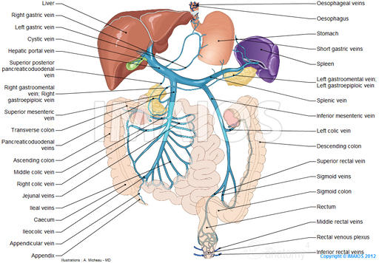
Isolated splenic vein thrombosis can develop in tandem with a patent portal vein. However, apparently it is unusual to have thrombosis of the inferior/superior mesenteric veins without involvement of the portal vein itself. Thrombosis may involve the whole venous plexus - mesenteric venous thrombosis.

Why? Portal vein thrombosis, like thrombosis elsewhere, can occur due to disturbance of any one of Virchow triad

- reduced flow / portal hypertension
  - cirrhosis: most common- venous stasis secondary to portal hypertension
  - hepatobiliary malignancies (HCC, pancreatic , cholangiocarcinoma) + gastric CA
  - (Tumour thrombus may occur with malignant invasion with HCC)
- hypercoagulable state
  - inherited prothrombotic conditions / malignancy / myeloproliferative disorders / inflammatory bowel disease / dehydration (ie potentially following a bout of gastro) / OCP / pregnancy / trauma
- endothelial disturbance
    - local inflammation/infection (most common in some series )- acute pancreatitis, ascending cholangitis, abdominal surgery
The presentation of acute portal vein thrombosis (PVT) depends on the extent of the obstruction, the speed of development and associated comorbidities.

Symptoms — Acute PVT may be clinically silent and be diagnosed coincidentally during investigations performed for other indications eg bilary Dx.
In addition to pain, patients may also report fever (esp if acute pylephlebitis) and dyspeptic symptoms.
Patients may also have symptoms related to conditions that predispose to the development of PVT, such as acute pancreatitis.

If there is involvement of the superior mesenteric vein, the presentation is similar to other types of mesenteric ischaemia. Although we have discussed mesenteric ischaemia earlier this year it is worth covering the diagnosis again as the diagnosis can be a bit tricky at times (see below).

Patients may present with gradual (may be sudden) onset colicky, dull periumbilical abdominal pain which may radiate to the back. The nature of the pain may be reflected by the fact that, as reported by uptodate and as seen in this patient, > 75% of patients report at least 2 days of pain before seeking medical attention. Nausea, vomiting and diarrhoea may be seen in ~ ½ of patients. With progressive gut ischaemia there may be features as described below.

Patient may present with variceal bleeding. When PVT occurs in a noncirrhotic patient, they can develop some symptoms of portal hypertension, but it is important to note that these patients, in general, will develop varices but no ascites. Ascites is indicative of the process complicating cirrhosis.
Another difference is that bowel ischaemia can occur with noncirrhotic patients whereas this rarely occurs in cirrhotics with PVT.

Signs. Abdominal distension may be seen secondary to ileus / bowel distension or from ascites or esp in the context of previous liver Dx . Signs of peritonitis may occur with bowel infarction or intrabdominal inflammation

DIAGNOSIS- to confirm the diagnosis, look for precipitating or complicating factors and to look for alternative diagnoses.

Laboratory testing — Laboratory test show a spectrum of abnormalities depending on the clinical presentation. Liver tests are often normal in those with no pre-existing liver disease (as hepatic arterial blood flow compensates for decreased portal inflow), though a transient, moderate increase in AST and ALT may be seen in some patients. Blood cultures may be positive for Bacteroides or E.coli in thgose with septic PVT.

Abdominal CT — A non-contrast scan may show may show hyperattenuating material in the portal vein yet this is suboptimal imaging and a contrast CT with portovenous images need to be included. In these images there may be a lack of luminal enhancement, increased hepatic enhancement in the arterial phase, and decreased hepatic enhancement in the portal phase. Compare the images above to that of a “normal” patient – note the degree of enhancement of the portal and sup mesenteric veins
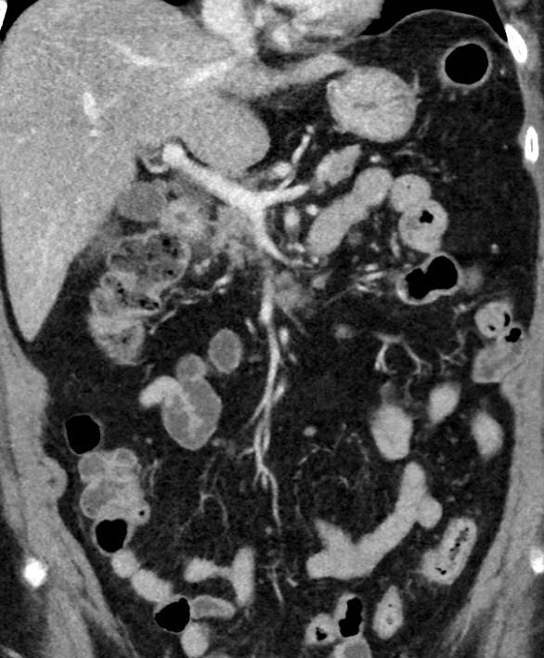
Tumour thrombus may enhance during the arterial phase or have an arterial phase with Doppler US, result in markedly enlarged PV diameter or disrupt the vein wall.

Abdominal ultrasound with Doppler imaging — US may show initially hypoechoic then hyperechoic material within the portal vein, with distension of the portal vein and its tributaries. The portal vein may be enlarged and not vary with inspiration – normally this is 9-13mm in diameter at the porta hepatis while holding the breath. When combined with Doppler, US is estimated to be 89-93% sensitive and 92-93% specific for diagnosing PVT. However if PVT is noted, a CT will often follow, it does not elucidate the extent of the thrombosis and is unlikely to detect predisposing conditions or ischemia. With chronic PVT there may be cavernous transformation of the PV with multiple small periportal vessels, which represent dilated collateral veins.

MANAGEMENT:
- laparotomy with bowel resection if evidence / suspicion of bowel ischaemia – surgical thrombectomy may be considered
- anticoagulation – consider risk esp if varices
- Broad spectrum antibiotics if septic PVT is suspected.
- Interventional radiology including TIPPS or endovascular infusion of thrombolytics

MESENTERIC ISCHAEMIA

Looking at mesenteric ischaemia in general, it is a “tough” pathology. Early signs and symptoms are nonspecific, and definitive diagnosis often requires invasive testing, exposing the patients who typically have several comorbidities to risk and a result, the diagnosis is often delayed. However rapid diagnosis is essential to prevent the catastrophic events associated with intestinal infarction. As a result mortality is high.

Intestinal ischemia can be divided into acute and chronic (with meal related symptoms with episodic or chronic pain), based upon the rapidity and the degree to which blood flow is compromised.

The three major causes of acute mesenteric ischemia are:
●Arterial occlusion (85-95%)
- Superior mesenteric artery embolism (50 percent)-especially involving the mid jejunal region - inf mesenteric artery is rarely effected
- Superior mesenteric artery thrombosis (15 to 25 percent)- this usually occurs as a superimposed phenomena on a Hx of atherosclerotic Dx associated with advanced age, atherosclerosis, low cardiac output states, cardiac arrhythmias, severe cardiac valvular disease, recent myocardial infarction, and intra-abdominal malignancy – most often at the origin of the vessel

●Nonocclusive ischemia (20-30%)- probably results from splanchnic vasoconstriction or a period of decreased cardiac output / hypoperfusion. Risks include factors associated with hypoperfusion- older pts, heart failure, presence of PVD, hypotension, increased sympathomimetic activity, sepsis, vasopressors etc. Vasoconstriction may persist even after the precipitating cause has been eliminated or corrected.- a more immediate precipitating cause (eg pulmonary oedema, arrhythmia, shock) is frequently present although the consequent mesenteric ischaemia may not become manifest for hours to days.

●Venous occlusion (5%)- includes venous obst’n via hernias etc - tends to occur in younger patients compared with acute mesenteric ischemia due to arterial embolism or thrombosis. Risk factors are shown above.

CLINICAL MANIFESTATIONS — the teaching is that those with acute mesenteric ischemia have a rapid onset of severe periumbilical abdominal pain, which is often out of proportion to findings on physical examination. Nausea and vomiting is also common. Sudden pain associated with minimal abdominal signs and forceful bowel evacuation in a patient with risk factors for acute mesenteric ischemia should greatly heighten suspicion for the diagnosis.
A couple of caveats:
- Symptoms and signs of mesenteric ischaemia are seen in a variety of pathologies.
- The severity and location of the abdominal pain that accompanies nonocclusive mesenteric ischemia (NOMI) is usually more variable than the classic severe pain of acute occlusive mesenteric ischemia so be suspicious in those with risks. Other symptoms may predominate in those who present with hypotension, congestive heart failure, hypovolemia, and cardiac arrhythmias
- In those with mesenteric vein thrombosis the presentation may be more insidious with pain present for days to weeks (typically 5-14 days) before diagnosis. About ½ have nausea and vomiting.
- Severe pain is more likely with acute small bowel mesenteric ischemia compared with mesenteric ischemia involving the colon, in which extreme pain is usually not as prominent a feature.
- In patients with SBO leading to ischemia, pain often precedes vomiting.
- The onset of pain is sudden when ischemia is caused by embolic disease. In contrast, the pain may occur more insidiously (hours to days) in patients with thrombotic causes, vasculitis, or nonocclusive ischemia.
- Lower abdominal pain associated with PR bleeding is more likely with colonic ischemia.
- Other differences between small bowel and large bowel ischaemia include:

Colonic | Small bowel
90% > 60yo | Age depends on aetiology
Acute ppt illness is rare | Acute ppt illness is typical
Less commonly appear ill | Pt usually appear ill
Mild abdominal pain with tenderness | Pain severe yet tenderness not prominent early
Rectal bleeding, bloody diarrhoea typical | Bleeding uncommon till late
Colonoscopy is the procedure of choice | CT angiography

Examination - may be normal initially or reveal only abdominal distension or occult blood in the stool yet as ischaemia progresses there may be signs of peritonism (ie this is a late sign). Another tricky part is that mental status changes are seen in 1/3 with acute ischaemia.

DIAGNOSIS —This should be based on a high clinical suspicion, especially in patients with known risk factors- note that there are multiple cause and precipitants and that AF is not the only risk factor.

Patients suspected of having acute mesenteric ischaemia should be resuscitated (including measures aimed at relieving acute congestive heart failure and hypotension, correction of hypovolemia and cardiac arrhythmias), early surgical consultation and consider organising a CT- as noted below this does not exclude mesenteric ischemia but may identify whether it has progressed irreversibly and also helps to exclude other causes of abdominal pain. Direct transfer to OT may be considered in those at risk particularly in the presence of necrosis / peritonism.

Laboratory studies — Laboratory studies are nonspecific; while abnormal laboratory values may be helpful in bolstering suspicion for acute mesenteric ischaemia, normal laboratory values do not exclude AMI and do not justify delaying urgent radiologic evaluation when clinical suspicion for ischaemia exists.
- Lactate – sensitivities of 77-100%- not specific- more likely to rise once the ischemic insult has progressed to bowel necrosis
- Other findings – non-specific – raised WCC, elevated Hct, elevated amylase and phosphate

Imaging:
- CT may demonstrate findings consistent with acute ischemia such as focal or segmental bowel wall thickening, intestinal pneumatosis with portal vein gas, bowel dilation, mesenteric stranding, portomesenteric thrombosis, or solid organ infarction, in addition to ruling out other causes of acute abdominal pain. It is suggested that the scan should be performed without oral contrast, which can obscure the mesenteric vessels, obscure bowel wall enhancement, and can lead to a delay of the diagnosis.
- Note that the CT is not 100% sensitive, one study which included 39% of surgically proven ischaemia found the sensitivity of 64%
- Angiography may be considered if the diagnosis remains in question yet in the setting of hypotension or hypovolemia, angiography will demonstrate mesenteric vasoconstriction even in the absence of mesenteric ischemia.
- Note that Plain AXR relatively nonspecific and may be completely normal in more than 25% - may see an ileus with distended loops of bowel, bowel wall thickening (particularly prominent in acute mesenteric venous thrombosis), and/or pneumatosis intestinalis

TREATMENT
- Resuscitation - aggressive hemodynamic monitoring and support, correction of metabolic abnormalities, initiation of broad spectrum ABs, and placement of a NGT for gastric decompression. Avoid vasoconstrictors if possible. Anticoagulation to prevent thrombus propagation
- Surgery - should not be delayed in patients suspected of having intestinal infarction or perforation based upon clinical, radiographic, or laboratory parameters. Laparotomy, embolectomy / revascularisation and resection of ischaemic bowel may be required.
- Interventional radiology – may be considered if contraindications to OT, if early with no evidence of necrosis – direct infusion of thrombolytics or vasodilators- stenting may be considered
- Anticoagulation-esp for mesenteric vv thrombosis

Prognosis - depends on the age of the patient, comorbidities, complications, time to diagnosis (less than 12–24 hours and before gangrene), extent of ischaemia and the underlying cause:
- venous thrombosis - 32% mortality
- arterial embolism - 54% mortality
- arterial thrombosis - 77% mortality
- non-occlusive ischemia - 73% mortality

Refs – Schofield N, Acute mesenteric ischaemia J Intensive Care society July 2014;15(3):226 / auntminnie.com / Uptodate) / Boyer TD, Management of Portal Vein Thrombosis, Gastroenterol Hepatol (N Y). 2008 Oct; 4(10): 699–700. Radiopaedia http://radiopaedia.org/articles/portal-vein-thrombosis

JOKE / QUOTE OF THE WEEK
If you’ve searched Firstnet for “fever” many potential diagnoses come up – abbatoir fever , three day fever , bolivian fever etc etc yet not this one..
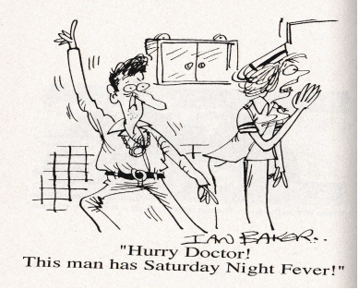

Please forward any funny and litigious quotes you may hear on the floor (happy to publish names if you want)

THE WEEK AHEAD
Monday 1230-1330 Surgical Meeting – Auditorium, level 2
Tuesday 0815-0930 Medical Grand Rounds – Auditorium, level 2
Wednesday 1230-1330 JMO Education – Thyroid and Parathyroid disorders
Dr Ganesh Chockalingam. Auditorium, Level 2

