EMERGENCY MEDICINE Sutherland Hospital
The Weekly Probe
10th November 2017 Volume 14 Issue 31
UP-TO-DATE on CIAP – If you are a frequent user of Up-to-date o CIAP please complete the 2 minute questionnaire that appears on the top of the CIAP page. Conspiracy theory maybe but I suspect there is a push to replace it with a cheaper alternative as was tried a year or 2 ago. If you want it retained please spend 2 minutes on the survey!!

MENINGOCOCCAL – a reminder that late winter and spring are our “peak” times for meningococcal disease and after a case last week, it’s a remember to consider this potentially nasty illness when assessing and educating patients .

THIS WEEK
Shoulder Dislocation (anteroinferior) techniques
Next week’s Case
Joke / Quote of the Week
The Week Ahead

After a couple of recent cases here’s a quick review...

Techniques for Anteroinferior Shoulder Dislocation
An injury that we commonly see throughout the year is the dislocated shoulder. A couple of years ago we looked at the variety of techniques you can use for reduction focussing on a review titled “Techniques for Reduction of Anteroinferior shoulder Dislocation” in EMA 2005; 17: 463-471 by Neil Cunningham , a Emergency Physician from Victoria.
This reviews the anatomy, types and complications of shoulder dislocations. However the bulk of the article looks at the multitude of different techniques which echo the thought that if there are lot of different approaches, then none of them are perfect. Thus we should keep a couple of different techniques up our sleeve to use for different patient types (in addition to an ampoule of propofol!). For full details on all of the techniques, see the article as I’ve summarised the commonly used or newer techniques. They all sound so easy and painless yet you wouldn’t try a Kochers, Hippocratic or traction, countertraction without significant analgesia +/- muscle relaxation! The key is to individualise the technique for the patient depending on the level of cooperation (ie screaming & uncooperative vrs quiet & compliant), ability to provide sedation / anaesthesia, and likelihood of success (time shoulder out, size of patient, previous attempts etc).
However Cunningham discussed the issues and a technique called the Cunningham technique for reducing glenohumeral dislocations and he pointed to his web site http://shoulderdislocation.net where there are videos and discussion of the various techniques (especially his).
Everyone has their favourite technique and this may vary depending on the patient – personally the Spaso has worked the best.
Techniques in the Anatomical position
- Kocher’s – needs significant force – bend elbow, press it against the body, rotate externally until resistance is felt. Lift the externally rotated upper arm in the sagittal plane as far as possible and finally turn inwards (adduct).
- Cunningham – pt sits in chair with elbow flexed and arm against the body. The operator kneels next to the pt and places his wrist onto the pts forearm whilst the patients hand rests on the operator’s shoulder. The patient is asked to shrug the shoulders posteriorly and superiorly. The biceps is massaged at mid-humeral level to specifically relax the muscle (removing dynamic obstruction) – the head then reduces!!
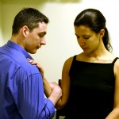
Techniques in the “Zero” position
- Milch technique – pt is supine and the operator stands on the side of the dislocation. In a right sided dislocation the operator places his right hand upon the patient's right shoulder, so that the fingers find firm support on the top of the shoulder, while the thumb is braced against the dislocated humeral head. The right hand then fixes the head as the left hand gently abducts the arm into the overhead position. During this manoeuvre the head of the humerus is supported so that it cannot move from its dislocated position. As a consequence, instead of moving downward as the arm moves upward, the head rotates in place. Once the arm has been brought into complete abduction in this overhead position, all cross stresses exerted by all the muscles have been eliminated; the head can be gently pushed over the rim of the glenoid and the dislocation reduced.
Techniques with the arm in forward flexion
- Hippocratic – pt supine with the operator holding the arm applying traction. A 'well stockinged foot' ( preferably not smelly) in the axilla applies countertraction and is also used to lever the humeral head supralaterally.
- Traction countertraction- Traction is applied to the arm with the shoulder in abduction; an assistant applies firm countertraction to the body using a folded sheet.
Techniques with the arm in forward flexion
- Stimsons hanging arm technique – Don’t mind trying this for probable 1st dislocations pre-Xray. The patient lies prone on a table with the affected arm hanging downward. Get a radiology sandbag and tie to the wrist or get the pt to hold it. Reduction occurs secondary to fatigue of the spasming muscles.
- Spaso – good method for the cooperative patient – the key is gradual movements and constant reassurance– can be done sitting or supine - With the patient supine gradually the arm is gently lifted vertically with gentle traction and externally rotated whilst in an adducted position. While applying traction rotate the shoulder externally. Gentle pressure to the medial humeral head / deltopectoral groove is performed by an assistant to aid the movement of the humeral head into position.
Techniques with the arm in forward flexion plus scapular manipulation
- Scapular manipulation – similar to Stimson - The patient is placed prone on the examining table with the shoulder in a position of 90 degrees of forward flexion and external rotation. The forearm is suspended from the table with the wrist secured and the elbow flexed. Traction on the forearm is maintained with 5 to 15 lbs for a variable period, usually less than five minutes. After the patient begins to relax, the operator pushes on the tip of the scapula medially (lifting it on occasion), while simultaneously rotating the superior aspect of the scapular laterally. Variations include the sitting patient with one physician performing gentle traction in the forward flexion position with counterbalancing in the patient's midclavicular region. A second physician manipulates the scapula.
Autoreduction techniques – you can advise patients to watch Lethal Weapon movie and watch the self treatment of Mel Gibson and his dislocated shoulder, but a more researched technique is the Boss-Holzach-Matter autoreduction technique, as described at http://shoulderdislocation.net

- The patient clasps their hands together, and the forearms and wrists are placed around the homolateral knee, which is flexed at 90 degrees, (the patient may need some assistance to keep the hands together – a separate person can do this, or the wrists can be gently tied together with a crepe bandage).
- The head of the examination table is lowered slowly, and the patient is asked to lean backward with his or her neck in hyperextension. In this position, they exert increasing anteriorly directed axial traction on the dislocated shoulder.
- The patient also must push his or her shoulders (shrug) anteriorly, thus creating a rotational movement of the scapula around a vertical axis.

Whatever the technique the key to reduction is the relaxation and cooperation of the patient. Explain what you are going to do and do it slowly, with ongoing encouragement. This may be supplemented by patient specific analgesia +/- sedation which should be individualised- ?age ?recurrence ?duration of dislocation ? level of pain / cooperation etc . Pain ++ and spasm = unsuccessful reduction

NEXT WEEK’S CASE
A 70yo lady with a history of diabetic nephropathy presented with fevers and foot pain after having her foot run over by a toy car (one that the toddler sits inside of (not a matchbox car!).
She is febrile 38.5C – the rest of the leg looks more swollen to the knee with pitting oedema but the skin is normal.
What is going on and what treatment does she need?
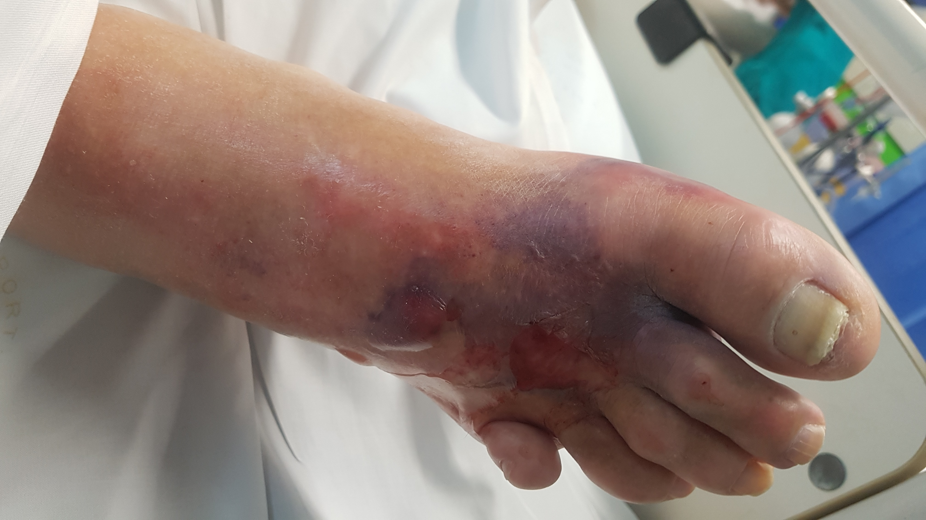

JOKE / QUOTE OF THE WEEK
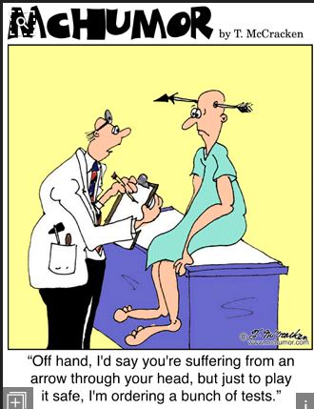

Please forward any funny and litigious quotes you may hear on the floor (happy to publish names if you want)

Tuesday: 0815-0930 Medical Grand Rounds
Thursday: 1200-1330 JMO Education

