EMERGENCY MEDICINE Sutherland Hospital
The Weekly Probe
17th November 2017 Volume 14 Issue 32
Welcome - welcome to both Mark Wilson and Lorna Bishop to the Sutherland ED as new Transitional Nurse Practitioners!

Congrats -To celebrate the Rewards and Recognition Team Award for the ED team, Will has put together a short clip to review and reflect on our values on what it means to be a part of our great team. Check it out at https://youtu.be/UaYjVtZTLBg

Gastroenterology – some important points were raised by the Gastro department:
1. Food bolus/oesophageal foreign body
a. Call them early
b. Don’t give glucagon & get them to drink Coke etc
c. Don’t do lateral soft tissue or chest x-rays, unless clinically warranted
2. They ‘scope down to 14 years
3. Gastro take all bleeds, upper AND lower (a lot of other hospitals have surgery taking lower bleeds)
4. Don’t do CT angios without asking Gastroenterologist first. Often a waste of time & scoping is best first management strategy
5. Don’t do AXR!!!
6. Haemoccult is dead!!!!

Lyssavirus and Rabies – The Ministry of Health have recently released info on the management of potential rabies and lyssavirus contacts.
In summary, contact the Public Health Unit if you have a patient bitten or scratched by a bat (not faecal or urine contact with intact skin) or a traveller returning after a potential rabies contact. They will then assess risk and organise immunisation and immunoglobulin to be delivered to the patient’s nearest hospital for administration.

Parechovirus – a warning was received concerning this viral illness which presents as rapid onset sepsis in children of any age yet more severe in those with < 3 months of age. Initial treatment should be unchanged (ie treat as bacterial sepsis) yet consider testing for this agent as this is not done routinely. A stool specimen and CSF are the preferred samples yet NP, throat swabs may also be used.

- THIS WEEK
Last week’s case – Necrotising Fasciitis
Oxycodone / Naloxone Combination (AKA Targin) Warning
Next Week’s Case
Joke / Quote of the Week
The Week Ahead

LAST WEEK’S CASE- NECROTISING FASCIITIS
A 70yo lady with a history of diabetic nephropathy presented with fevers and foot pain after having her foot run over by a toy car (one that the toddler sits inside of (not a matchbox car!).
She is febrile 38.5C –there were skin changes over the mid and forefoot with erythema, subcutaneous ecchymosis and haemorrhagic bullae (see below) - the rest of the leg looks more swollen to the knee with pitting oedema but the skin is normal- no crepitus was noted.
What is going on and what treatment does she need? (PROGRESS – see below) *Oedema

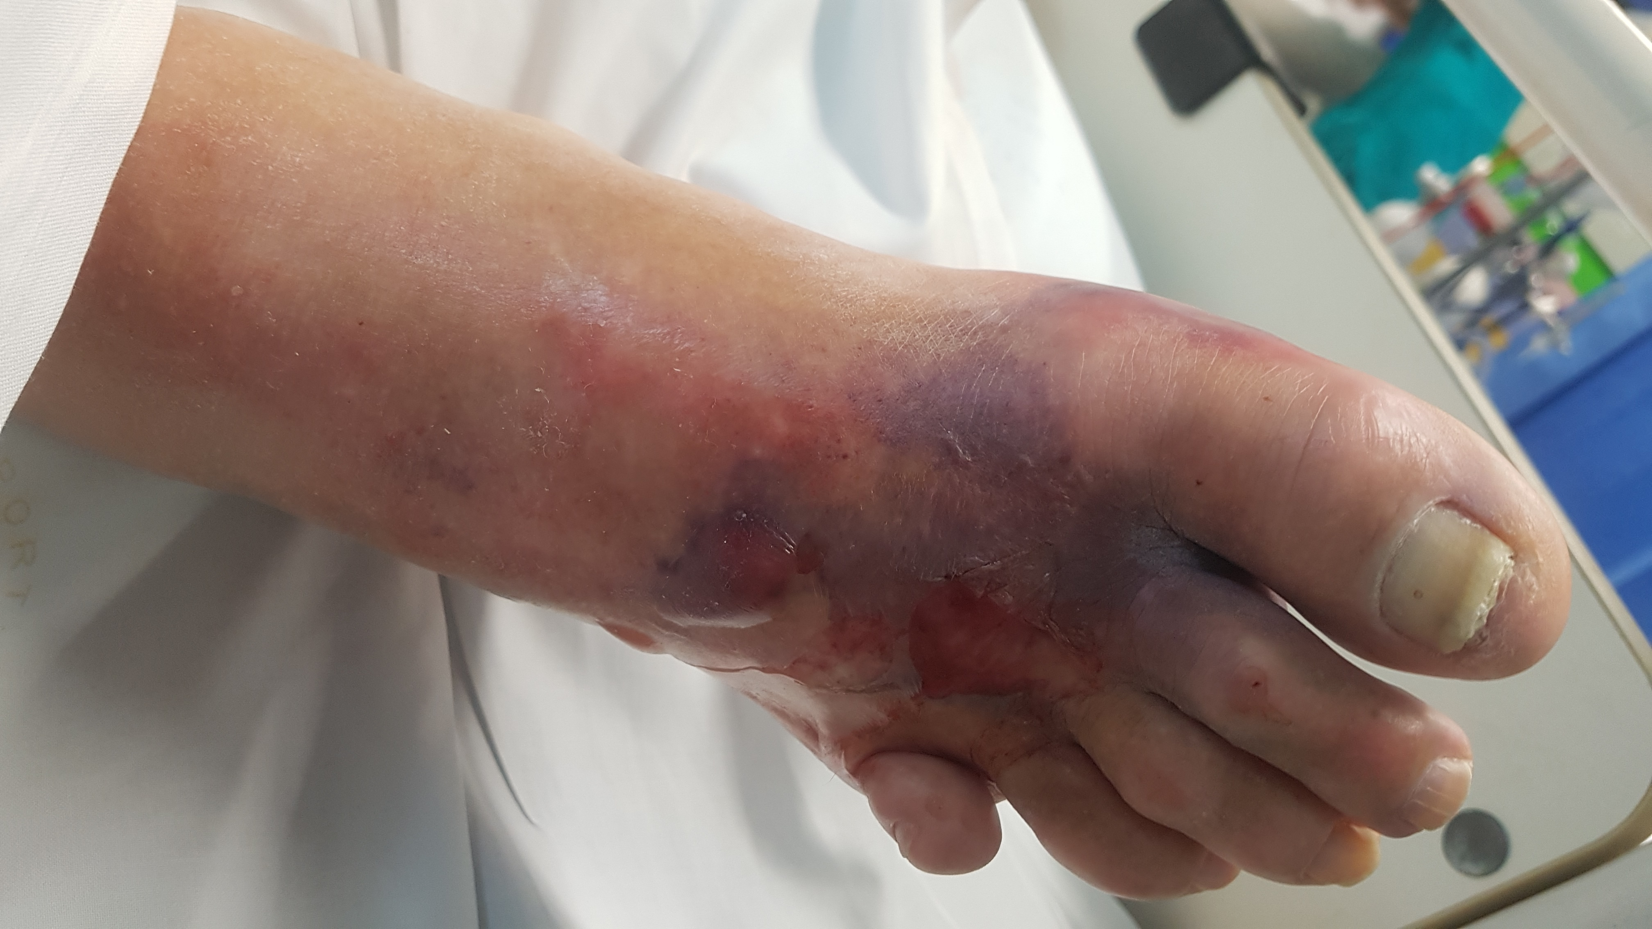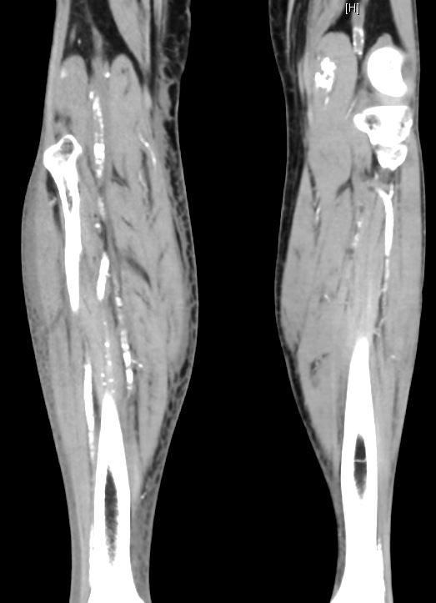

A more severe case - 56yo man presents with 2 days of progressive pain in his right leg.
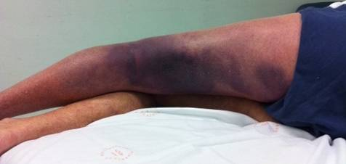
Diagnosed with necrotising fasciitis – treated with broad spectrum antibiotics. The man progressed over the subsequent hours with progressive pain , signs or sepsis with the leg developing large confluent bullae. He was taken to OT for debridement and fasciotomies.

Necrotising fasciitis is one of a group of highly lethal infections that cause rapidly spreading necrosis of fascia and subcutaneous tissues, sometimes involving muscles and skin. In the past they were referred to as hospital gangrene, gas gangrene, and Fournier’s gangrene and are now referred to by the generic term “necrotising soft tissue infections”.

How common is necrotising fasciitis? This is an uncommon illness yet catastrophic if missed.

Even with surgery, mortality is 20-40% with delays in diagnosis associated with increased mortality and morbidity.

What is the cause?
These infections can be:
- monomicrobial—pathogens include streptococci especially Streptococcus pyogenes, Clostridium perfringens (gas gangrene) and other clostridial species, Staphylococcus aureus (incl MRSA) , Vibrio & Aeromonas hydrophila (both water-related infections)- more often associated with (minor) cutaneous / muscular injuries in otherwise healthy, immunocompetant patients – especially head, neck and extremities
- Polymicrobial—synergistic gangrene involves mixed aerobe–anaerobe bacterial flora (eg Escherichia coli, Bacteroides fragilis, streptococci and staphylococci). – typically at the trunk, abdominal wall, perianal and groin areas and post-op wounds.

What are the clinical features?
Necrotising fasciitis is notoriously difficult to diagnose, one study reporting early diagnosis being missed in 85-100% of cases. . The symptoms and signs may mimic haematoma, bursitis,sciatica, septic arthritis, or DVT / thrombophlebitis.
The initial symptoms may be non-specific till the patient rapidly deteriorates, and septicaemia develops, often accompanied by shock or confusion. However progress may be slower with fever or pain developing first. The pain may seem to be disproportionate to the clinical findings- this is caused by tissue necrosis and swelling yet also from nerve infarction (with associated sensory changes) .
Skin changes may start as local cyanosis yet often develops a cellulitic appearance later- oedema may extend beyond the area of erythema indicative of a pathological process deep to the skin.
Note that skin changes may not be seen early. The classic textbook picture of haemorrhagic bullae, crepitus (seen in only 14-25% of cases), and skin necrosis may not occur until day 5 or later. Fever is seen in 50-70% on presentation ie not universal, despite potential severity of the illness.
Who ? All age groups, but is particularly rare in childhood (varicella is a recognised risk factor preceding group A strep). Nec fasc is more common in patients with diabetes (30%), immunosuppresion (17%), ESRF, chronic hepatitis, and malignancy (particularly leukaemia and intraabdominal malignancy) and in people who inject drugs (illegal and legal).
However, about 25% of cases occur in patients without comorbidity or precedent trauma.

Investigations? No investigations are diagnostic. Elevated inflammatory markers may be seen. Hyponatraemia in the presence of sepsis and clinical signs of soft tissue infection should be considered highly suspicious for a necrotising soft tissue infection.
Blood cultures take too long to influence immediate management but have a role in guiding further antibiotic use.

Xrays may show subcutaneous gas yet this is not sensitive- see linear lucencies in soft tissue on the pictures below
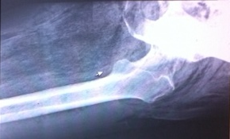. CT can show fascial swelling, inflammation, and soft tissue gas - it may also identify the aetiology if the process is secondary to an intra-abdominal source
TREATMENT - The mainstay for investigation and treatment remains surgical exploration and debridement ie source control. This decision should be made early. Where doubt over the appearances persists, send specimens for histology to look for evidence of necrosis and microbiology for urgent Gram staining.
Empirical therapy
Therapeutic guidelines recommend for empirical therapy, where the diagnosis is uncertain and until tissue and blood culture results are available, use initially meropenem 1gm tds and clindamycin 600mg tds and Vancomycin 25-30mg/kg (actual body weight).
- For strep pyogenes – penicillin 1.8gm q4h with clindamycin. They add that use of immunoglobulin if Streptococcus pyogenes necrotising fasciitis is suspected should be considered (discuss with ID).
- For Polymicrobial necrotising fasciitis and synergistic gangrene (organisms are thought to act synergistically)- in addition to surgical debridement, use meropenem. See Fourniers Gangrene – Probe 2006 no 16
- Clostridial infection - varies from mild cellulitis to overwhelming myonecrosis (gas gangrene). The basis of treatment is surgical debridement of necrotic tissue, resuscitation and antibiotic therapy. In severe infections, hyperbaric oxygen should be considered if available. The diagnosis of gas gangrene is a clinical one. For clostridial infection with or without myositis/myonecrosis (gas gangrene), use benzylpenicillin 2.4gm q4h or metronidazole 500mg tds. :

PS Clindamycin is active against Gram-positive aerobes and most anaerobes.

PPS Meropenem is a carbepenam and being a beta-lactam is structurally related to cephalosporins, monobactams and penicillins. It has wide activity against enteric Gram-negative rods and Pseudomonas aeruginosa, comparable to that of aminoglycosides, and excellent activity against anaerobes, including Bacteroides fragilis, and many Gram-positive organisms. It is inactive against Enterococcus faecium, MRSA, Mycoplasma, Chlamydia, and some Pseudomonas species.

If the patient has a history of an immediate hypersensitivity reaction (urticaria, angioedema, bronchospasm, or anaphylaxis within 1 hour of drug administration) or other life-threatening reactions (eg Stevens-Johnson syndrome) to a beta-lactam it contraindicates further exposure to penicillin and other beta lactams apart from aztreonam (a monobactam). Late manifestations are only a relative contraindication.

- Supportive management - pre and post op – look for and treat complications – analgesia ++
- Consideration for hyperbaric Tx post-operatively

Progress- The patient was treated as nec fasc with vancomycin, clindamycin and meropenam– A POCUS was performed showing extensive “cobble-stone” appearance consistent with oedema.
A CT showed extensive subcutaneous oedema extending from the ankle to above the knee marked with * on the CT image - no gas.
She was taken to OT noting extensive below knee necrotic subcutaneous tissue and a mid femur AKA was performed.
Culture grew group A Strep (Strep pyogenes)

Refs - Therapeutic guidelines- Lancerotto L, Necrotizing fasciitis: classification, diagnosis, and management. [Review], J Trauma Acute care Surg 2012; 72(3):560-6

Oxycodone / Naloxone Combination (AKA Targin) Warning
We see a number of patient with chronic pain who are prescriced combination oxycodone / naloxone therapy. There may be benefits in terms of the reduced incidence of constipation (with one study showing it increased the number of bowel motions per week by 1) yet there are potential complications.
As the combination relies on hepatic metablism of the naloxone, in those with liver disease reduced first-pass metabolism results in increased concentrations of naloxone reaching the systemic circulation and antagonising the effect of opioids. This causes reduced analgesia and elevates the risk of opioid overdose when changing between opioids.
They suggest:
- not using prolonged-release oxycodone with naloxone if there is any degree of liver dysfunction as there is a risk of poor analgesia or withdrawal
- avoiding prolonged-release oxycodone with naloxone in combination with other long-acting opioids, especially methadone
- caution when ceasing or rotating the prolonged-release oxycodone with naloxone when prescribed alone or with other opioids.

Ref: Ward A et al Complications with oxycodone and naloxone Aust Prescr 2017 Aug; 40(4): 156–157. Published online 2017 Aug 1. doi: 10.18773/austprescr.2017.018

NEXT WEEK’S CASE
39yo man with a Hx of cystic fibrosis and diabetes presented after his second seizure (last 12 years ago related to hypoglycaemia). He works in an enclosed excavator (it’s a hot Feb!) – he went home the day before with leg cramps, unwell during the night with vomiting X2-3 yet then walked to GP surgery where he had a brief TC seizure. On exam BP 95/50 BSL 16.3– afebrile – clinically dry – agitated – GCS 10 (E4 V1 M5) – no focal abN- clonus in legs Initial bloods pre-saline are below. How do you treat this guy? Do we have a protocol?

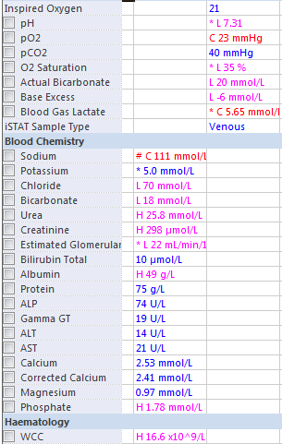

JOKE / QUOTE OF THE WEEK
Following on from the nec fasc case…
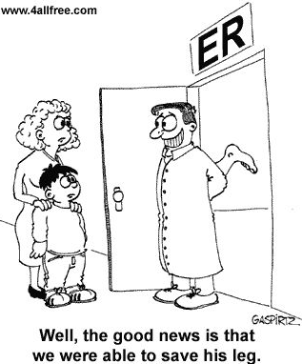

Please forward any funny and litigious quotes you may hear on the floor (happy to publish names if you want)

THE WEEK AHEAD
Tuesday 08:15-19:30 Medical Grand Rounds, Auditorium, Level 2
Thursday 12:00-13:30 JMO Education, Multi Purpose Function Room, level 4
Mental Health

