EMERGENCY MEDICINE Sutherland Hospital
The Weekly Probe
24th November 2017 Volume 14 Issue 33
Farewell and Thanks – Farewell to all the JMOs moving onto new rotations at the end of the term. Thanks for all your hard work during a very trying time of the year. Good luck also for your new term!

Farewell- special farewell to Will and Eilidh who return back to the pebbly beaches in sunny UK.
Thanks for your camaraderie and hard work during your time at Sutho. Keep in touch and all the best for the future from your Aussie ED family.

Welcome – welcome to all the new JMOs starting their term this week. Remember there is always someone to ask and there is no such thing as a stupid question (unless they are from me regarding eMeds) PS- please pass on any good jokes or any salacious quotes (especially if they relate to Esther).

Sample Mislabelling – In response to the significant number of mislabelled samplesthere are now checks to make sure the form and the sample correspond. Please sign the label and the form! 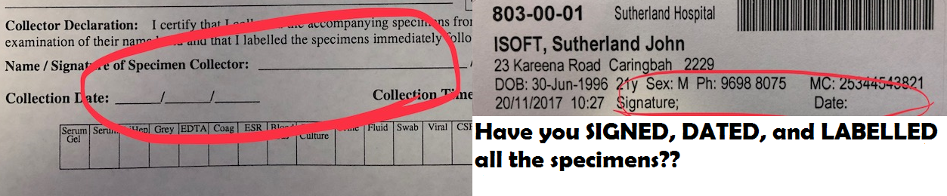

Surgical Review of Paeds Patients- A reminder on the business rule for the surgical review of patients > and < 12 years old.
Children 12 years of age or under who require a surgical review or an operation may need to be transferred to Sydney Children’s Hospital. Indications may include but not confined to appendicitis, abdominal pain for investigations, biliary disease, bowel obstruction (volvulus, malrotation), ischaemic bowel, pyloric stenosis or intussusception.
Those over 12 years of age should be discussed with the general surgeon on call at Sutherland who may accept the patient or refer to a Paediatric surgeon/hospital.

THIS WEEK
Last week’s case – Hyponatraemia
Joke / Quote of the Week
The Week Ahead

LAST WEEK’S CASE – Hyponatraemia
We see patients in the ED on more days than not with hyponatreaemia. It is a very common problem yet most cases are mild and asymptomatic. However occasionally they can be more extreme in numbers and presentation. We looked at this early last year yet it is worth looking at again. Once again we’ll refer to “Clinical practice guideline on the diagnosis and treatment of hyponatraemia” (see refs and link to the full text below).
Consider 3 cases
- 60yo Cambodian lady with a hx of HT’n on indapamide and telmisartan walks into the ED with her relatives after collapse at home proceeded by 1 week of lethargy. O/E Vitals N – clinically dry (mucosa dry yet skin N) – orientated person, place and time (Month, year only) – chest / abdo NAD – no focal neuro signs
Bloods show (no kidding):
- Na 98 K 2.4 Cl < 60 Bicarb 28 Urea 2.9 Cr 39 L 8.6
Normal LFT (alb 43) calcium / Mg -normal PO4 0.6 ( 0.8-1.5)
Haem results – non-contributory - CT head and CXR normal
Urine Na 45 Urine osm 433 TSH normal Cortisol normal

- 39yo man with a Hx of cystic fibrosis and diabetes presented after his second seizure (last 12 years ago related to hypoglycaemia). He works in an enclosed excavator (it’s a hot Feb!) – he went home the day before with leg cramps, unwell during the night with vomiting X2-3 yet then walked to GP surgery where he had a brief TC seizure. On exam BP 95/50 BSL 16.3– afebrile – clinically dry – agitated – GCS 10 (E4 V1 M5) – no focal abN- clonus in legs
Normal saline commenced while awaiting bloods. Initial bloods pre-saline are below
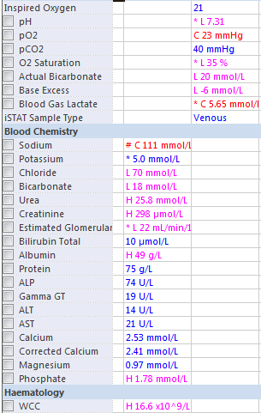
- 33yo previously well lady on no meds who is 1 week post-partum (NVD- no significant blood loss) presents with lethargy, headaches (onset at delivery – never before – no positional or diurnal variation), and difficulty with production of breast milk. No other neuro symptoms O/E NAD – clinically euvolaemic
Na 113 K 4.5 Cl76 Bicarb 20 WCC 14 osm 238 – CT head N – urine N1 155 urine osm 555

What is your approach to assessment and management?

Pathophysiology

Hyponatraemia < 135mmol/L
The total body water is 60% of lean body weight. 60% is in the ICF and 40 % in the ECF..
Generally, sodium reflects water balance.
- Osmoregulation is controlled by ADH (vasopressin) - this determines urine osmolarity (and stimulates thirst) while
- volume regulation is controlled by sodium excretion via aldosterone, angiotensin and ANP.
Hyponatremia, in most cases, is a disorder of water balance with impairment of free water excretion by the kidney and subsequent retention of water in excess of body solutes.
Vasopressin activity is key in the development of hypoNa

Total osmololality – concentration of all solutes in a given weight of water – regardless of whether they can move across a membrane (2X Na + urea + glucose+K)- normally 280-300 - note urea and alcohols are permeable and contribute to the total osmolality yet not produce hypoNa
Effective osm- number of osmmoles that contribute to water movement and as a result create an osmotic gradient – function of solute permeability (2XNa + glucose + K) - never higher than measured or total osmolalility

Most cases of hypoNa reflect low effective osmolality
However can occur with isotonic or hypertonic serum if it contains additional osmoles eg glucose or mannitol

Classification
There are a number of ways to classify these patients- all have their limitations:
- Biochem level – Mild 130-135 / mod 125-130 / severe < 125
- Duration < or > 48 hrs – relates to cerebral adaption
- Symptoms- see symptoms below – however you may see acute on chronic symptoms, symptoms can evolve over hours and many symptoms are non-specific
- Serum osmololality – the European guideline’s first step is to confirm whether that it is hypotonic hypoNa. Measured osm < 280 always = hypotonic as effective can never be > measured osmololality. However if calculated osmolality is <275 mOsm/kg, hyponatraemia can be hypotonic, isotonic or hypertonic, depending on which osmotically active agents are present and whether or not they are incorporated in the formula
- Volume status – this is the approach most clinicians use yet this can be difficult at time? extracellular fluid ? intravascular – low specificity and sensitivity of clinical assessment – there may be combined causes

Volume status - Clinically divide into pseudo, HYPERvolaemic, HYPOvolaemic and EUvolaemic (yet can have mix of aetiologies).

A) PSEUDOHYPONATRAEMIA- lab arterfact- dilutional hypoNa will not result in cerebral oedema
1) Hyperglycaemia – a form of hyperosmolar hyponatreamia- a significant rise in BSL results in a reduction in measured sodium levels eg non-ketotic hyperosmolar states. Some add a ¼-1/3 of the level
If you want formulas Corrected Na = measured Na + 2.4 x( (glucose - 5.5)/ 5.5)
Eg lab Na of 135 and BSL 45 corrects to 135 + 2.4 X (45-5.5)/5.5) = 152
- works out to be ie between 1/3 and 1/4
2) Hyperlipidaemia
3) Hyperproteinaemia (eg myeloma)
4) Other hyperosmolar agents eg mannitol – also seen post op after TURPs dependent on type and amount of irrigant used
5) Wrong site sampled – hypotonic IV solution simultaneously administered distal to the site sampled – sounds strange yet not uncommon

B) REAL HYPONATRAEMIA
If not pseudo and plasma Osm <280mOsm/kg
Determine the functional ECF volume and urine sodium concentration and urine osmolality.

As a guide you can classify the causes as per the grouping below yet often there is a mixed cause eg CCF with overloaded clinically + on diuretics – in these causes you need to prioritise the most significant of pathologies and how to treat - then watch response eg fluid restrict, add ACE and decrease diuretic depending on the specific case

1) Decreased extra-cellular fluid (ECF) (HYPOVOL)
-Extrarenal losses (Urine Na <10mmol/L)
Sweating, vomiting, diarrhoea
Third space sequestration (burns, peritonitis, pancreatitis)
Severe metabolic alkalosis with vomiting may be associated with increased urinary Na losses.
-Renal losses (Urine Na >20mmol/L)
Thiazide diuretics – also increase release and responsiveness to vasopressin
Loop (less marked problems c/w thiazides) or osmotic diuretics
Aldosterone deficiency (Addisons)
Ketonuria
Salt losing nephropathies (polycystic kidneys, interstitial nephritis, post obstruction etc); renal tubular acidosis (produces metabolic acidosis)
Metabolic alkalosis with hypokalaemia

2) Increased ECF (HYPERVOL)
Urine Na >20mmol/L
Renal failure
Urine Na <20mmol/L (“failures”)
Cirrhosis (“liver failure”)
Cardiac failure
Renal failure
Inappropriate intravenous fluids
NSAID therapy
Pregnancy

3) Normal ECF (EUVOL)
SIADH
Sickle cell or reset osmostat syndrome (can occur in elderly or in pregnant pts – they regulate their serum osmolality around a reduced set point; yet in contrast to patients with SIADH, they are able to dilute their urine in response to a water load to keep the serum osmolality around the preset low point.)
Stress or pain
Hypothyroidism, Addisons, Sheehans syn
Excessive water intake (primary polydipsia, dilute infant formula, multiple tap water enemas) – note drugs like ecstasy are associated with increased oral intake + increased ADH secretion
Decreased intake of solutes

SIADH (defined as secretion of ADH in the absence of appropriate physiological stimulus in the euvolaemic patient with normal cardiac, endocrine, renal function and normal acid base status who has no other cause.)

- Hypotonicity and hyponatraemia (<280mOsm/kg)
- Inappropriately conc. urine (U osm >100mOsm/kg)
- No evidence of hypo or hypervolaemia
- Urine sodium conc. variable – often high but note that the urinary sodium will be determined by intake as ADH only changes the water reabsorbed- usually > 30mOsm
- Normal renal, cardiac, hepatic, thyroid, and adrenal function.
- Correctable by water restriction and treatment of cause
(other supplemental criteria include – low uric acid(<0.24), low urea < 3.6, failure to correct after saline infusion, correction through fluid restriction

Causes (esp Head, chest, drugs)
CNS
Trauma, tumour, infections, SAH, DTs Gullian Barre, acute porphyria (note with cerebral salt wasting there is a natruresis –results in high urine Na, low BP/postural drop, normal-high serum urea)
Neoplasia
Lung, lymphoma, thymoma, pancreas, Ewings, prostate, Resp
TB, pneumonia, empyema, abscesses, CF, IPPV, CAL
Drugs
Narcotics, NSAIDS, thiazides, chemo, phenothiazines, tricyclic antidepressants, carbamazepine, clofibrate.
Endocrine
Hypothyroidism, decreased glucocorticoids
Misc
Pain, idiopathic, ACUTE PSYCHOSIS (central aetiology rather than renal)

Thus you need to look at
- Historical features esp renal, liver and cardiac disease and drugs.
- Look at clinical exam ? dry, overloaded ? neither
- Urine osmolality – used to assess vasopressin activity – in cases due to water excess vasopressin activity is reduced resulting in a maximally dilute urine with urine osm < 100mOsm/kg – in cases of non-suppressed vasopressin activity, urine osm usually > serum osm. Between these uncertain
- Urine sodium can be a useful tool in the assessment of hyponatraemia. - Urine sodium <20mmol/l suggests volume depletion (including reduced effective circulating arterial volume such as CCF or liver disease, >20mmol/l occurs with euvolaemia or hypervolaemia. However note that this is unreliable however with diuretics, osmotic loads or severe metabolic alkalosis.
- Urine potassium may help - will be less than 30 mEq/L in hyponatremia due to extrarenal loss and greater than 30 mEq/L due to renal loss in oedematous states and diuretic use
- Symptoms range from nausea and malaise, with mild reduction in the Na, to lethargy, anorexia, confusion, gait disturbances, decreased LOC, headache, incontinence, delirium and (if severe) cardioresp distress, seizures and coma. Neurologic symptoms most often are due to very low serum Na levels (usually <115 mEq/L), resulting in intracerebral osmotic fluid shifts and cerebral oedema. This neurologic symptom complex can lead to tentorial herniation with subsequent brain stem compression and respiratory arrest, resulting in death in the most severe cases.
- Note that the severity of neurologic symptoms correlates well with both the rapidity and the severity of the drop in the serum Na. A gradual drop of the serum sodium, even to very low levels, may be tolerated well if it occurs over several days to weeks because of neuronal adaptation. In an attempt to limit neuronal swelling, the brain reduces the number of osmotically active substances within its cells (esp K and organic solutes) –this takes 24-48 hours. The presence of an underlying neurologic disease, like a seizure disorder, or non-neurologic metabolic abnormalities, like hypoxia, hypercapnia, or acidosis, also affects the severity of neurologic symptoms

Tying all this together Spasovski’s group suggests the below algorithm
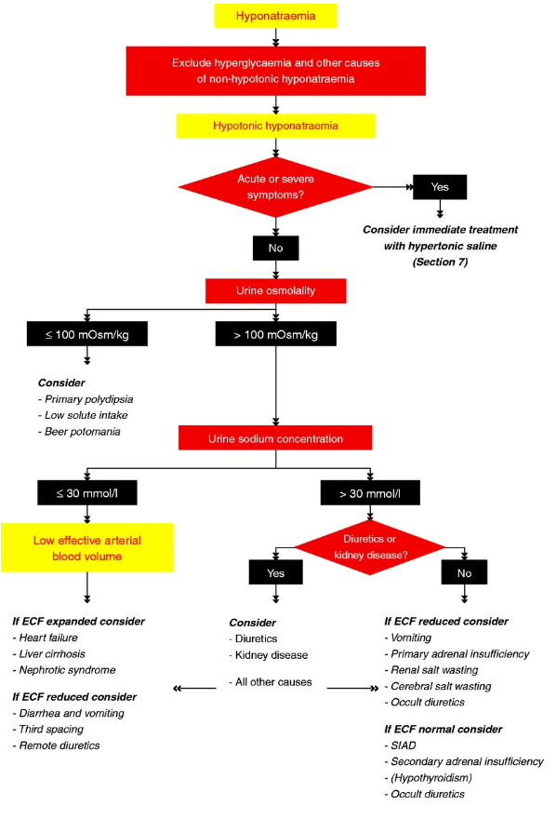

MANAGEMENT - Management of hyponatraemia depends on the type, severity and duration of hyponatraemia. Our current understanding is that there is poor CNS adaptation to an alteration in serum osmolality. In the setting of an acute drop in the serum osmolality, neuronal cell swelling occurs due to the water shift from the extracellular space to the intracellular space. Therefore, correction of hyponatremia should take into account the limited capacity of this adaptation mechanism to respond to acute alteration in the serum tonicity because the degree of the brain oedema and consequent neurologic symptoms depend largely on the rate and duration of hypotonicity as much as its magnitude.

Treat seizures with benzos - initially

Manage conservatively unless the patient is symptomatic.

Correct hypokalaemia.

If the patient is haemodynamically unstable then restore this volume. This will change the sodium levels. (However one secondary consideration is that excessively rapid replacement may suppress vasopressin secretion, resulting in a dilute urine and a rapid increase in sodium levels).

If the patient is hypervolaemic, correct the underlying disorder +/- fluid restriction and diuretics may be required.
If euvolaemic, fluid restrict. Pharmacological agents such as demeclocycline can be used in some cases of more refractory SIADH.

Treating patients with overtly symptomatic hyponatremia in whom rapid correction of the hyponatremia is warranted is more challenging because it carries a significant risk of inducing neurologic damage and the guidelines for treatment are not uniformly agreed on- therefore d/w the renal physician on call.

Acute hyponatraemia (duration <48 h) can be safely corrected more quickly than chronic hyponatraemia. A symptomatic patient with acute hyponatraemia is more in danger from cerebral oedema. This mandates rapid correction.

In contrast, a symptomatic patient with chronic hyponatraemia is more at risk from rapid correction of hyponatraemia. As mentioned earlier the brain adapts to this chronic hyponatraemia in an attempt to limits neuronal swelling, the brain reduces the number of osmotically active substances within its cells (esp K and organic solutes). Correction of serum sodium that is too rapid can precipitate osmotic demyelination with effects on the pons (central pontine myelinosis) yet it can also involve the mid brain, thalamus, basal nuclei, and cerebellum with resultant spastic quadriparesis, swallowing dysfunction, pseudobulbar palsy, and mutism.

In chronic severe symptomatic hyponatraemia, GO SLOWLY & CAREFULLY - the rate of correction should not exceed 0.5-1 mEq/L/h, with a total increase not to exceed 10-12 mEq/L/d. It is necessary to correct the hyponatraemia to a safe range (usually to no greater than 120 mEq/L) rather than a normal value. Repeat bloods frequently with close clinical observation. Spontaneous diuresis secondary to ADH suppression with intravascular volume repletion could lead to unnoticed overcorrection.

This correction is usually best achieved with hypertonic (3%) saline. Note that normal saline can exacerbate hyponatremia in patients with SIADH, who may excrete the sodium and retain the water. 1L normal saline contains 154 mEq sodium chloride (NaCl) and 3% saline has 513 mEq NaCl. During therapy, closely monitor serum electrolytes (ie, every 2-4 h) to avoid overcorrection.

With patients who are acutely symptomatic (duration <48 h, such as after surgery), the treatment goal is to increase the serum sodium level by approximately 1-2 mEq/L/h for 3-4 hours until the neurologic symptoms subside or until plasma Na is over 120 mEq/L .

How much 3% saline?

Two ways to calculate the volume required

- First work out the Sodium Requirement (mEq) = TBW X (Desired Na - Serum Na)
where TBW = Body Weight X 0.6
Then the Volume of Hypertonic Saline = Na Requirement (mEq) X 1000 / Infusate Na Concentration (mEq/L)
For example in case 2 - 75-kg man with serum sodium level of 111 mEq/L in whom you want to increase the Na by 4 mmol/l over 2hrs needs 75 X 0.6 (4) = 180 mmol of Na. As each L of 3% has 513 mmol you need to give 350 mL of 3% over 2 hrs (144 / 513 X 1000) As a guide give until resolution of seizures or herniation. (see how this compares with the treatment given at the time)

If you can’t remember this – give 100ml over an hour and then reassess clinically and biochemically The European guideline suggests for severe symptoms this can be increased to 150ml over 20 min with an aim to increase the Na by 5mmol/L. Repeat if necessary
- If improvement after this 5mmol/L rise- aim for 10mmol/L increase over 24 hrs or until Na reaches 130 .
- If no improvement after the 5mmol/L rise then use 3% saline aiming for rise of 1mmol/hr till symptoms improve, 10mmol/L increase or reaches 130mmol/L. Look for other causes of the symptoms

If the hyponatreaemia is corrected too fast, they recommend seeking expert advice- 10ml/kg glucose over 1 hour with strict monitoring of fluid balance.

Cerebral pontine myelinosis: over correction or overly rapid correction of sodium may predispose to the development especially in those with chronic (> 48 hrs hypoNa). Risk factors for the development of CPM include -alcoholism, malnutrition, pre existing CNS disease, use of thiazides, female sex, menstruating women and liver disease.

Other Ix –
- CT head – when altered mental status when the diagnosis of hyponatremia is not established, in severe hyponatremia unresponsive to therapy, and to rule out intracerebral mass in patients with SIADH.
- In patients with hyponatremia, chest x-ray is indicated if wheezes or tachypnoea is present. Chest x-ray is useful to rule out pulmonary TB, CCF, abscess, or tumour in appropriate clinical setting.
- Look for other causes of pseudohyponatraemia – lipids, protein (eg myeloma)

Progress of the cases?
- Looking at the classification we can see that her symptoms were mild, her duration probably chronic, she was clinically dry (presumably from her diuretics – high urine Na) yet biochemically noted to have severe hyponatraemia.
“Don’t stand there and do something” – go slow. She was given 0.9% saline as gentle rehydration and diuretics ceased with potassium supplementation.

- Cystic fibrosis predisposes to increase salt losses in sweat – based on history and exam we’d classify this case as acute (< 24 hrs ), hypovolaemic hypoNa – he was given resus fluids with 1L normal saline (on arrival Na 111, Urea 25.8 Cr 295 (previously normal) ) - repeat Na 116 (post 1L) – GCS still 10 (mute) ? post ictal ? related to Na – 100ml hypertonic saline given (1 hr) - Na 118 & GCS 10 (2 hrs) – Further 50ml hypertonic Na given – Na 120 (4 hrs post arrival) – GCS unchanged at 10 - renal consulted “not for further hypertonic – happy with Na 120-125”-–patient requiring transfer, and as agitated, ETT requested – not surprisingly labile BPs post ETT necessitated further IV fluids - Na 126 (8hrs) (by this time 2L saline + 150ml hypertonic = 375mmol Na total) on departure then 130 on arrival (10 hrs) –this was thought to be an excessively rapid rise in Na levels – given 5% dextrose- Na 127 (17 hrs) then 128 (20 hrs) – extubated and discharged day 5
Lessons learnt / questions raised – 1) it is difficult to limit the rise in Na - 2) teams will often err on the side of gradual reduction in Na even in the context an acute pathology and ongoing symptoms - 3) how long does it take for cerebral oedema to resolve particularly in the context of guidelines which suggest repeat doses of hypertonic saline if there is “no improvement”? – the main point in this patient was that although he didn’t improve, he did not deteriorate nor have a further seizure/ signs of herniation.

- Clinically this patient was euvolaemic and fitted the criteria for SIADH (all above criteria including low urea and uric acid) yet in the context of her headache and recent delivery there were concerns regarding pituitary problems particularly Sheehan’s syndrome (ischaemia of the anterior pituitary due to excessive blood loss). However her ACTH / cortisols, TSH, prolactin and CT + MRI were all normal. With fluid restriction her Na improved with d/c day 6

Refs: Spasovski G et al Clinical practice guideline on the diagnosis and treatment of hyponatraemia European J Endocrinology 2014; 170: G1-47 http://www.eje-online.org/content/170/3/G1.full / up to date

JOKE / QUOTE OF THE WEEK
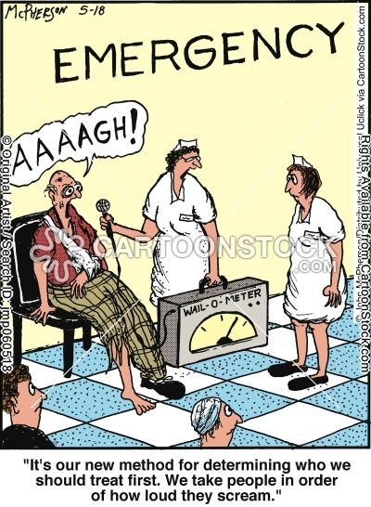

Please forward any funny and litigious quotes you may hear on the floor (happy to publish names if you want)

THE WEEK AHEAD

Tuesdays - 08:15-09:30 Medical Grand Rounds Auditorium, Level 2
Thursday 30th November JMO Education – Urology, Dr Joan Walsh
Auditorium, Level 2

