Investigation of the week 3rd May

78 year old man with multiple co-morbidities presents with lethargy and vomiting. His ECG is shown below.

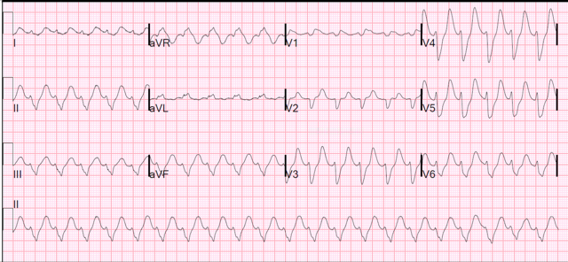

1. What are the abnormalities on the ECG.
2. What is the most likely cause of this?
3. Give 2 other differential diagnoses. What other features on the ECG make them NOT the likely cause of the ECG abnormalities?
4. Complete the table below for treatment options.

|  |  |  |  |
| --- | --- | --- | --- |
| Agents | Mechanism of action | Dose and route | Onset of action |
|  |  |  |  |
|  |  |  |  |
|  |  |  |  |
|  |  |  |  |
|  |  |  |  |
|  |  |  |  |