**TSH ED Teaching: Investigation of the Week for 28/3/18**

A 43 yo motorcyclist presents to your tertiary trauma centre after being hit by a car at 60 km/h. He has an isolated right leg injury and generalised abrasions. The injury is closed but the knee is obviously deformed.

He received 180mg of ketamine and 20mg of morphine en route to ED. He is still is pain.

These are his XRays:

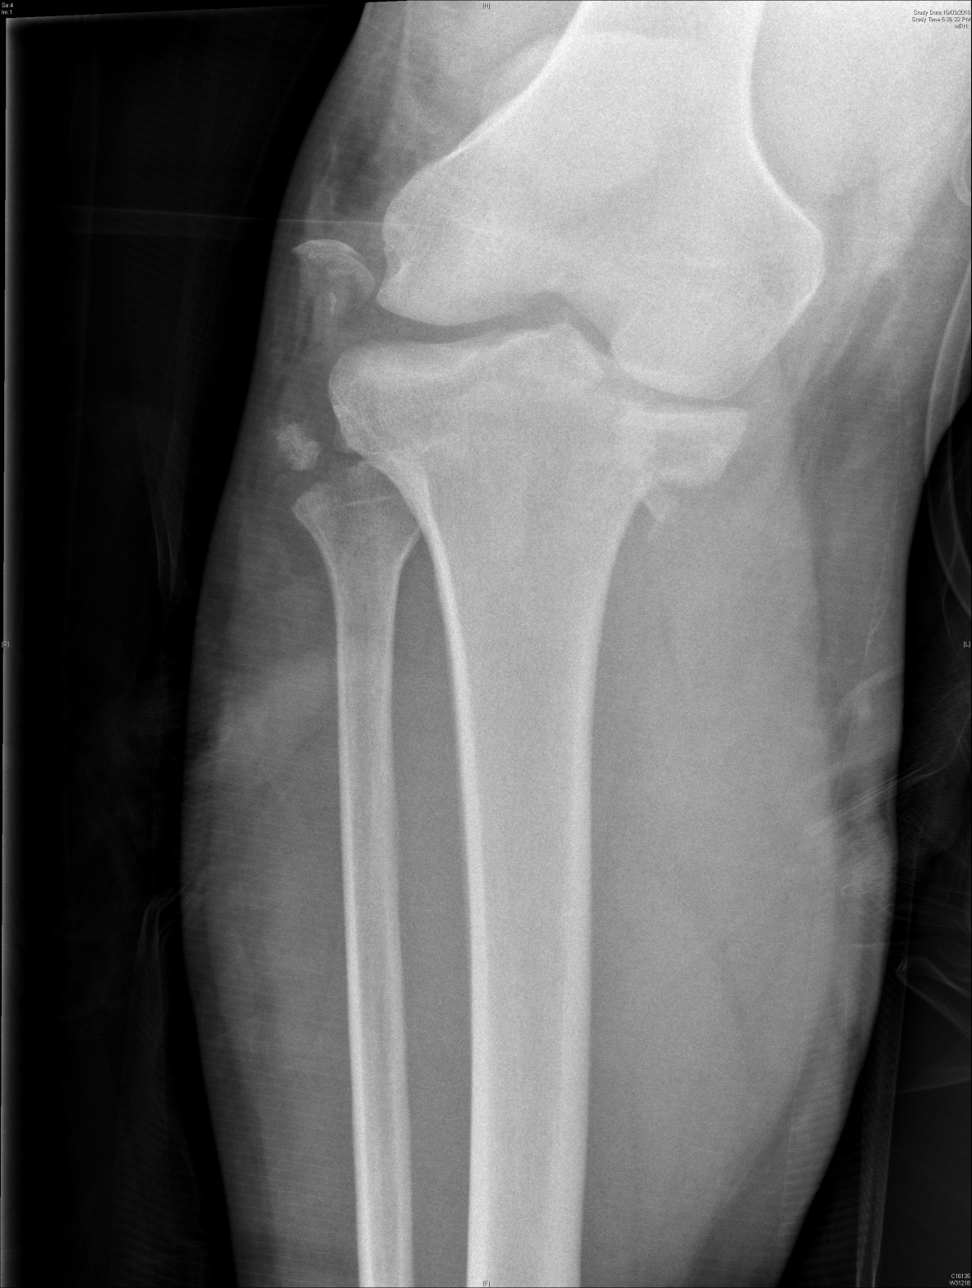

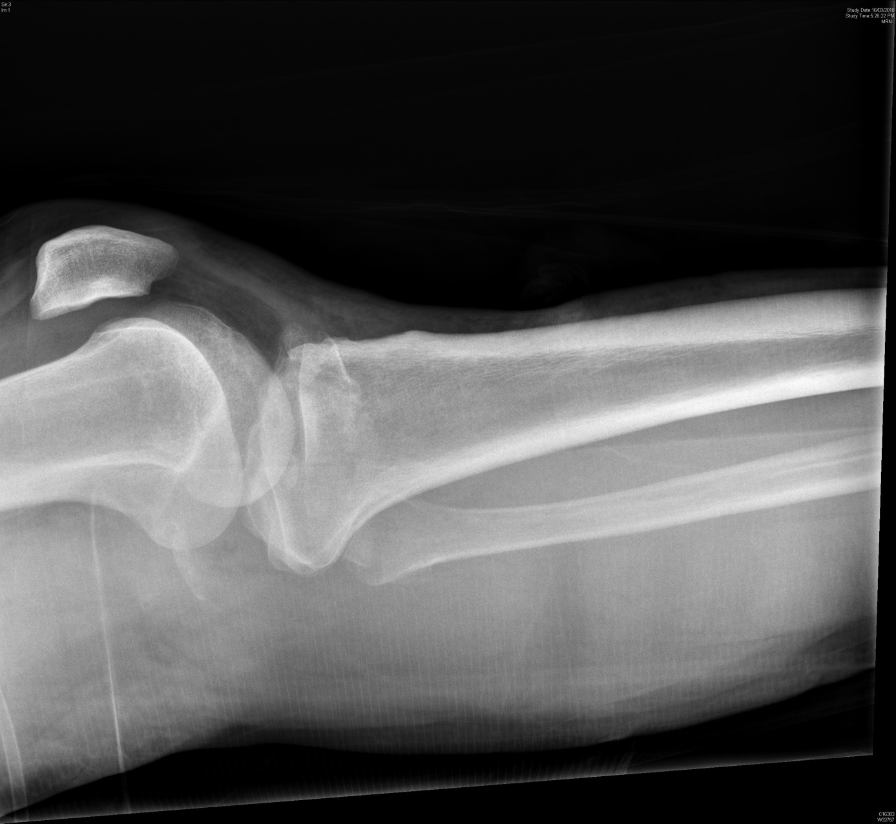

**Describe the above X-rays. (3 marks)**

**Complete the classification table for this type of injury: (3marks)**

|  |  |
| --- | --- |
| ____________ (name) Classification | |
| Type I |  |
| Type II |  |
| Type III |  |
| Type IV |  |
| Type V |  |
| Type VI |  |

**List 3 complications you would look for on clinical assessment. (3 marks)**

**List 5 management priorities for this patient. (5 marks)**

**Despite further ketamine and morphine boluses he is still in pain. Outline your approach to this. (2 marks)**