CR

**Registration: Full 4 day**

* Registrars/residents **$2200 GST included**
* Specialists : **$3300 GST included**

Registration details to:

Email: [susan.roncal@health.nsw.gov.au](mailto:susan.roncal@health.nsw.gov.au)

**IMPORTANT: Please email Sue Roncal (course coordinator) if your application has been successful. You will then be instructed to pay by DIRECT DEBIT to:**

Critical Care Sonography PTY LTD

BSB number: 012606

Account number 458258185

**A proof of payment is to be emailed to the course coordinator. She will then send an email to confirm your spot in the course.**

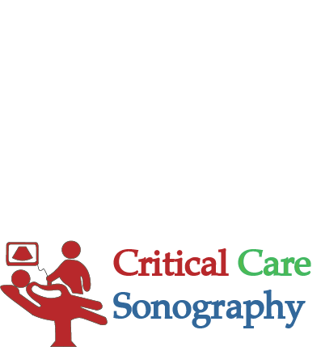

**1st-4th November 2018**

**Program includes:**

* Accredited course by ACEM and ASUM for AAA, EFAST, Biliary, DVT, Early Pregnancy, Lung, Vascular Access, ECHO and renal ultrasound
* Use of ultrasound in shock scenarios
* Maximum of 3 participants for each station
* Access to full on line course material to be done prior to workshop, multiple choice questions and clinical cases.
* Worksheets to accompany e- learning

**CRITICAL CARE SONOGRAPHY  
POINT OF CARE 4 DAY ULTRASOUND WORKSHOP**

**Venue:**

**Sydney**

Royal Prince Alfred Hospital

Seminar rooms, Level 2, **Kerry Packer Building**, Missenden Rd., Camperdown NSW 2050

