TSH ED CEME 11/4/18

Investigation of the week:

44 year old man BIBA last night vomited x2 and had diarrhoea all day.

1. What abnormalities do you see on this transverse view of abdo CT?

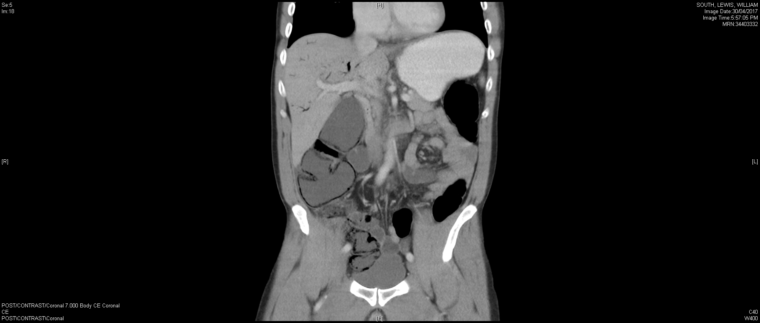

1. What are the risk factors for this condition?
2. Outline your management
3. What are the complications?