**Investigation of the Week – 23 May 2018**

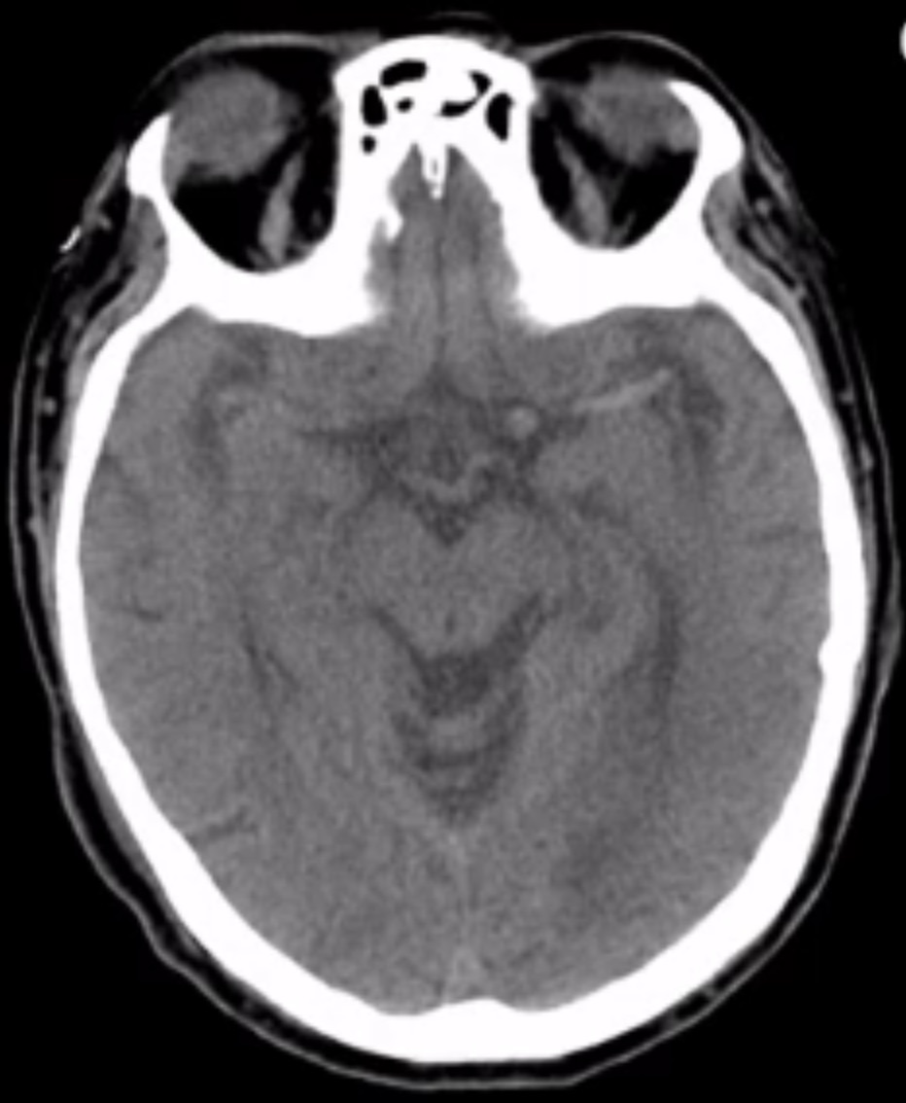

1. What is the most significant finding on this non-contrast brain CT?
2. What does this finding indicate?
3. What findings would you expect to see on physical examination?
4. What are 2 treatment options?