You receive this ECG via PAPAS on Tuesday 9.30pm.

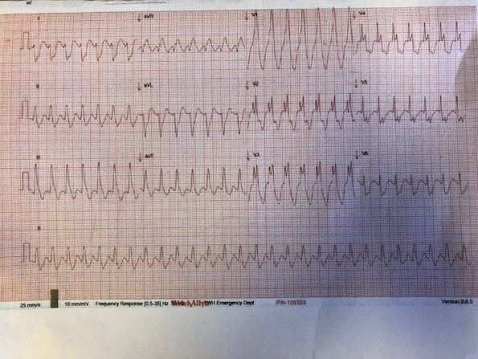

1. **Describe the ECG.**
2. **What are your DDx?**

**Scenario 1**

The paramedics is bringing this patient to ED as BAT call – 55 year old man who called the ambulance due to palpitations.

His vital signs

GCS 15

Bp 65/40 pale, diaphoretic

RR 25

Sats 95% RA

**List your management priorities.**

**Scenario 2**

The paramedics is bringing this patient to ED. On arrival, the patient is a 55 year old man who complained of palpitations. He told you he has a history of “abnormal heart tracing”. Apart from that, he is otherwise healthy.

His vital signs

GCS 15

Bp 130/70

RR 22

Sats97% RA

**What is your management plan?**

**How do you differentiate VT from SVT?**