TSH Registrar Teaching

Investigation of the Week: 1st August 2018

67 year old man presented with 2 hours of right sided loin pain. Past history of renal calculi and hypertension. On aspirin.

1. What are your differential diagnoses? List 4.
   1. _______________________________
   2. _______________________________
   3. _______________________________
   4. _______________________________
2. What abnormalities do you see on these coronal views of his CT abdomen?

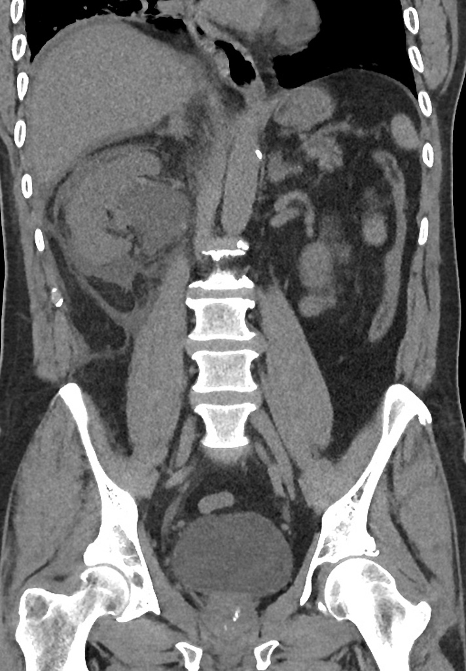

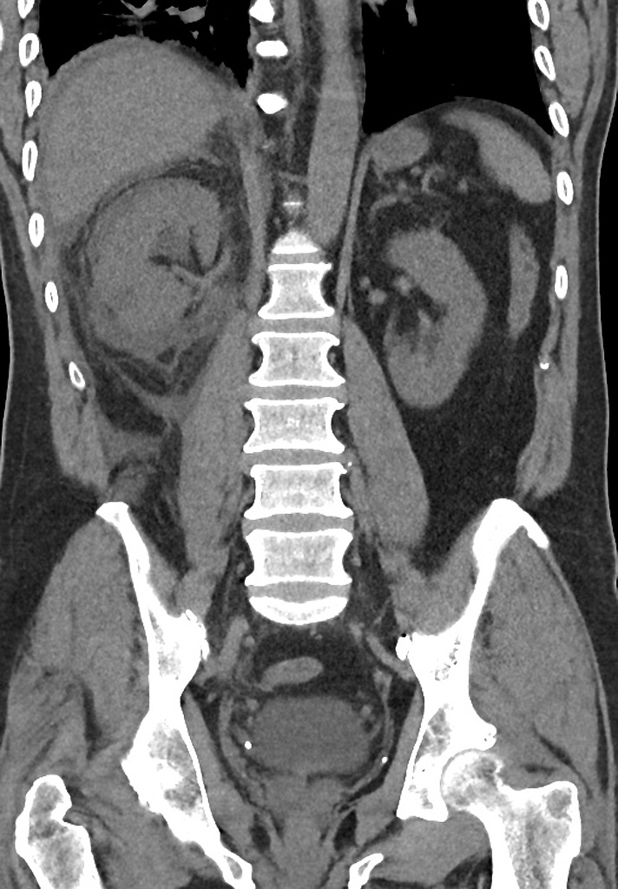

1. Outline your management in ED
2. What are the complications of this condition?
3. What is the disposition of the patient?