**Investigation of the week**

**1st May 2019**

39 Male presented after falling awkwardly in the surf:

He complains of right shoulder pain and XRs are obtained.

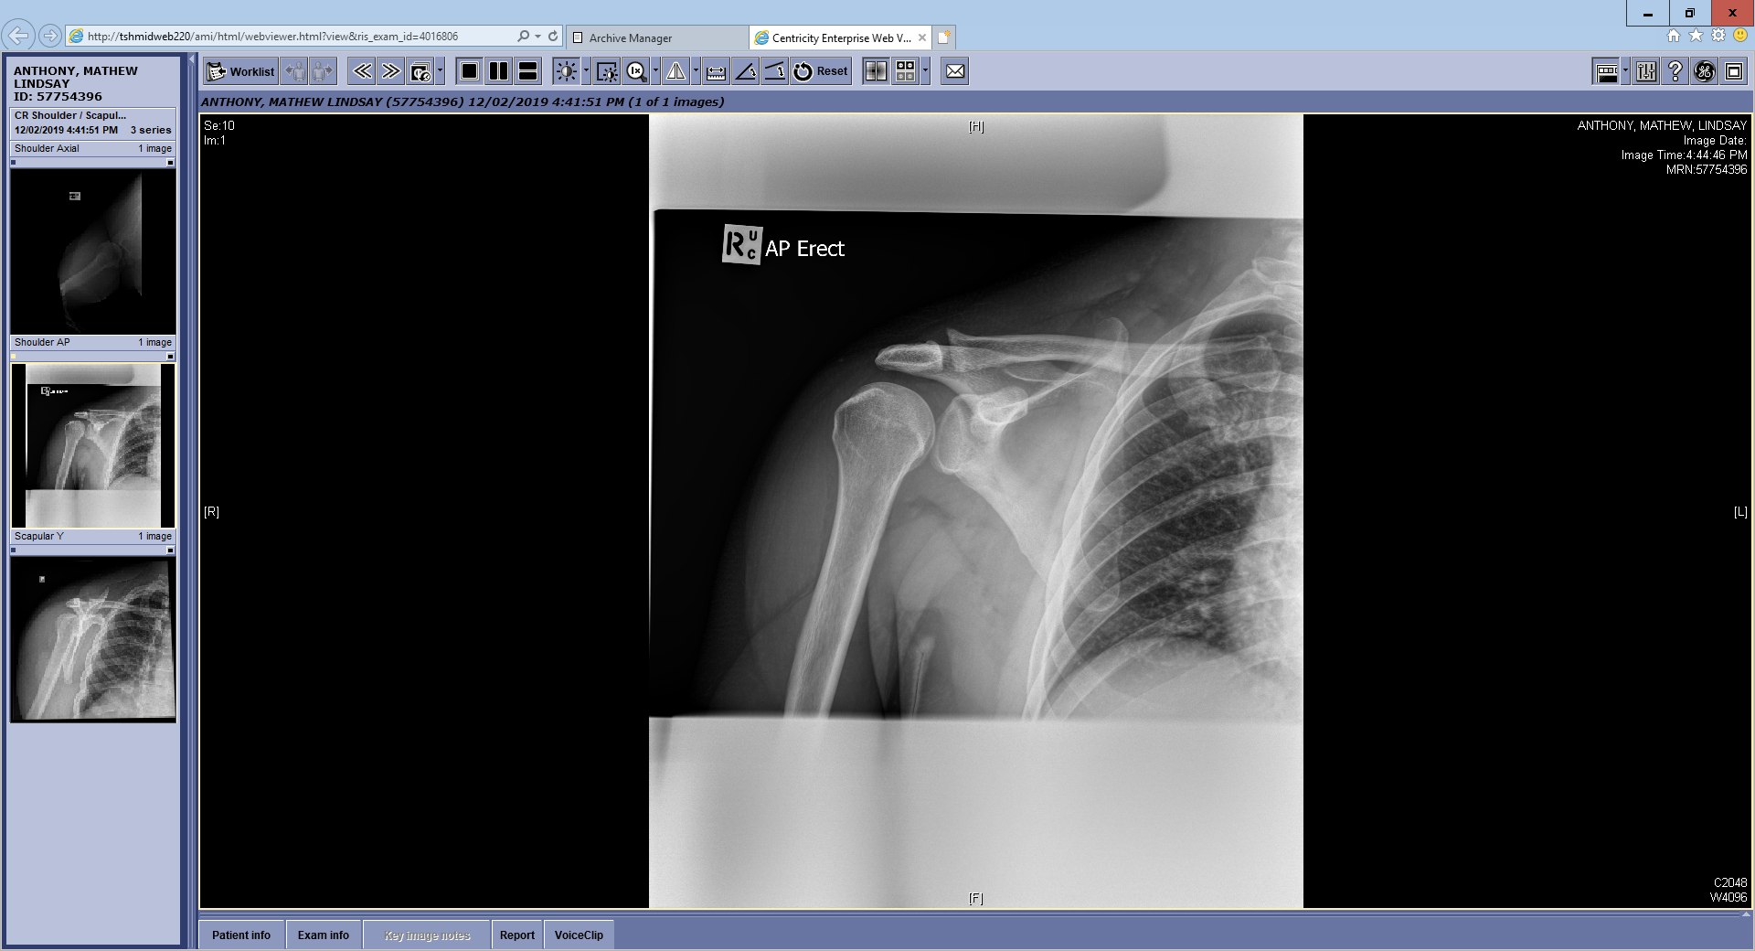

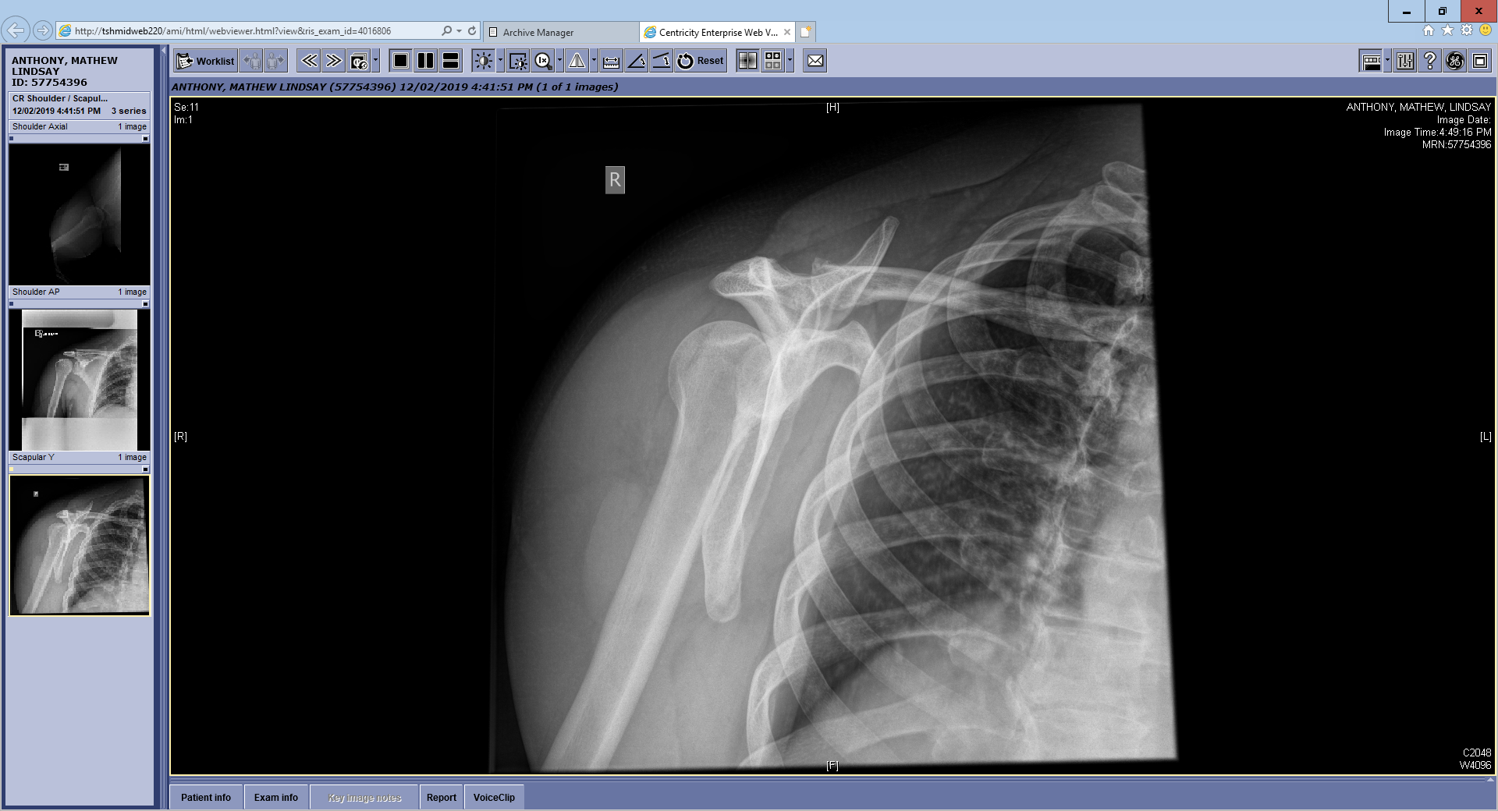

1. Describe the findings in this series of right shoulder XRs (include important negatives) (3)
2. What is the underlying diagnosis? (1)
3. After direct trauma what are the two most common causes for this injury? (2)
4. How would you manage this patient’s pain? (4 *different* options please)
5. Outline the steps you would take to definitively manage this patient’s condition? (3)