**IOW April 24**

**An 8 year old boy is brought into the emergency complaining of left elbow pain following a fall on an outstretched hand.**

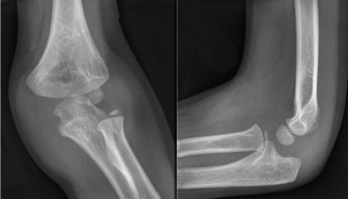

1. Describe 3 abnormalities seen (2 points)
2. What is the diagnosis? (1point)
3. What is the appropriate management? (2 point)