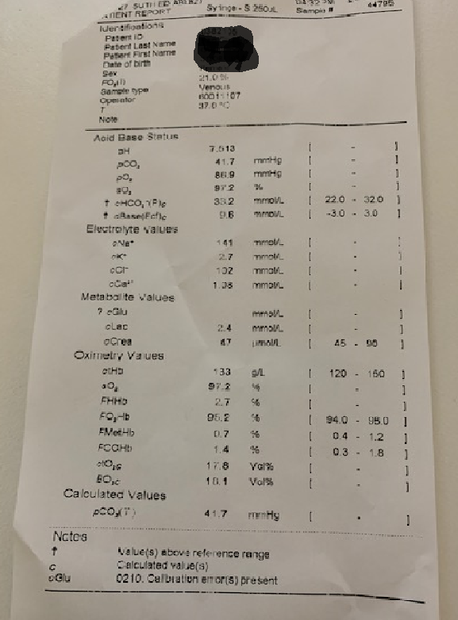

78 year old woman on multiple medications feels unwell.

HR 80

Bp 180/100

RR 20 Sats 97% RA

1. What are the abnormalities on VBG?
2. What are the causes of the abnormalities?
3. What do you need to find out on history in order to determine the cause?
4. What are the complications of the abnormalities on VBG?