Request for accommodation for COVID-19 related isolation
Clinical/PHU Staff Role:
- A patient may present to SESLHD with a request to access accommodation for COVID-19 related self-isolation. This is most likely to occur when interview of new cases by the public health nurse identifies a patient who is unable to be isolated from others in their current accommodation.
- Clarify current living arrangements (number of people within the residence, access to ensuite/separate bathroom, ability to remain separated from other residents by at least 1.5 metres).
- Advise the patient to arrange and book their own accommodation. SESLHD Accommodation Guide (Attachment A) can be provided to patients by public health nurses, NUMs, Fever/COVID-19 Clinics, outpatient departments and Emergency Departments. Any room booked must have an ensuite bathroom.
- Provide Information on appropriate COVID-19 self-isolation processes: https://www.health.nsw.gov.au/Infectious/factsheets/Pages/advice-for-confirmed.aspx
- Where possible, clearly document in eMR which accommodation the patient went to for self-isolation.
- If the person is unable to arrange their own accommodation, for example because of limited English; being overwhelmed by current situation; no phone/internet access; or limited financial capacity, advise the patient that referral will be made to the local social work department via hospital switch for additional support.
- Each facility has an identified Emergency Accommodation Social worker available during normal business hours. To contact the Emergency Accommodation Social Worker, please go via the hospital switchboard to page:
- Pager 44170 (POWH) | - Pager 061 (SGH)
- Pager 22330 (SSEH) | - Pager 431 (TSH)
- After hours, the role of the Emergency Accommodation social worker will be undertaken by the on-call social worker contactable through switchboard.

Social Work Role:
- Clarify the need to use an interpreter.
- Conduct a psychosocial assessment: financial, accommodation, family, supports, employment, and wellbeing.
- Confirm if patient is able to access funds to pay for accommodation, meal delivery service, groceries and sundries.
If able to fund own accommodation:
- Provide SESLHD Accommodation Guide (Attachment A) and explore with the patient the process of calling and clarifying accommodation needs with the accommodation provider.
- Recommend that taxi be used as preferred form of transport to accommodation (see Attachment C for transport guidelines). Patients to be provided with instructions on how to take infection control measures whilst using transport.
- Follow up with accommodation provider and confirm the booking. This is to ensure we have a record of any COVID-19 patients accessing accommodation in the community.
- Enter details into local COVID-19 Accommodation spreadsheet.
- Refer the accommodation provider to the NSW Health Fact Sheet – Advice for people suspected to have COVID-19 (Coronavirus) infection (Attachment B) available on the NSW Health website.
If unable to fund own accommodation:
- In exceptional circumstances, accommodation may be funded by SESLHD. This is dependent on a thorough financial assessment conducted by the social worker. Patients are not to be guaranteed free accommodation.
- Conduct a thorough financial assessment and identify what funds are available for the patient to access. If limited or no funds are available, consider accessing consular help through the patient’s home embassy (if relevant).
- Clarify if there are family and/or friends able to provide accommodation where self-isolation would be possible.
- If no family or friends are able to provide appropriate accommodation, the social worker will identify the local accommodation options from the SESLHD Accommodation Guide (Attachment A) closest to the hospital of presentation.
- Notify the Director Allied Health before proceeding with the booking.
- Contact the accommodation provider and book the accommodation. Billing details and method of payment will need to be confirmed.
- Ensure the appropriate information (with consent from the patient) is provided to accommodation provider to assist with recommended practices when guests are in self-isolation.
- Recommend that taxi be used a preferred form of transport to accommodation (see Attachment C for transport guidelines). Patients to be provided with instructions on how to take infection control measures whilst using transport.
- Follow up with accommodation provider and confirm the booking to ensure we have a record of any COVID-19 patients accessing accommodation in the community. Enter details into local COVID-19 Accommodation spreadsheet (include billing details when appropriate).

If all accommodation options from the SESLHD Accommodation Guide have been exhausted:
- Escalate the matter to the Director of Allied Health, Claire O’Connor, on 0412 911 199

Public Health Unit Role:
- Monitor and follow-up regarding patient with positive COVID-19 diagnosis in the community.

Director Allied Health Role:
- Review and approve requests for accommodation
- Escalate any issues identified to the Chief Executive.
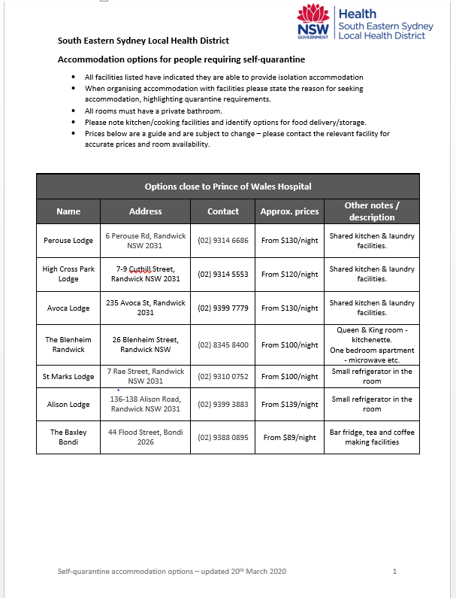
Attachment A: SESLHD Accommodation Guide
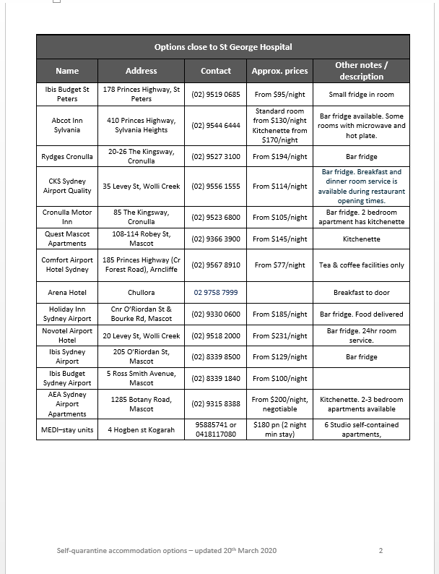

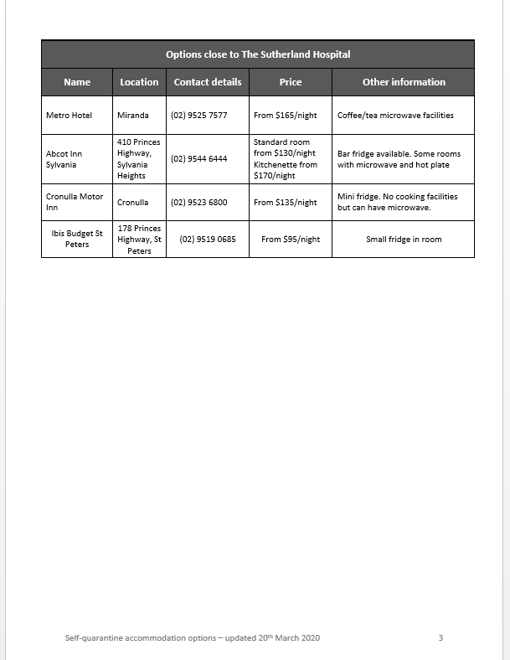

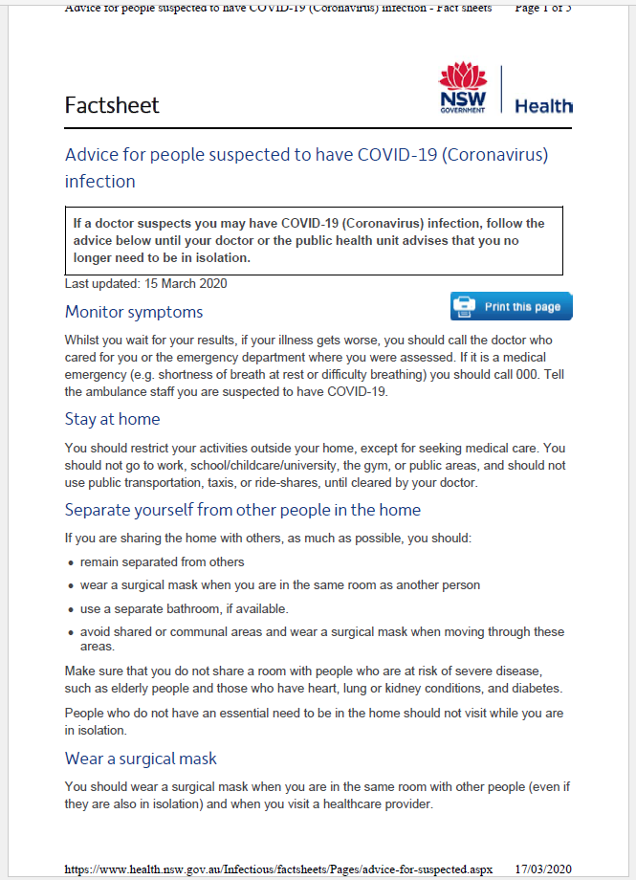
Attachment B: COVID-19 Information for hotels and hotel staff

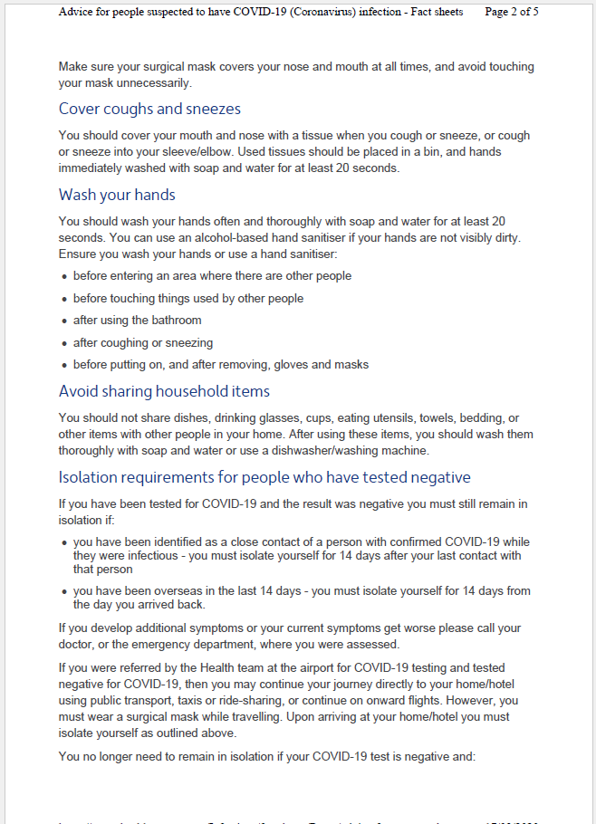
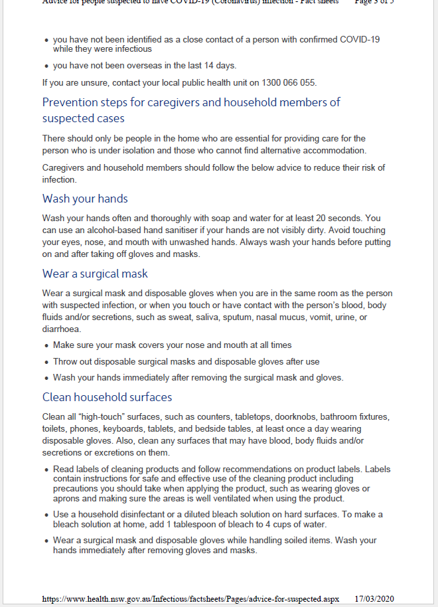
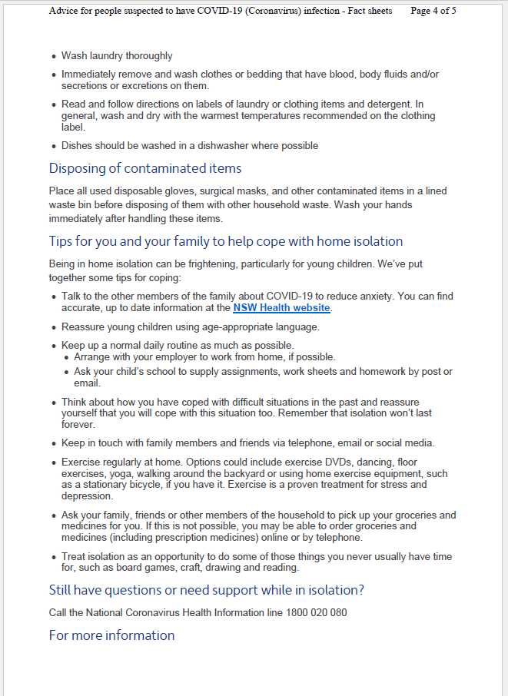
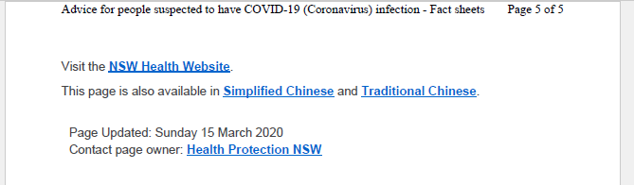
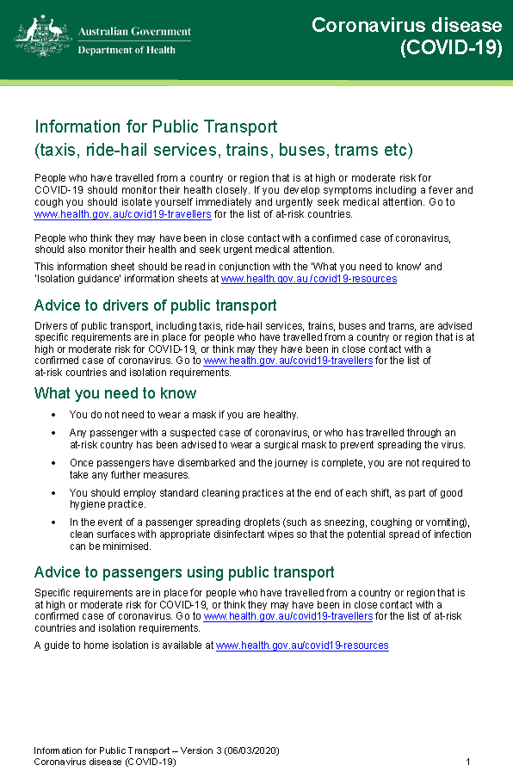
Attachment C: COVID-19 Information for Public Transport
