**Performance**

The GeneXpert Rapid COVID test is highly sensitive and specific test for the detection of SARS-CoV2 from nasopharyngeal swabs in liquid viral transportmedium, similar to the standard test platform. The laboratory testing time of one hour allows for rapid turn-around of results to support critical decision making. The result is uploaded directly to the patient’s eMR real-time, usually within 1 hour.

Recent increase in supply of reagent cartridges has improved access to this Rapid test.

**Drawbacks**

* the cost per test for the GeneXpert is higher
* limited by machine capacity and lab staff time
  + Although testing is available 24/7, between 2000h-0600h the laboratory is staffed by a single scientist responding to all urgent testing requests (including biochemistry).

We recommend the following:

* All COVID screening must be done in conjunction with an appropriate risk assessment incorporating clinical and epidemiological risk.
* GeneXpert rapid COVID testing should only be performed where the faster turnaround is likely to impact on clinical decisions and/or facilitate patient care.
* Screening for patients to be discharged into home isolation, to de-isolate close contacts, for planned transfer to RACF or other healthcare facility the next day should continue using standard testing via the Virology laboratory on the Randwick campus.

**Indications for Rapid test WITHOUT prior approval from Infectious Disease service.**

Emergency Department/COVID testing clinic

1. Patient assessed as WARM or HOT AND for (likely) admission to STG or TSH*
2. Code Crimson and Unknown patient requiring intubation where epidemiology and/or likelihood of infection cannot be determined.
3. Child assessed in ED as WARM or HOT AND likely to require admission to STG/TSH/SCH*
4. Patients from Residential Aged Care Facility (RACF) fit for discharge from ED AND swab result is required before return to RACF
5. NSW Health staff (HCW) identified by public health as a CLOSE contact AND who has worked since the time of their exposure.

*WARM or HOT per assessment of the senior ED clinician. ED have a demonstrated track record in appropriate rapid test ordering. If a team requests a test that the senior ED clinician feels is not indicated they may be directed to contact the infectious disease physician on call for rapid COVID swab approvals. Ordering inappropriate tests slows the turnaround for the tests that are truly necessary and delays transfer from ED.

* **Approvals under these conditions can be given by ICU, ED, Paediatric or Anaesthetic Department Staff Specialist/Consultant (or a Senior Registrar proxy after hours in ED/ICU) (ID clarification/adjudication available if required).**
* **The name of the approving senior clinician must be on the request form**.
* **All requests outside the above indications must be approved by an Infectious Diseases Consultant.**

We will continue to review these indications (and whether we can broaden them) regularly taking into account the requests we receive, community COVID case activity and evolving laboratory capacity.

**Collection media and sample delivery**

Samples for rapid tests MUST be in a specimen bag labelled as a rapid test and hand-delivered to pathology specimen reception and given to a staff member. There are now TWO acceptable sample collection media for rapid tests 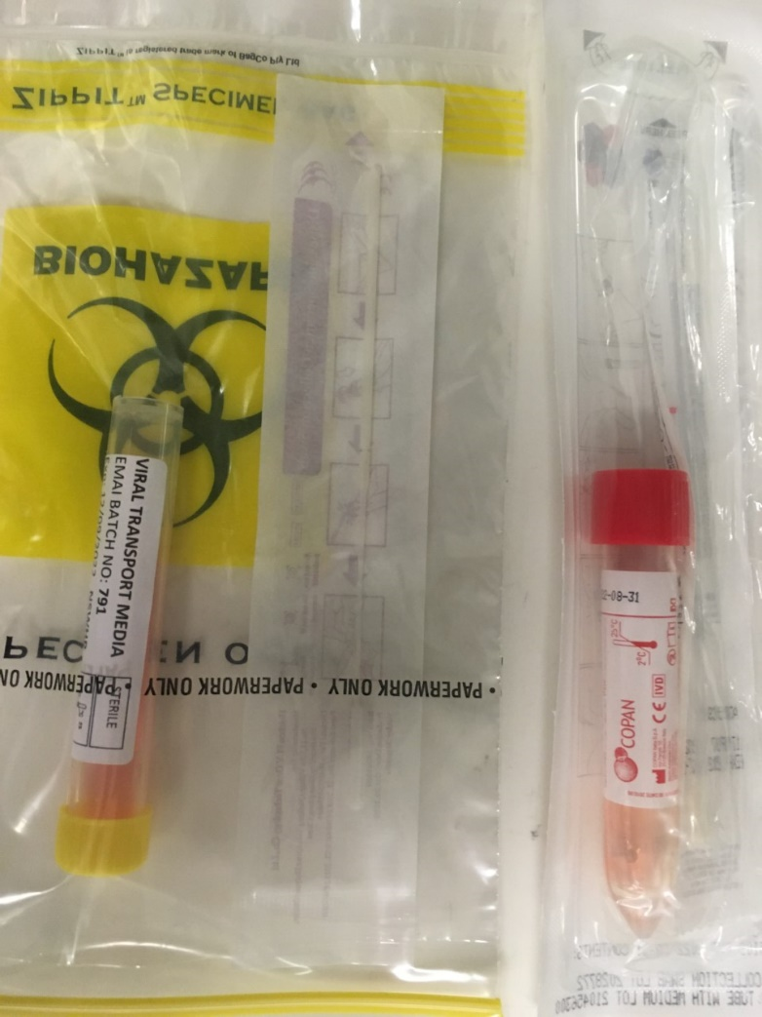

proprietary COPAN liquid transport media (top)

generic liquid media prepared for NSWHP (bottom)

**Results**

Result are automatically uploaded to EMR in real time

PLEASE DO NOT RING THE LABORATORY FOR RAPID TEST RESULTS. PHONE CALLS SLOW TEST TURNAROUND TIME FOR EVERYONE BY TAKING LAB STAFF AWAY FROM THE LABOUR-INTENSIVE TEST PROCESS