**Ultrasound Guided Peripheral Intravenous Catheter Insertion Module**

The Sutherland Hospital Emergency Department

Dr Erin Newman BMed MD CCPU DCH

March 2021

**Introduction**

Ultrasound Guided Peripheral intravenous Catheter (US-PIVC) insertion is a valuable skill in the Emergency Department. It can be useful in many patients who have difficult IVC (DIVC) placements. It can improve success rates for first time cannulation and improve patient satisfaction.

The skill requires background knowledge of ultrasound and cannulation. This module will outline the theory behind US PIVC insertion including indications, contraindications, ergonomics, vascular anatomy and the procedure itself.

After reading this module, complete the Post Module Quiz to confirm and solidify the theory behind US PIVC. Following this, attend a workshop to practice the technique on vascular phantoms. To be accredited in US-PIVC through Sutherland Hospital Emergency Department, you will need to complete a logbook of three supervised successful US PIVC placements.

Completing this structured accreditation process for US-PIVC will be invaluable in gaining expertise in the skill.

**Contents**

1. Indications for US guided PIVC
2. Contraindications for US Guided PIVC
3. Advantages for US Guided Cannulation
4. Disadvantages of US guided cannulas
5. Alternatives to US-PIVC
6. Informed Consent
7. How to use the Ultrasound / Orientation to US machine
8. Procedural Hygiene
9. Optimisation of the Ergonomics of the Patient and Proceduralist
10. Venous Anatomy
11. Differentiation of Arteries and Veins on Ultrasound
12. Appropriate Cannula Selection
13. Equipment
14. Techniques – The transverse and Longitudinal Approach
15. Procedure
16. Post Procedure Care
17. Complications
18. Accreditation for Ultrasound Guided Peripheral Intravenous Catheter Insertion
19. Logbook
20. Bibliography

**Indications for US Guided PIVC**

There are many situations where using and ultrasound to gain PIVC would be beneficial, including:

* No palpable or visible peripheral veins
* Unsuccessful placement of PIVC using standard techniques
* History of Intravenous Drug User suspected or known DIVC
* Multiple previous peripheral lines causing scarring and thrombosis
* Obesity
* Previous surgeries causing distortion of the anatomy
* Known DIVC

**Contraindications for US Guided PIVC**

These contraindications should sound familiar, as they are the same contraindications that apply to standard non-ultrasound guided PIVC.

**Absolute Contraindications**

* Ipsilateral arteriovenous fistula
* Overlying infection
* Acute burns or trauma overlying insertion site
* Ipsilateral lymph node dissection
* Phlebitis
* Thrombosis of vein

**Relative Contraindications**

* Non compliant patient

**Advantages for US Guided PIVC**

* Increase success rate of PIVC
* Decrease number of attempts necessary
* More ideal placement of IVC on forearm possible (i.e. avoiding cubital fossa).
* Decrease time to placement of PIVC
* Increase overall patient satisfaction

**Disadvantages of US guided PIVC**

* Training required for the procedure
* Knowledge of Ultrasound required to optimise image and procedure
* Premature failure of US-PIVC due to
  + Veins being cannulated that are too deep (i.e. > 1cm deep)
  + Standard cannulas used for deep veins when a longer cannula would be more optimal
  + The cannula is directed very acutely through the soft tissue and kinks on entering the vessel.
* Risk of contaminating the ultrasound probe with blood if probe cover not used

**Alternatives to US-PIVC**

Ultrasound guided PIVC may not be the most appropriate solution when a standard PIVC cannot be placed. Think about the different options and whether one of these would be appropriate in your clinical situation.

* Have you **optimised your chance of finding an appropriate vein** and cannulating it without ultrasound?
  + Ensure patients limb is below the level of the heart to minimise venous return to the heart.
  + Ensure tourniquet is placed and at an appropriate firmness to impede venous return.
  + Have a light above you.
  + Consider applying hot towel or glove filled with warm water to patients veins to vasodilate them.
  + Small tapping on the vein to make it dilate (beware too much force as the vein might spasm).
* **Oral route:** Do you really need the cannula? Could the patient have per oral fluids and medications?
* **Venepuncture:** If the patient only needs bloods and not a cannula, would it be more appropriate to perform venepuncture?
* **Intraosseous access**: If you are in a resus situation and access is required immediately, would an intraosseous be more ideal? Intraosseous needles can be placed in around 30 seconds and you can take bloods as well as give all medications and fluids through that route. It will allow you more time to find a suitable location for a US-PIVC if it is still necessary.
* **Central Venous Catheter**: does the patient need multiple infusions running simultaneously and a CVC might be more useful?

**Informed Consent**

* Verbal consent is required prior to placement of a US-PIVC.
* If the situation is a medical emergency and the patient is unable to consent then you can perform this procedure

**How to use the Ultrasound / Orientation to US machine**

Follow the below steps to find a vein with the ultrasound machine:

1. Turn on the Ultrasound machine
2. Select the linear probe: The linear probe has higher frequency, which means it has excellent visualisation of the superficial soft tissues that is ideal for US-PIVC.
3. Preset: choose the vascular preset (it will optimise your image)
4. Perform a scout scan to find an ideal vein. A scout scan involves sliding the probe proximally and distally on the arm to locate the most ideal vein. An ideal vein to cannulate under ultrasound will be patent, straight, be wide enough (at least 3mm), and be long enough to accommodate your cannula. Take care not to apply too much pressure as it may compress the vein.
5. Optimise depth, focus and gain to improve your ultrasound image.

**Procedural Hygiene**

* Perform **hand hygiene**
* **Standard precautions** (gloves) apply for all US-PIVC
* Use **Aseptic Non Touch Technique (ANTT)**
* Please use **probe cover** for all procedures and vascular access at Sutherland Hospital
* Please ensure appropriate **cleaning of the ultrasound machine**.
  + Remove probe cover
  + If there is nil blood on the probe, then you can perform **Low Level Disinfection** with clinell wipes. Please ensure you clean off all gel as well as clean the cables and touch screen.
  + If the ultrasound probe is contaminated with blood, then **High Level Disinfection** is required. Please take the probe to radiology to have it disinfected with the Trophon Machine. This will take ~7minutes to perform. A video outlining this procedure can be found at <https://www.sutherlanded.com/pocus/tsh-ultrasound-videos/>
* Please wash your hands after the procedure

**Optimisation of the Ergonomics of the Patient and Proceduralist**

Optimising the position of the patient and yourself is vital to ensuring a successful cannulation.

* **Optimisation of the Patient** 
  + Have the patient in a comfortable position either supine or seated;
  + Have their shoulder abducted and externally rotated with their elbow extended;
  + The patient needs to be comfortable in the position to be able to be stationary for the duration of the procedure;
* **Optimisation of the Proceduralist** 
  + Ensure that you are seated next to the patient’s arm that you are to cannulate;
  + Ensure bed at an appropriate height;
  + Have the ultrasound machine in a direct line of sight so you can easily move your eyes between the cannula and machine;

**Venous Anatomy**

A basic understanding of the venous anatomy of the upper limb is required to support your understanding of the 2 dimensional ultrasound sonoanatomy. The diagram below depicts the veins of the arm.

Veins of the upper limb which are suitable for US-PIVC include the cephalic vein, accessory cephalic vein, median antebrachial vein and basilic vein. Any vein that is straight, under 1cm deep, and > 3mm wide should be suitable for US-PIVC.

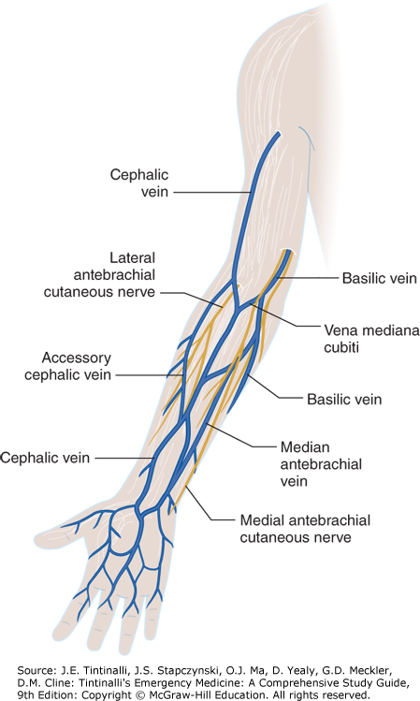

Figure: veins of the upper limb. Sourced from Tintinallis Emergency Medicine Textbook.

**Differentiation of Arteries and Veins on Ultrasound**

Having a firm grasp of the characteristics of veins and arteries on ultrasound is key to ensure you select the right vessel to cannulate.

**Arteries on ultrasound:**

* Have a thick bright wall;
* Are circular;
* Will pulsate (unless the patient is hypotensive);
* Are non compressible (unless you place excessive pressure through your probe);
* Are pulsatile on Colour Doppler;
* Lack venous augmentation when squeezing limb distal to probe.

**Veins on ultrasound:**

* Are thin walled;
* Are non pulsatile;
* Are compressible with probe pressure;
* Demonstrate venous augmentation when squeezing limb distal to probe.

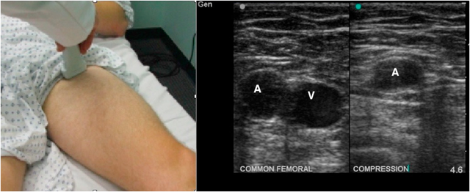

Figure: showing thick circular non compressible artery (A) and the thin oval shaped compressible vein (V). Sourced from: https://www.grepmed.com/images/1172/positioning-radiology-diagnosis-clinical-femoral

**Appropriate Cannula Selection**

The decision about what gauge and what length cannula to use will be based on a few key elements:

* **Width of vessel**: smaller veins will need a smaller width cannula. However most US-PIVC will be done with a 20g cannula.
* **Age of patient**: smaller cannulas are used for paediatrics and neonates. The 20G or 18G is the general cannula size for most adult emergency patients. The choice of the cannula is dependant on the haemodynamic stability of the patient and the indication.
* **What the cannula is to be used for:**
  + **Resuscitation of the Shocked Patient:** Suggest 14g cannula. Shorter and wider cannulas will have a higher flow rate, which is useful in trauma situations, massive transfusion protocols, or shocked patients. Be aware than longer cannulas will have slower flow rates than shorter cannulas.
  + **Blood products:** Suggest 16g cannula.
  + **Contrast injections for CT:** need at least 20g (however 18g would be preferable) to achieve adequate flow rate. If cannula required for contrast for CT Angiogram then need proximal cannula due to pressure and rate of contrast injection required.
  + **Sclerotic infusions**: preferable to have wider cannula in more proximal vein
  + **Vasopressors**: preferable to have a wider cannula in a more proximal vein
  + **Difficult intravenous access**: suggest 20g cannula.
* **Depth of vessel to be cannulated** 
  + Deeper vessels will need longer cannulas to utilised.
  + If a shorter cannula is used for a deep vein, there is increased change of failure of procedure and early failure of the cannula from tissuing.

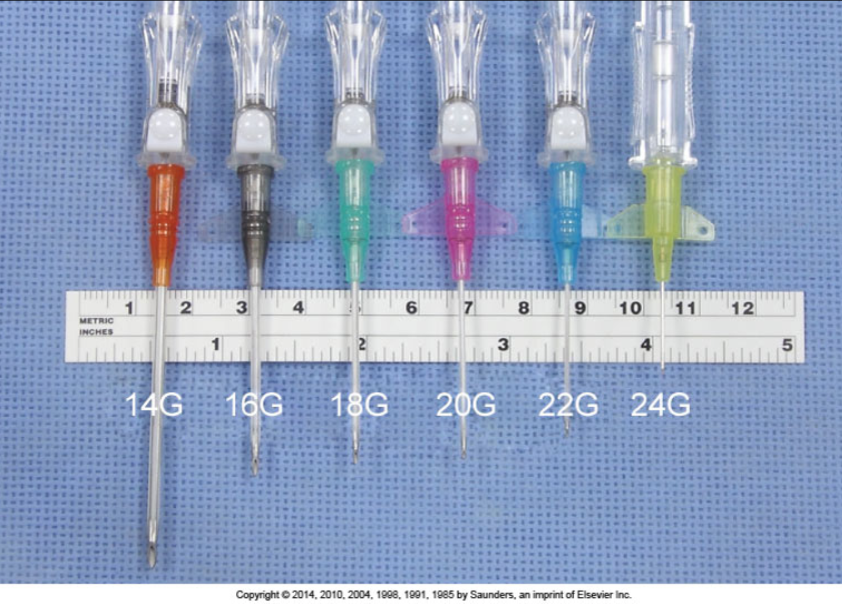

*Picture sourced from Robert and Hedges Clinical Procedures in Emergency Medicine* [*http://coursewareobjects.elsevier.com/objects/elr/ExpertConsult/Roberts/emergencymedicine6e/IC/jpg/Chapter21/021008.jpg*](http://coursewareobjects.elsevier.com/objects/elr/ExpertConsult/Roberts/emergencymedicine6e/IC/jpg/Chapter21/021008.jpg)

**Equipment**

The following equipment is required for all US-PIVC:

* Ultrasound machine (the Mindray Alpha or Beta Ultrasound Machines are very good for US-PIVC as they have a small footprint, have a linear probe and are easily portable)
* Venous cannula of appropriate size and length for vein
* Tourniquet
* Probe cover
* Ultrasound gel
* Non sterile gloves
* Alcohol wipes or chlorhexidine wipes
* If planning on using local anaesthetic then you will also require: 3mL syringe + 25 gauge needle + Lignocaine 1%
* Bung
* Tegaderm
* 10mL syringe for collection bloods
* Blood tubes and vacutaner for bloods
* 10mL syringe + 0.9% Normal saline to flush cannula
* Sterile gauze squares
* Sharps bin
* Chair

**Techniques**

There are two different techniques used for US-PIVC. They each have their own advantages and disadvantages. The most important factor is that you become competent in the technique that you choose to be able to do the procedure safely and successfully.

**Transverse Approach**

The transverse approach uses the probe in the short axis to the vein (i.e. out of plane approach). The technique is technically easier to master however it is mistake the position of your needle tip.

Steps involved:

1. The transducer is centred over the vein.
2. You insert your needle under the midpoint of the transducer until you see your hyperechoic needle on the ultrasound.
3. You advance your cannula incrementally ~1mm at a time towards the vein.
4. When the needle tip progresses out of your view (past the view provided by the probe) then you slide your ultrasound probe more proximally until you see your needle tip on the screen once more.
5. You continue to do this incremental movements of the needle and probe until you are just superficial to the vein on ultrasound.
6. You will see the needle tenting the superficial wall of the vein and then pop through the vein wall into the centre of the vein.
7. At this point you should see a flash back of blood into the cannula
8. Advance the cannula another 2mm to ensure that the plastic sheath is inside the vein as well as the needle tip
9. At this point you can remove the ultrasound probe and continue to cannulation procedure as you normally would without ultrasound guidance.

**Longitudinal Approach**

The longitudinal approach is more difficult to master but safer overall as you visualise the whole needle length as well as the needle tip entering the vein.

Steps involved:

1. Place your ultrasound probe on the long axis of the vein. Try and keep it in the centre of the vein by finding the brightest vein walls.
2. Insert your cannula at the skin underneath the distal aspect of the probe. Ensure that your needle is in the exact centre of the probe otherwise will not be able to visualise it on the screen.
3. Find your needle on the screen
4. Advance the needle into the vein whilst following it on the ultrasound.
5. The advantage of this method is that you will see you needle tip entering the vessel.
6. Once you get flash back in your cannula, advance the needle another 2mm until the sheath is in the vessel
7. At this point you can remove the ultrasound probe and continue to cannulation procedure as you normally would without ultrasound guidance.

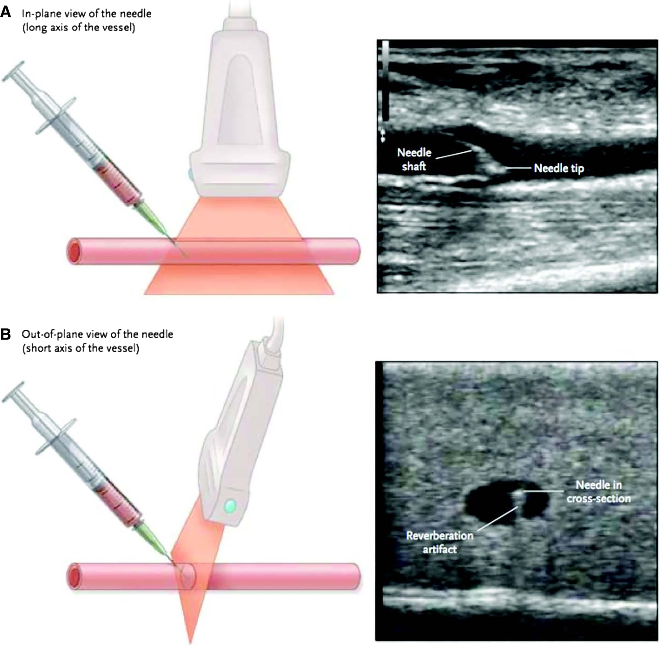

Figure: Transverse versus Longitudinal Appoach.   
Sourced from https://onlinelibrary.wiley.com/doi/10.1002/jum.14954 (Medicine n.d.)

**Procedure**

1. Set up room – optimise position of patient, proceduralist, bed height and ultrasound machine;
2. Set up equipment needed;
3. Apply tourniquet to upper arm proximal to where PIVC is planned to be inserted;
4. Apply probe cover to probe;
5. Do a scout scan to identify venous anatomy and an appropriate vein to cannulate. Aim for a vein that is >3mm wide and under 1cm deep to optimise first pass success;
6. Decide whether transverse or longitudinal approach is to be employed;
7. Centre transducer over the target vessel;
8. Optimise ultrasound settings to improve visualisation of the vessel – decrease depth, optimise gain, optimise focus;
9. Clean area with alcohol wipes or chlorhexidine swab;
10. Can either use sterile water or sterile gel on the skin under you probe.
11. Consider injecting a small amount of local anaesthetic to numb the skin.
12. Introduce the needle at 45degrees angle, slightly back from the transducer;
13. Once the tip is identified on screen, advance it toward the vessel;
14. Watch the catheter closely for a flash of blood;
15. Once the flash is obtained, set the ultrasound aside;
16. Advance cannula into vein;
17. Apply bung and secure with tegaderm;
18. Collect bloods;
19. Release tourniquet;
20. Flush IVC with 0.9% of Normal Saline;
21. Confirm correct placement of cannula with ultrasound;
22. Discard sharps, clean area;
23. Discard probe cover;
24. Clean ultrasound with clinell wipes and return to appropriate place.
25. Can flush the cannula under ultrasound to confirm correct cannula placement

**Post Procedure Care**

* Advise patient that procedure completed
* Advise patient not to touch insertion site or dressing
* Keep the site clean and dry
* Advise patient to please notify staff if increasing pain, swelling or redness occurs
* Document procedure in notes including insertion date, time, and any complications experienced.

**Complications**

The complications for US-PIVC are very similar to standard placement of PIVC and include:

* **Pain**: the procedure for placing a US-PIVC can take a couple of minutes (longer than standard PIVC). Consider using lignocaine to make this procedure more comfortable for your patient.
* **Failure of procedure**: If the procedure fails then analyse what went wrong? What could I have improved? What is my back up plan?
* **Vessel injury**: haematoma, haemorrhage, thrombophlebitis
* **Nerve injury**: ensure you recognise and avoid nerves on the scout scan.
* **Infection at insertion site**: asceptic non-touch technique required for this procedure as well as standard daily nursing checks on the ward to ensure nil infection.
* **Thrombosis**
* **Air embolism**
* **Vasovagal syncope on needle insertion**

**Accreditation for Ultrasound Guided Peripheral Intravenous Catheter Insertion**

There are two options for accreditation for ultrasound guided PIVC at Sutherland Hospital.

**CCPU Pathway**

The Certificate in Clinician Performed Ultrasound (CCPU) is a is a credential awarded by the Australasian Society for Ultrasound in Medicine (ASUM) for various point of care ultrasound skills. They have a vascular access module which can provide formal credentialing in the skill of ultrasound guided PIVC, arterial lines and central lines. More information can be found at: <https://www.asum.com.au/files/public/Education/CCPU/Syllabi/CCPU-Vascular-Access-Syllabus.pdf>

**Local Sutherland Hospital Emergency Department Credentialing Pathway**

The local pathway to credential doctors in ultrasound guided PIVC includes the following steps:

1. Read the Ultrasound Guided Peripheral Intravenous Access Insertion Module (this document).
2. Complete Pre and Post Module MCQ which includes ten multiple choice questions each.
3. Attend a formal 2 hour practical session
4. Complete the practical session feedback form
5. Complete a logbook with 5 supervised ultrasound guided PIVC

**Logbook for US- PIVC**

|  |  |  |  |  |  |
| --- | --- | --- | --- | --- | --- |
| **Date** | **Details of procedure** | **Complications** | **Successful** | **Supervisor Comments** | **Supervisor signature** |
|  |  |  |  |  |  |
|  |  |  |  |  |  |
|  |  |  |  |  |  |
|  |  |  |  |  |  |
|  |  |  |  |  |  |

# Bibliography

Archer-Jones, Amy, Peter Snelling, and Stuart Watkins. "Establishing a hospital-based ultrasound-guided peripheral intravenous catheter training program: A narrative of a 5-year experience ." Edited by Geoff Hughes. *Emergency Medicine Australiasia* (Wiley ) 32, no. 6 (December 2020): 1080-1083.

Custalow, Catherine, Todd Thomsen , James Roberts, and Jerris Hedges . *Roberts and Hedges' Clinical Procedures in Emergency Medicine.* 6. 1 vols. Philadelphia : Elsevier, 2014.

Emergency Care Institute "Circulation - Peripheral Cannulation ." Emergency Care Institute. December 2020. https://aci.health.nsw.gov.au/networks/eci/clinical/clinical-resources/procedures/procedures/575480 (accessed March 21, 2021).

Australian Institute of Ultrasound in Medicine "AIUM Practice Parameter for the Use of Ultrasound to Guide Vascular Access Procedures ." *Journal of Ultrasound in Medicine* (Wiley Online Library ) 38, no. 3: 4-18.

Sutherland Emergency Department. "Sutherlanded Emergency - Emergency Teaching and Educational Resources ." https://www.sutherlanded.com/pocus/tsh-ultrasound-videos/ (accessed March 21, 2021).

Tintinalli, Judith. *Emergency Medicine - A Comprehensive Study Guide .* McGraw Hill Education , 2016.

Walls, Ron, ed. *Rosen's Emergency Medicine Concepts and Clinical Practice.* 9. Elsevier, 2018.