Collapsed Lung Patient Discharge Information Leaflet

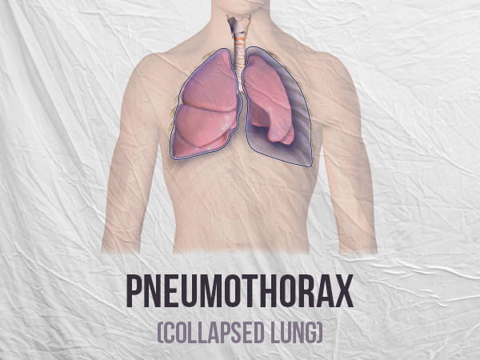

What is a collapsed lung?
A collapsed lung, also called a pneumothorax, happens when air enters the space between your rib cage and one of your lungs. The air makes it hard for the lung to expand and causes the lung to collapse.
What are the symptoms of a collapsed lung?
Symptoms usually start suddenly and include
- Chest pain that can be sharp or stabbing
- Difficulty breathing

Does my condition need any treatment?
In most cases the lung will re-expand without any treatment. However, a small number will not get better or may even get worse. That is why it is important you can attend the follow up appointment and that you are aware of worrying symptoms that mean you should go back to the Emergency Department

How can I look after myself when I go home?
Take painkillers as prescribed by your doctor to treat the pain
If you smoke you should talk to your GP about stopping smoking. This can reduce the chance of you getting another collapsed lung in the future.
You should avoid flying in a plane or scuba diving until the Respiratory doctor tells you it is safe to do so.

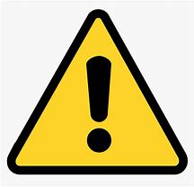 Go to ED or call 000 if you have new or worsening
- Chest pain that does not get better with painkillers
- Difficulty breathing
- Feeling like you are going to faint
- Blue or grey colour of your fingers or lips

Do not drive yourself if you have any of these symptoms

Do not drive yourself if you have any of these symptoms

