* **Management of PRIMARY Spontaneous Pneumothorax PRESENTING TO Sutherland Emergency Department**

|  |  |
| --- | --- |
| **1. Purpose** | To guide the management of primary spontaneous pneumothorax presenting to Sutherland Emergency Department |
| **2. Risk Rating** | Medium |
| **3. National Standards** | 1 – Clinical Governance  5 – Comprehensive Care  8 – Recognising and Responding to Acute Deterioration |
| **4. Employees it Applies to** | Emergency Department Medical Officers, Respiratory Physicians, Registered Nurses |

## 5. PROCESS

Conservative management of primary spontaneous pneumothorax has been shown to be non-inferior to pleural drain insertion when assessed by lung re-expansion at eight weeks 1

Other benefits to conservative management include lower rates of recurrence of pneumothorax within 12 months, lower rates of adverse events, shorter length of hospital stay and less days off work.

It is important to note in this study 15% of patients treated conservatively required insertion of a pleural drain and so adequate follow up is essential to this treatment strategy.

The purpose of this CBR is to provide a framework for the initial ED assessment, referral and ongoing management of primary spontaneous pneumothorax presenting to Sutherland ED.

**5.1 ASSESSMENT BY EMERGENCY DEPARTMENT MEDICAL STAFF**

For patients assessed in TSH ED with confirmed pneumothorax a senior Emergency doctor should make a clinical assessment to determine the stability of the patient.

Any patient who is demonstrating signs of clinical tension pneumothorax with haemodynamic compromise (SBP < 90mmHg and/or MAP < 65mmHg) should be managed in the ED resuscitation bay and have a pleural drain inserted immediately by a senior Emergency doctor

**5.2 SUITABILITY FOR CONSERVATIVE MANAGEMENT**

The size of the pneumothorax does not correlate well with clinical symptoms but should be estimated using the Collins method (below) to allow comparison at subsequent follow up appointments

Percentage Pneumothorax Volume = 4.2 + 4.7 (A + B + C)

A is the maximum apical interpleural distance

B is the interpleural distance at midpoint of upper half of lung

C is the interpleural distance at midpoint of lower half of lung

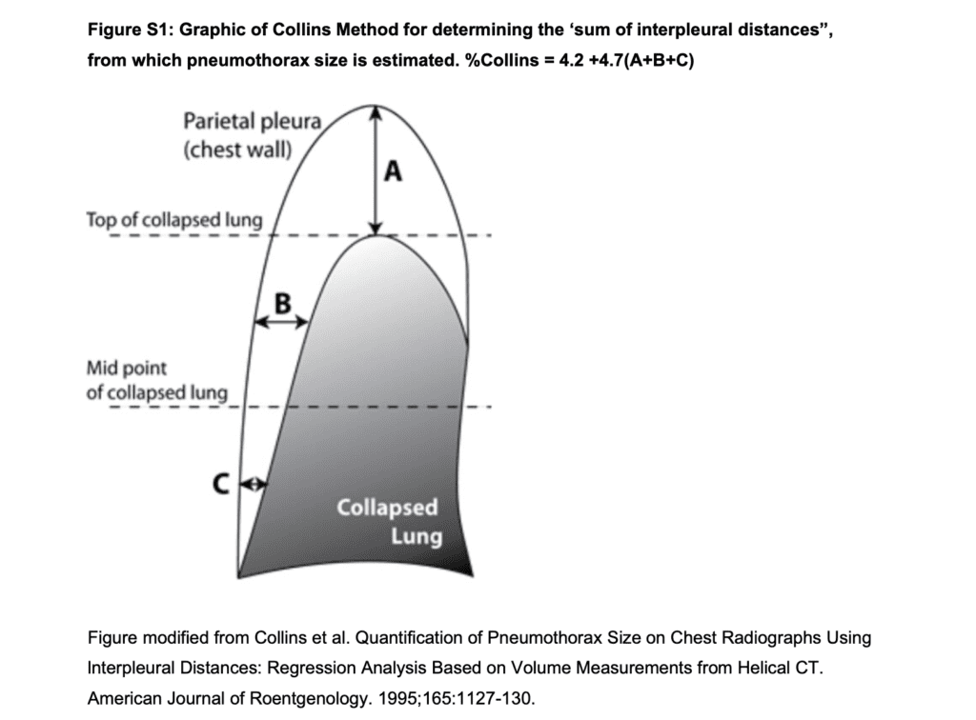

**In defining a management strategy, the size of a pneumothorax is less important than the degree of clinical compromise 2. To be considered suitable for conservative management a patient must fulfil the following criteria at the initial assessment**

**Inclusion Criteria**

* Age 14-50 years old
* Pain controlled with oral analgesia
* No supplementary oxygen requirement (oxygen saturation ≥ 90% on room air)
* Respiratory rate < 30 breaths/minute
* Haemodynamic stability: SBP > 90mmHg; MAP > 65mmHg

**Exclusion Criteria**

* Previous pneumothorax on the same side
* Secondary pneumothorax
* Co-existent haemothorax
* Bilateral pneumothoraces
* Clinical Tension pneumothorax (systolic BP <90mmHg or MAP < 65mmHg)
* Social circumstances make outpatient follow up not possible
* Difficulty in presenting to ED in event of worsening symptoms
* Pregnancy
* Planned air travel in the next 12 weeks

In patients who meet the inclusion criteria with no exclusion criteria identified conservative management should be offered to the patient.

In those patients who do not fulfil these criteria a management plan should be discussed with the senior Emergency doctor and Respiratory Physician on call

**5.3 CONSERVATIVE MANAGEMENT IN THE EMERGENCY DEPARTMENT**

The patient should remain in ED for observation for 4 hours to ensure no clinical deterioration and have a progress chest X-ray at 4 hours to ensure there is no change in the size of the pneumothorax.

When there is an available bed the patient should be moved to EDSSU for the observation period

If after observation the patient fulfils the below criteria they should be discharged home with a discharge letter and written instructions on reasons to reattend ED. See **Appendix 1** Patient Information Discharge Leaflet

**Safe Discharge Criteria**

* Walking comfortably in the ED
* Pain controlled with oral analgesia
* No supplementary oxygen requirement (oxygen saturation ≥ 90% on room air)
* No haemodynamic compromise (SBP <90mmHg or MAP < 65mmHg)
* Pneumothorax size stable on repeat chest X-ray

**5.4 REFERRAL FOR FOLLOW UP**

Prior to discharge the patient should be discussed with the on call Respiratory Physician to ensure conservative management is considered appropriate and referred to the Respiratory clinic on extension 37067 for follow up in 1 week

Patients should be advised to attend follow up for assessment on the next morning that is more than 24 hours after the index visit.

* When this will fall on a weekend or public holiday they should be advised to reattend ED and be placed on the expected patient list on EMR
* When this will fall on a weekday (excluding public holidays) the patient should be referred to the Respiratory Clinic at Hurstville Private Hospital by faxing a copy of the discharge summary marked “*URGENT”.* The patient can then call the phone number to book an appointment

Suite 11, Level 1

37 Gloucester Rd, Hurstville, NSW 2220

**Tel: 95704800; Fax: 95704855**

email reception@sirespiratory.org

**5.5 ASSESSMENT AT FOLLOW UP APPOINTMENT**

When the follow up visit takes place in Sutherland ED a clinical assessment of stability including a full set of physiological observations and progress Chest X-ray should be performed to ensure no clinical deterioration or progression in size of the pneumothorax has occurred. Whilst in ED the patient should be discussed with the Respiratory Physician on call.

If there has been clinical deterioration or an increase in size of the pneumothorax a pleural drain should be inserted and the patient admitted under the Respiratory team

-refer to the [ACI Pleural Drains in Adults - A Consensus Guideline](https://www.aci.health.nsw.gov.au/resources/respiratory/pleural-drains/pleural-drains-in-adults)

If the patient remains clinically stable and there is no increase in size of the pneumothorax on Chest X-ray the patient can be discharged for follow up in Respiratory clinic with written instructions on reasons to reattend ED . . See **Appendix 1** Patient Information Discharge Leaflet

**Definitions**

**Primary Spontaneous Pneumothorax** one that occurs without an apparent cause such as trauma and in the absence of significant lung disease

**Secondary Pneumothorax** defined as occurring in the setting of acute trauma or underlying lung disease including asthma

**Senior Emergency Doctor** refers to Emergency Department Advanced Trainees and Consultants.

**Pleural Drain** refers to a Seldinger approach pigtail chest/pleural drain

|  |  |
| --- | --- |
| **6. Cross References** | [**https://www.aci.health.nsw.gov.au/resources/respiratory/pleural-drains/pleural-drains-in-adults**](https://www.aci.health.nsw.gov.au/resources/respiratory/pleural-drains/pleural-drains-in-adults) |
| **7. Keywords** | Pneumothorax, Chest Drain, Pleural Drain |
| **8. BR Location** | http://seslhdweb.seslhd.health.nsw.gov.au/TSH/Business_Rules/Emergency/default.asp, under P |
| **9. External References** | 1. Conservative versus interventional treatment for spontaneous pneumothorax. Brown et al N England J Med 2020; 382:405-415 DOI: 10.1056/NEJMoa1910775 2. Management of spontaneous pneumothorax: British Thoracic Society pleural disease guideline 2010. MacDuff et al BMJ Thorax 2010 DOI:10.1136/thx.2010.136986 |
| **10. Consumer Advisory Group (CAG)** **Approval** | Not Applicable |
| **11. Aboriginal Health Impact Statement** | The Aboriginal Health Impact Statement does not require completion because there is no direct or indirect impact on Aboriginal people. This document is clinical and relates to all population groups. |
| **12. Implementation and Evaluation Plan** | **Implementation:** The document will be published on the SGH-TSH business rule webpage and distributed via the monthly SGH-TSH CGD report. Distribution to Emergency Registrars and Consultants, Respiratory and General Medicine physicians  **Evaluation**: Clinical audit to be performed prior to and after the implementation of the CBR to assess the impact |
| **13. Knowledge Evaluation** | **Q1: Can primary spontaneous pneumothorax be treated conservatively?**  *A1: If a patient is stable and does not have any exclusion criteria conservative management is an appropriate treatment strategy*  **Q2: What treatment should be given if a patient is clinically unstable or deteriorates?**  *A2: In clinically unstable patients a pleural drain should be inserted by an appropriately trained senior doctor and the patient admitted under Respiratory medicine*  **Q3: Will all patients with primary spontaneous pneumothorax who receive conservative treatment make a full recovery?**  *A3: A proportion of patients managed conservatively will require a pleural drain insertion because of clinical progression or deterioration. It is important the patient has appropriate follow up and is able to reattend ED if they become more unwell* |
| **14. Who is Responsible** | Director of Emergency Department TSH |

|  |  |
| --- | --- |
| * **Approval for**: **Management of PRIMARY Spontaneous Pneumothorax PRESENTING TO Sutherland Emergency Department** | |
| **Nurse Manager / Co-Director (TSH)** | Elizabeth Burd, Nurse Manager Emergency Department TSH  Signature: Date |
| **Medical Head of Department (TSH)** | Oliver Barrett, Acting Director Emergency Department TSH:  Signature: Date: Click or tap to enter a date. |
| **Executive Sponsor / s** | Leanne Horvat, Co-Director Nursing & Operations TSH  Signature: Date: Click or tap to enter a date. |
| **Contributors to BR** | **Contribution**  Todd Steggles, Staff Specialist Emergency Department TSH |
| **Consultation**:  Ben Kwan, Director Respiratory Medicine TSH |

|  |  |  |  |  |
| --- | --- | --- | --- | --- |
| **Revision and Approval History** | | | | |
| Revision Date | Revision number | Reason | Coordinator/Author | Revision Due |
| January 2023 | 0 | New | Todd Steggles | January 2026 |

|  |
| --- |
| **General Manager’s Ratification** |
| Angela Karooz (SGH) Signature: Date: Click or tap to enter a date. |
| Vicki Weeden (TSH) Signature: Date: Click or tap to enter a date. |